Helsinki, Uusimaa, Finland
Finland's compact capital packs neoclassical grandeur, a UNESCO island fortress, and world-class design into one very walkable Baltic shoreline. Most sights are reachable on foot or by tram from the pier.
⚓ Docked — multiple terminals · 🕒 Typical call: 8-10 hrs · 💶 Euro (€) · 🗣️ Finnish / Swedish / English widely spoken
✍️ MY DAY IN PORT (FILL IN)
Ship / Date
In port | arrive ______ · all aboard ______
Booked excursion
Notes / meeting point
GETTING ASHORE
- Docking: Docked at West Harbour, Katajanokka, Hernesaari, or South Harbour — no tendering
- Walk to center: 5 min (Katajanokka) to 20 min (West Harbour); trams available from all piers
- Best For: Architecture, Baltic history, design shopping, island day trips
- Don't Miss: Suomenlinna UNESCO fortress (15-min ferry from Market Square)
GETTING AROUND
- 🚕 Taxi: €15–€25 — Metered taxis available at West Harbour (Länsisatama) terminal exit. The city center is about 3 km away — most rides tak
- 📱 Rideshare: ✅ Uber, Bolt
- 🚌 Hop-on hop-off: ✅
TOP THINGS TO DO
- Suomenlinna Sea Fortress — A UNESCO World Heritage site spread across six islands, built by Sweden in the 18th century and now home to museums, cafés, and…
- Senate Square & Helsinki Cathedral — The neoclassical heart of Helsinki: the gleaming white Lutheran cathedral, the Government Palace, and Helsinki University all…
- Design District & Esplanadi — Helsinki is one of Europe's design capitals.
- Temppeliaukio Rock Church — A church blasted directly into bedrock, finished in 1969 — the copper-ringed interior is instantly recognizable and acoustically…
- Market Square & Old Market Hall — Kauppatori (Market Square) sits right on the South Harbour waterfront — stalls sell smoked salmon, crayfish, cloudberries, and…
BEST WALKS
- South Harbour Waterfront Loop: 2-3 km · 45-60 min · Easy flat — Start at Market Square, walk east along the waterfront past the Presidential Palace to Uspenski…
- Esplanadi to Temppeliaukio: 3-4 km · 1 hr · Easy — Walk the tree-lined Esplanadi from Market Square to the Swedish Theatre, then head north through…
WEATHER · DAYLIGHT · MONEY
Month | High °F | Low °F | Rainy days
May | 56 | 43 | 10
Jul | 69 | 57 | 12
Sep | 59 | 50 | 11
Daylight: May 4:41AM–9:53PM · Jul 4:23AM–10:28PM · Sep 6:48AM–7:40PM
cruiseports.org/helsinki · Confirm terminal & all-aboard time with your ship

Helsinki, Uusimaa, Finland — Port Map
Red = walkable sights · Amber = excursions farther out · P = cruise terminal
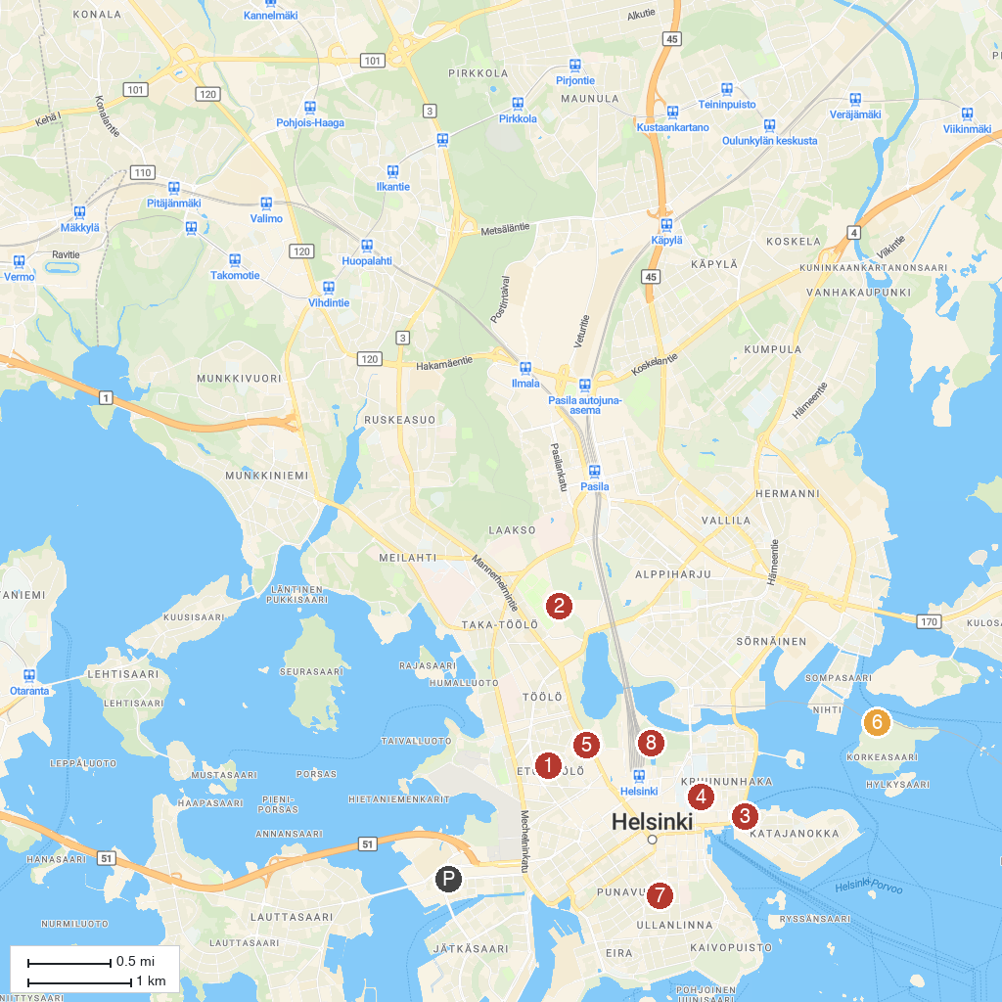
MAP KEY
1. Temppeliaukio Church | 5. Suomen Kansallismuseo
2. Helsinki Olympic Stadium | 6. Korkeasaari Zoo
3. Uspenski Cathedral | 7. St. John's Church
4. Helsinki Cathedral | 8. Kaisaniemi Park
P. Cruise port / terminal
Map © MapTiler © OpenStreetMap contributors · cruiseports.org

