Helsingborg, Skåne, Sweden
Sweden's gateway to Denmark, Helsingborg packs a medieval keep, a vibrant pedestrian high street, and a 20-minute ferry ride to Kronborg Castle into a single shore day.
⚓ Pier (city center or south harbour) · 🕒 Typical call: 7–10 hrs · 💳 Cashless — card everywhere, no SEK needed · 🗣️ Swedish (flawless English spoken universally)
✍️ MY DAY IN PORT (FILL IN)
Ship / Date
In port | arrive ______ · all aboard ______
Booked excursion
Notes / meeting point
GETTING ASHORE
- Docking: Pier — City Pier (centre) or South Harbour (5–10 min ride); tender rare
- Walk to centre: 0 min from City Pier; ~25–30 min or shuttle from South Harbour
- Best For: History, day-trip to Denmark, Swedish fika, coastal walks
- Don't Miss: Climbing Kärnan tower for views across the Öresund to Denmark
GETTING AROUND
- 🚕 Taxi: 150–300 SEK — Taxis are readily available at all piers. Fares from the South or Ocean pier to the city center are short (5–10 min); pr
- 📱 Rideshare: ✅ Uber, Bolt
TOP THINGS TO DO
- Climb Kärnan & the Castle Terraces — The 35-metre medieval keep is all that survives of a mighty Danish fortress.
- Ferry to Helsingør & Kronborg Castle — Board the Øresundslinjen ferry (20 min crossing) to Denmark and visit Kronborg — Shakespeare's Elsinore Castle and a UNESCO World…
- Sofiero Palace & Rhododendron Gardens — Former royal summer residence 5 km north of town, world-famous for its spectacular rhododendron blooms (peak May–June) and…
- Fredriksdal Open-Air Museum — One of Sweden's largest open-air museums with 18th-century Skåne farmhouses, working period shops, a rose garden, and farm animals.
- Beach Fika & Kallbadhuset Sauna — Helsingborg's 'Tropical Beach' near the harbour has sun loungers and a summer beach bar.
BEST WALKS
- Historic City Loop: 3 km · 1 hr · Easy — From the waterfront, walk Kullagatan (Sweden's oldest pedestrian shopping street) north to…
- Waterfront Promenade Stroll: 2 km · 40 min · Easy — Head north from the City Pier along Gröningen, the seaside promenade.
WEATHER · DAYLIGHT · MONEY
Month | High °F | Low °F | Rainy days
May | 60 | 46 | 12
Jul | 69 | 58 | 14
Sep | 64 | 53 | 11
Daylight: May 4:56AM–9:16PM · Jul 4:44AM–9:45PM · Sep 6:41AM–7:26PM
cruiseports.org/helsingborg · Confirm terminal & all-aboard time with your ship

Helsingborg, Skåne, Sweden — Port Map
Red = walkable sights · Amber = excursions farther out · P = cruise terminal
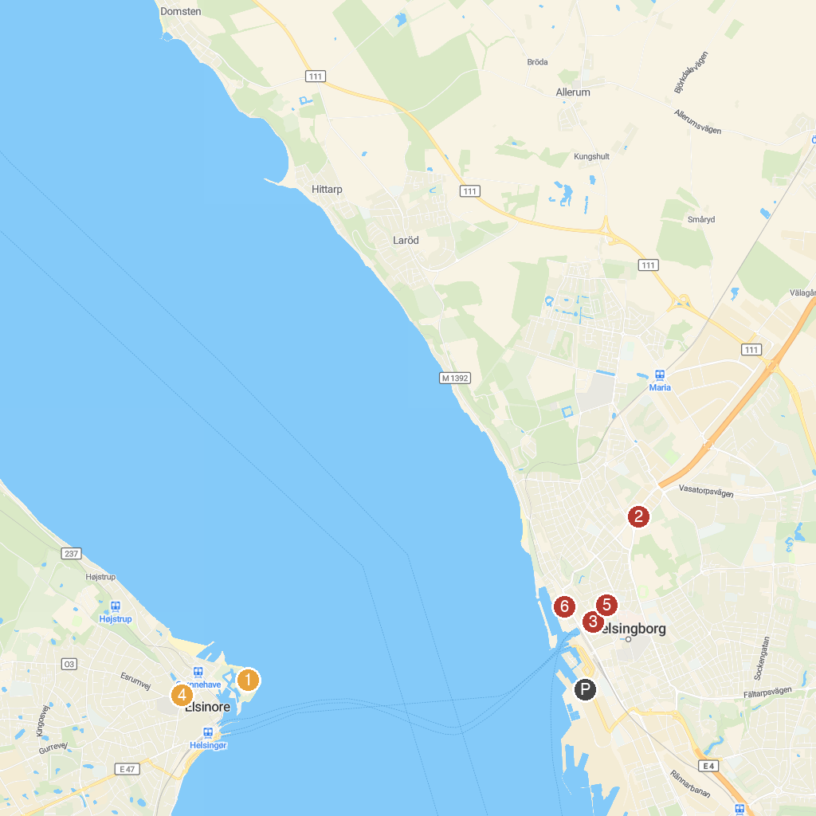
MAP KEY
1. Louisiana Museum of Modern Art | 5. St. Mary Church
2. Kronborg Castle | 6. St. Vincent's Church
3. Tropikariet | 7. Slottshagen
4. Borgen | 8. Sundstorget
P. Cruise port / terminal
Map © MapTiler © OpenStreetMap contributors · cruiseports.org

