Hellesylt, Møre og Romsdal, Norway
A roaring waterfall splits the village in two, and the world-famous Geirangerfjord begins just around the bend. Hellesylt is small, gorgeous, and surprisingly easy to explore on foot.
⚓ Pier (occasional tender when busy) · 🕒 Typical call: 4–7 hrs · 💵 Norwegian Krone (NOK) — card widely accepted · 🗣️ Norwegian (English spoken in tourist areas)
✍️ MY DAY IN PORT (FILL IN)
Ship / Date
In port | arrive ______ · all aboard ______
Booked excursion
Notes / meeting point
GETTING ASHORE
- Docking: Modern cruise pier; tender possible if pier occupied by another ship
- Walk to center: 2–5 min flat walk from pier to village and waterfall
- Best For: Geirangerfjord ferry, fjord scenery, relaxed village wandering
- Don't Miss: Hellesyltfossen waterfall and the Peer Gynt Gallery wood carvings
GETTING AROUND
- 🚕 Taxi: From NOK 500+ for regional trips — Taxis are very limited in Hellesylt and must be booked in advance. No standard port-to-town transfer is needed as the po
TOP THINGS TO DO
- Geirangerfjord Ferry Cruise — Board the public car ferry for a 1-hour sail through the Geirangerfjord, passing the thundering Seven Sisters and The Suitor…
- Dalsnibba Mountain Skywalk & Geiranger — A guided bus tour climbs to 1,500m elevation at Mount Dalsnibba's Skywalk for jaw-dropping fjord views, then descends to…
- RIB Speedboat Fjord Safari — Blast through the Geirangerfjord on a rigid inflatable boat, getting up close to waterfalls and vertical cliffs.
- Briksdal Glacier Discovery — A scenic bus journey through valleys and past Hornindalsvatnet (Europe's deepest lake) to the Briksdal Glacier arm of the…
- Kayaking on Sunnylvsfjord — Paddle the calm inner fjord directly from Hellesylt, surrounded by towering mountains and waterfalls.
BEST WALKS
- Village & Waterfall Walk: 30–45 min | Easy | Flat — Stroll from the pier through the village center to Hellesyltfossen, where the waterfall roars…
- Sunnylven Church Viewpoint: 20 min uphill | Easy-moderate | Panoramic views — Climb the hill behind the village to the 1859 wooden Sunnylven Church for one of the best views of…
- Fjord Swimming Area (Badeplass): 15 min flat | Easy | Optional swim — Walk along the fjord shore to Hellesylt Badeplass, a park with a grassy area and multi-level wooden…
WEATHER · DAYLIGHT · MONEY
Month | High °F | Low °F | Rainy days
May | 53 | 41 | 16
Jul | 68 | 55 | 20
Sep | 60 | 49 | 18
Daylight: May 4:38AM–10:21PM · Jul 4:15AM–11:00PM · Sep 6:58AM–7:54PM
cruiseports.org/hellesylt · Confirm terminal & all-aboard time with your ship

Hellesylt, Møre og Romsdal, Norway — Port Map
Red = walkable sights · Amber = excursions farther out · P = cruise terminal
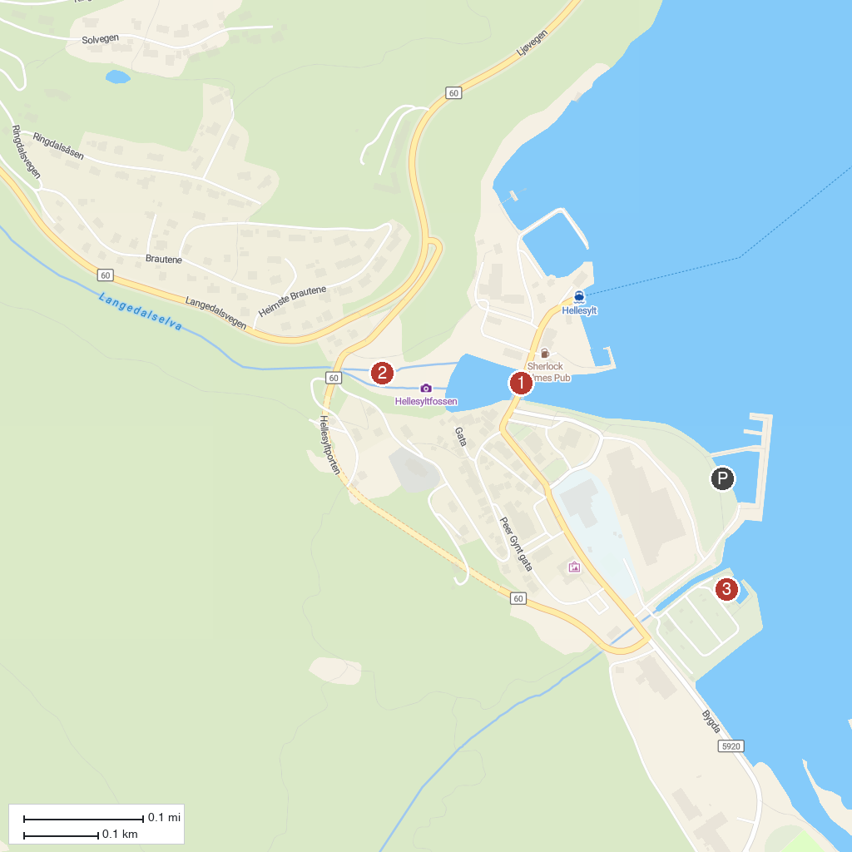
MAP KEY
1. Brudesløret (Bridal Veil) | 4. RIB Fjord Guiding Hellesylt
2. Hellesylt bro | 5. The Seven Sisters
3. Hellesylt Waterval (fossen) | 6. Giftesteinen
P. Cruise port / terminal
Map © MapTiler © OpenStreetMap contributors · cruiseports.org

