Heidelberg, Baden-Württemberg, Germany
Perched above the Neckar River, Heidelberg is Germany's most romantic city — a perfectly preserved Baroque Old Town overlooked by a ruined sandstone castle that has inspired poets, philosophers, and travelers for three centuries.
⚓ Docked pier (Mannheim/Speyer transfer) · 🕒 Typical call: 7–9 hrs · 💶 Currency: Euro (€) · 🗣️ Language: German · 🏰 UNESCO City of Literature
✍️ MY DAY IN PORT (FILL IN)
Ship / Date
In port | arrive ______ · all aboard ______
Booked excursion
Notes / meeting point
GETTING ASHORE
- Docking: Ships dock in Mannheim (~30 min) or Speyer (~45 min); motorcoach transfer to Heidelberg
- Walk to center: Coach drops at Marktplatz or Neckarmünzplatz — Old Town is entirely flat and walkable
- Best For: Castle & history fans, romantic Old Town strolls, German food and wine
- Don't Miss: Heidelberg Castle terrace view, the Bronze Bridge Monkey on the Old Bridge, Student Prison
GETTING AROUND
- 🚕 Taxi: €7–€15 — Taxis are readily available at the port and in the city center. Base fare is €3.90; short rides to Bismarckplatz or the
- 📱 Rideshare: ✅ Uber, Bolt
TOP THINGS TO DO
- Heidelberg Castle & Funicular — Ride the historic Bergbahn funicular up to the sandstone ruins for panoramic views over the Neckar valley, then explore the Great…
- Old Town Walking Tour — Wander the Hauptstraße pedestrian zone, Marktplatz, and Kornmarkt — a Baroque city center that survived WWII intact.
- Student Prison (Studentenkarzer) — From 1778 to 1914, the university jailed students for pranks and brawls here.
- Philosophers' Walk — Cross the Old Bridge to the north bank, climb the steep Schlangenweg (Snake Path), and reach the hilltop promenade where…
- Wine & Regional Food Tasting — Sample Palatinate wines and regional specialties — Saumagen (stuffed pig's stomach), Maultaschen ravioli, and the famous…
BEST WALKS
- Old Town Core Loop: 1.5 km · 30–45 min · Flat — Start at the Old Bridge, walk west along the Neckar bank to Neckarmünzplatz, up to Marktplatz and…
- Castle Climb & Terrace View: 1 km · 20 min up · Steep cobblestones — From Kornmarkt, follow the Burgweg cobblestone path steeply up through the wooded hillside to the…
- Old Bridge to Philosophers' Walk: 2 km · 45–60 min · Steep then flat — Cross the Karl-Theodor Bridge (touch the Bridge Monkey for luck), then climb the Schlangenweg path…
WEATHER · DAYLIGHT · MONEY
Month | High °F | Low °F | Rainy days
May | 67 | 50 | 13
Jul | 79 | 61 | 11
Sep | 70 | 54 | 9
Daylight: May 5:41AM–9:02PM · Jul 5:35AM–9:25PM · Sep 7:01AM–7:37PM
cruiseports.org/heidelberg · Confirm terminal & all-aboard time with your ship

Heidelberg, Baden-Württemberg, Germany — Port Map
Red = walkable sights · Amber = excursions farther out · P = cruise terminal
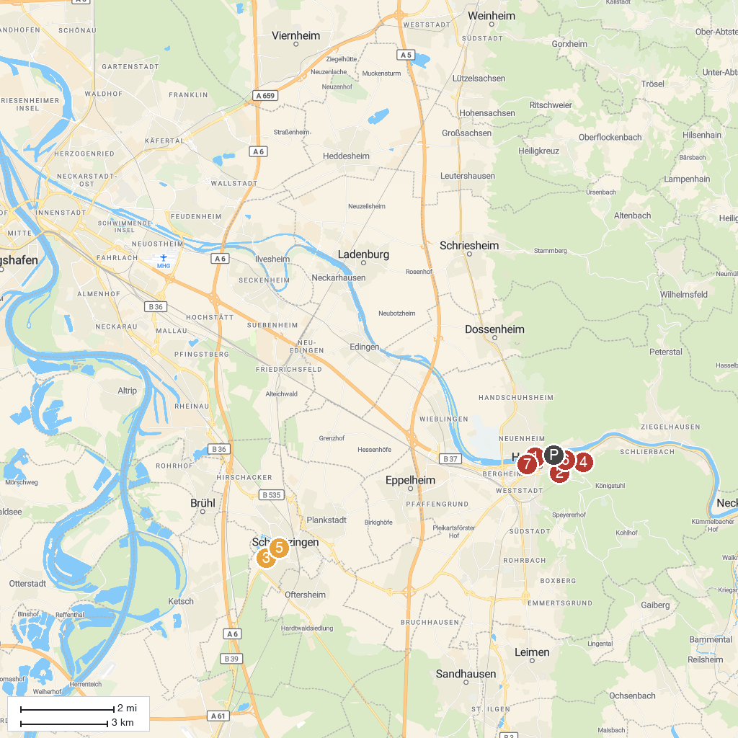
MAP KEY
1. Theodor-Heuss-Brücke | 5. Schwetzingen Palace
2. Riesenstein | 6. Studentenkarzer
3. Mosque in The Palace Garden | 7. Sammlung Prinzhorn
4. Heidelberg Castle
P. Cruise port / terminal
Map © MapTiler © OpenStreetMap contributors · cruiseports.org

