Havelberg, Saxony-Anhalt, Germany
A medieval island town where the Havel meets the Elbe — hilltop cathedral, cobblestone streets, and some of Germany's finest freshwater cycling paths right from the dock.
⚓ River pier (docked) · 🕒 Typical call: 4–6 hrs · 💶 Currency: Euro (€) · 🗣️ Language: German · 🚲 Cycling hub
✍️ MY DAY IN PORT (FILL IN)
Ship / Date
In port | arrive ______ · all aboard ______
Booked excursion
Notes / meeting point
GETTING ASHORE
- Docking: Riverside pier — ship ties up directly; town center is a short walk
- Walk to center: 5–10 min flat walk to the island old town; 15–20 min uphill to the Dom
- Best For: History lovers, cyclists, and those seeking a quiet, authentic German river town
- Don't Miss: Dom St. Marien (1170 AD) and the Prignitz Museum in the old monastery
GETTING AROUND
- 🚕 Taxi: Varies — contact in advance — Local operator TAXI- UND MIETWAGEN KURT HARBART offers ship transfer services (+49 39387 8341). Pre-booking recommended
TOP THINGS TO DO
- Dom St. Marien & Prignitz Museum — The cathedral was consecrated in 1170 and blends Romanesque and Gothic styles.
- Havelberg Old Town Island Walk — Wander the cobblestone Stadtinsel and discover St.
- Elbe Cycle Route Ride — Havelberg sits on the famous Elberadweg (Elbe Cycle Route).
- Haus der Flüsse (House of Rivers) — An interactive nature and visitor centre dedicated to the Havel and Elbe river ecosystems — local flora, fauna, and the ecology…
- Riverside Dining at Restaurant Hoffnung — The restaurant ship 'Hoffnung' is moored on the waterfront and serves regional dishes while boats pass by — a relaxing spot to…
BEST WALKS
- Island Old Town Loop: 1.5 km · 20 min · Easy, flat — A circuit of the Stadtinsel taking in the marketplace, St.
- Cathedral Hill Climb: 1 km each way · 30 min round trip · Moderate (steep hill) — From the island, follow Domstraße uphill to Dom St.
WEATHER · DAYLIGHT · MONEY
Month | High °F | Low °F | Rainy days
May | 66 | 48 | 9
Jul | 75 | 59 | 12
Sep | 68 | 53 | 9
Daylight: May 5:14AM–9:02PM · Jul 5:05AM–9:28PM · Sep 6:46AM–7:26PM
cruiseports.org/havelberg · Confirm terminal & all-aboard time with your ship

Havelberg, Saxony-Anhalt, Germany — Port Map
Red = walkable sights · Amber = excursions farther out · P = cruise terminal
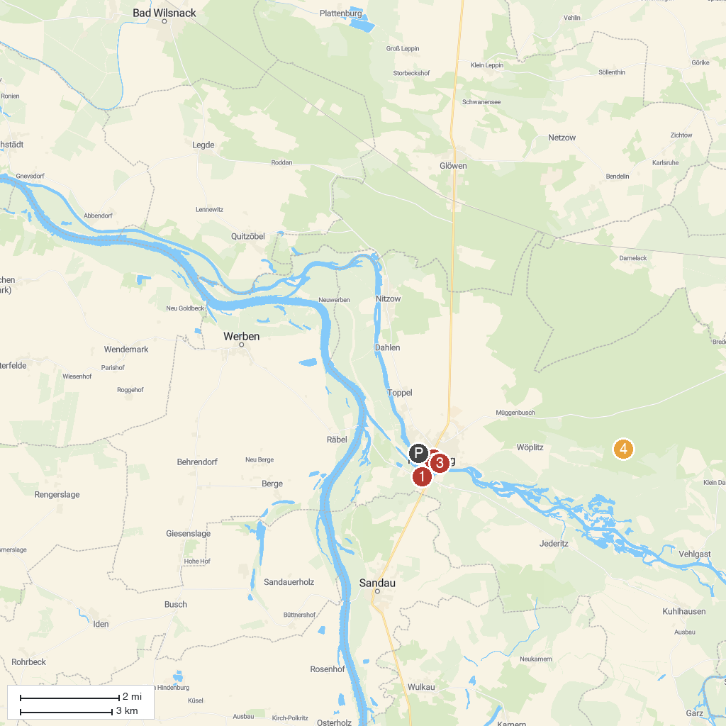
MAP KEY
1. Haus der Flüsse | 3. Prignitz Museum am Dom Havelberg
2. Burggrafenstein | 4. Untere Havel Angel
P. Cruise port / terminal
Map © MapTiler © OpenStreetMap contributors · cruiseports.org

