Haugesund, Vestland, Norway
The self-proclaimed homeland of the Viking kings, Haugesund offers an authentic slice of Norwegian coastal life — a colorful waterfront, genuine Norse heritage, and a surprising connection to Marilyn Monroe.
⚓ Pier (Garpeskjær Quay) · 🕒 Typical call: 7–10 hrs · 💵 Norwegian Krone (NOK) — but cards everywhere · 🗣️ Norwegian (English widely spoken)
✍️ MY DAY IN PORT (FILL IN)
Ship / Date
In port | arrive ______ · all aboard ______
Booked excursion
Notes / meeting point
GETTING ASHORE
- Docking: Pier at Garpeskjær Quay, Risøy island
- Walk to center: ~1 km (15–20 min) across Risøy Bridge
- Best For: Viking history, waterfront strolling, DIY exploration
- Don't Miss: Haraldshaugen monument & the Marilyn Monroe statue
GETTING AROUND
- 🚕 Taxi: ~115–150 NOK to city center — Taxis queue at the cruise pier. Haugaland Taxi and Karmøy Taxi are the main operators. Base fare ~95 NOK plus ~20 NOK/km
- 🚌 Hop-on hop-off: ✅ City Sightseeing / Grayline / Hopon.no
TOP THINGS TO DO
- Avaldsnes & Nordvegen History Centre — Visit Norway's oldest royal seat on nearby Karmøy island.
- Langfoss Waterfall — One of Norway's most spectacular waterfalls — 612 m of free-falling water straight into the Åkrafjord.
- Skudeneshavn Old Town — A perfectly preserved 19th-century sailing village at the southern tip of Karmøy — all white wooden houses, narrow lanes, and a…
- Åkrasanden Beach — A Blue Flag beach on Karmøy island with white sand and clear turquoise water — surprisingly Caribbean-looking for Norway.
- Haugesund Waterfront & Haraldshaugen Walk — Self-guided DIY walk: stroll Haraldsgata, photograph the Marilyn Monroe statue and pink Town Hall on Smedasundet, then continue 2…
BEST WALKS
- Waterfront Stroll: Pier to Haraldshaugen: 4 km round trip | ~1.5 hrs | Easy (one gentle hill at monument) — Cross Risøy Bridge into town, walk north along the colorful Smedasundet waterfront, snap a photo…
- City Center Highlights: 1.5 km | ~30 min | Easy — A compact loop of the city core: walk Haraldsgata pedestrian street for shopping and coffee, detour…
WEATHER · DAYLIGHT · MONEY
Month | High °F | Low °F | Rainy days
May | 55 | 43 | 14
Jul | 64 | 53 | 18
Sep | 60 | 51 | 18
Daylight: May 5:05AM–10:06PM · Jul 4:48AM–10:39PM · Sep 7:08AM–7:58PM
cruiseports.org/haugesund · Confirm terminal & all-aboard time with your ship

Haugesund, Vestland, Norway — Port Map
Red = walkable sights · Amber = excursions farther out · P = cruise terminal
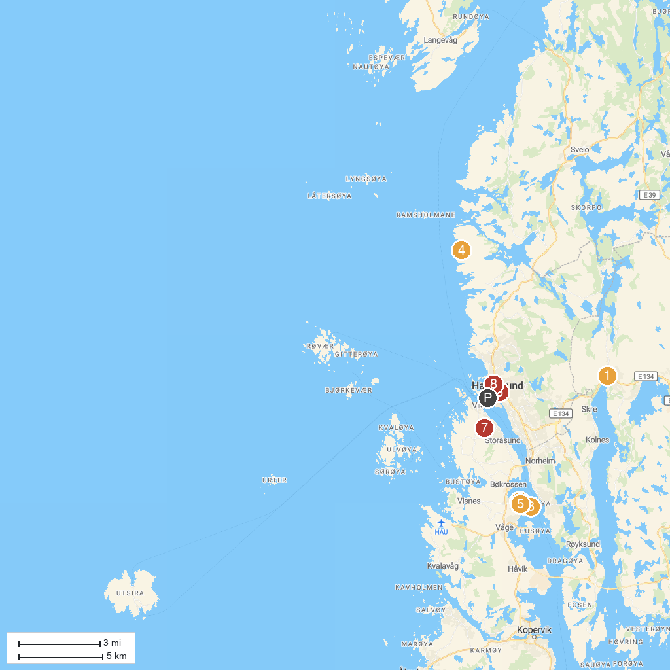
MAP KEY
1. Arquebus Krigshistorisk museum | 5. Nordvegen Historiesenter
2. Mary's Needle | 6. Our Savior's Church
3. The Viking Village on Bukkøy (Viking Farm at Bukkøy) | 7. Haugaland Zoo
4. Hagland fortress | 8. Haugesund Art Gallery
P. Cruise port / terminal
Map © MapTiler © OpenStreetMap contributors · cruiseports.org

