Harwich, Essex, England
A maritime town steeped in seafaring legend — and your easiest gateway to London. But spend time in Old Harwich itself; it punches well above its size.
⚓ Docked (pier port) · 🕒 Typical call: 8–10 hrs · 💷 British Pounds (GBP) · 🗣️ English
✍️ MY DAY IN PORT (FILL IN)
Ship / Date
In port | arrive ______ · all aboard ______
Booked excursion
Notes / meeting point
GETTING ASHORE
- Docking: Pier — Harwich International Port (Parkeston Quay), no tendering
- Walk to Centre: Old Harwich is 2.5 miles; take the local train (6 min) or taxi
- Best For: Maritime history, London day trips, Mayflower heritage, fresh seafood
- Don't Miss: Ha'penny Pier, the Kindertransport memorial, and crab at The Pier restaurant
GETTING AROUND
- 🚕 Taxi: £7–£9 — Short 2-mile ride from Harwich International Port to Harwich Town; journey takes about 3 minutes. Fixed-price services a
- 📱 Rideshare: ✅ Uber
TOP THINGS TO DO
- Old Harwich Maritime Trail — Follow the self-guided trail through the grid of narrow Georgian streets.
- London Day Trip by Train — From the station steps of Harwich International, you can be in central London in roughly 80 minutes.
- Harwich Redoubt Fort — A circular Napoleonic-era fort with a dry moat, built in 1808 to defend the harbor.
- Electric Palace Cinema — One of the oldest surviving purpose-built cinemas in the UK, opened in 1911 and beautifully restored to its Edwardian glory.
- Dovercourt Bay Beach — A quiet Blue Flag sand-and-shingle beach just one train stop from the port.
BEST WALKS
- Old Harwich Maritime Trail: 2–3 hrs · Easy · Free — Start at Harwich Town station and head toward the waterfront.
- Dovercourt Promenade & Lighthouses: 1–2 hrs · Easy · Free — From Dovercourt station, walk down to the seafront promenade.
WEATHER · DAYLIGHT · MONEY
Month | High °F | Low °F | Rainy days
May | 59 | 50 | 12
Jul | 75 | 68 | 8
Sep | 70 | 63 | 10
Daylight: May 5:02AM–8:41PM · Jul 4:53AM–9:08PM · Sep 6:29AM–7:11PM
cruiseports.org/harwich · Confirm terminal & all-aboard time with your ship

Harwich, Essex, England — Port Map
Red = walkable sights · Amber = excursions farther out · P = cruise terminal
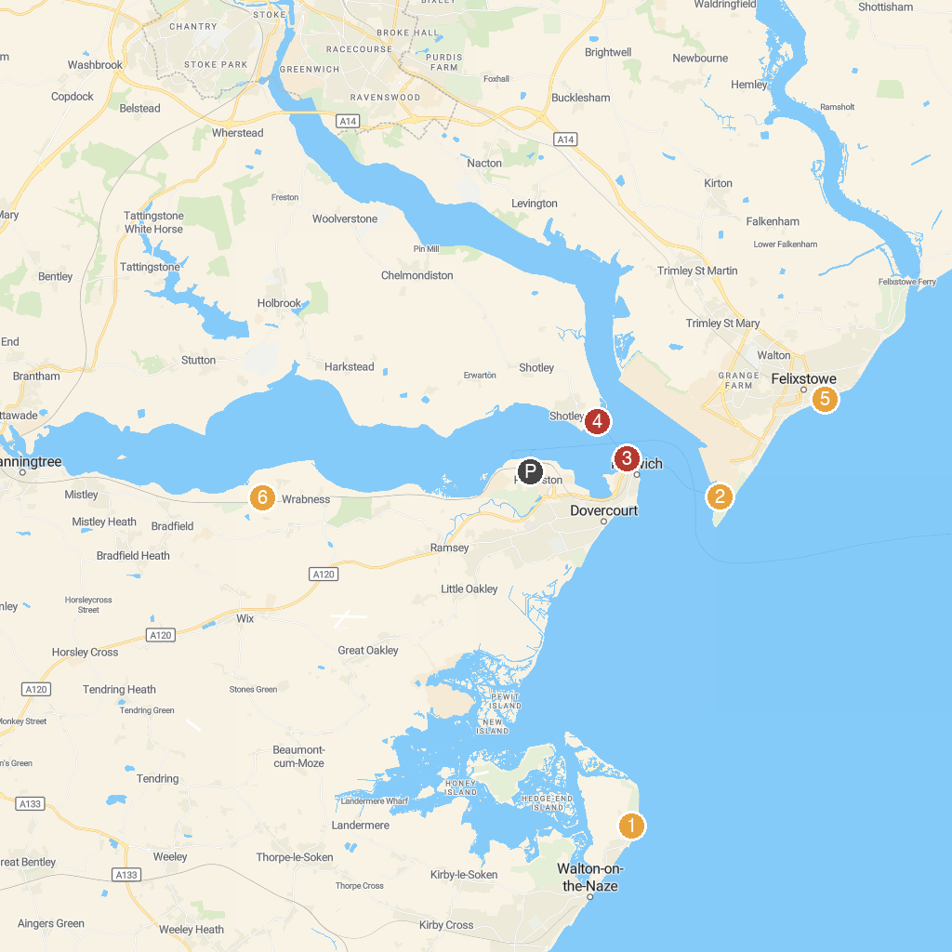
MAP KEY
1. Naze Tower | 5. Felixstowe Sea Front Gardens
2. Felixstowe Museum | 6. Wrabness Nature Reserve
3. Ha'penny Pier | 7. Suffolk Aviation Heritage Museum
4. HMS Ganges Museum | 8. Old Knobbley
P. Cruise port / terminal
Map © MapTiler © OpenStreetMap contributors · cruiseports.org

