Harstad, Troms, Norway
Above the Arctic Circle on Norway's largest island, Harstad delivers Viking churches, a colossal WWII cannon, and a walkable harbor town — all with pier access straight into the heart of it.
⚓ Pier (new 2023 quay) · 🕒 Typical call: 6-8 hrs · 💳 Cashless — card everywhere · 🗣️ Norwegian (English widely spoken) · ☀️ Midnight Sun: late May – late Jul
✍️ MY DAY IN PORT (FILL IN)
Ship / Date
In port | arrive ______ · all aboard ______
Booked excursion
Notes / meeting point
GETTING ASHORE
- Docking: Pier — central quay (2023), ships up to 300 m
- Walk to centre: 2-5 min flat walk from gangway
- Best For: WWII history, Viking heritage, Arctic scenery
- Don't Miss: Trondenes Church + Adolf Gun combo tour
GETTING AROUND
- 🚕 Taxi: ~135 NOK (5 km) — Local taxis are available at the port. A 5 km ride from the outer quay to the city center costs approximately 135 NOK; b
- 📱 Rideshare: ❌ not available
TOP THINGS TO DO
- The Adolf Gun (Adolfkanonen) — One of the largest land-based naval guns ever built, installed by German forces during WWII on what is now an active Norwegian…
- Trondenes Church & Historical Centre — Built around 1250, Trondenes is the world's northernmost medieval stone church.
- Grottebadet Waterpark — An unusual attraction built entirely inside a mountain cave in the middle of town — water slides, a wave pool, therapy pools, and…
- Folkeparken & Coastal Walk — A peaceful recreational park on the edge of town with forest trails, traditional wooden shelters, and small lakes.
- Arctic Seafood Lunch in Town — Harstad has a surprisingly strong dining scene.
BEST WALKS
- Town Centre Stroll: 1.5 km · 20 min · flat — From the pier, walk through the harbour front to the main square (Torget), past Harstad Church on…
- Coastal Walk to Trondenes: 3 km one way · 40 min · easy — Follow the waterfront north from the pier along a beautiful coastal path to the Trondenes peninsula.
WEATHER · DAYLIGHT · MONEY
Month | High °F | Low °F | Rainy days
May | 47 | 37 | 16
Jul | 61 | 51 | 13
Sep | 53 | 45 | 16
Daylight: Sep 6:09AM–7:25PM
cruiseports.org/harstad · Confirm terminal & all-aboard time with your ship

Harstad, Troms, Norway — Port Map
Red = walkable sights · Amber = excursions farther out · P = cruise terminal
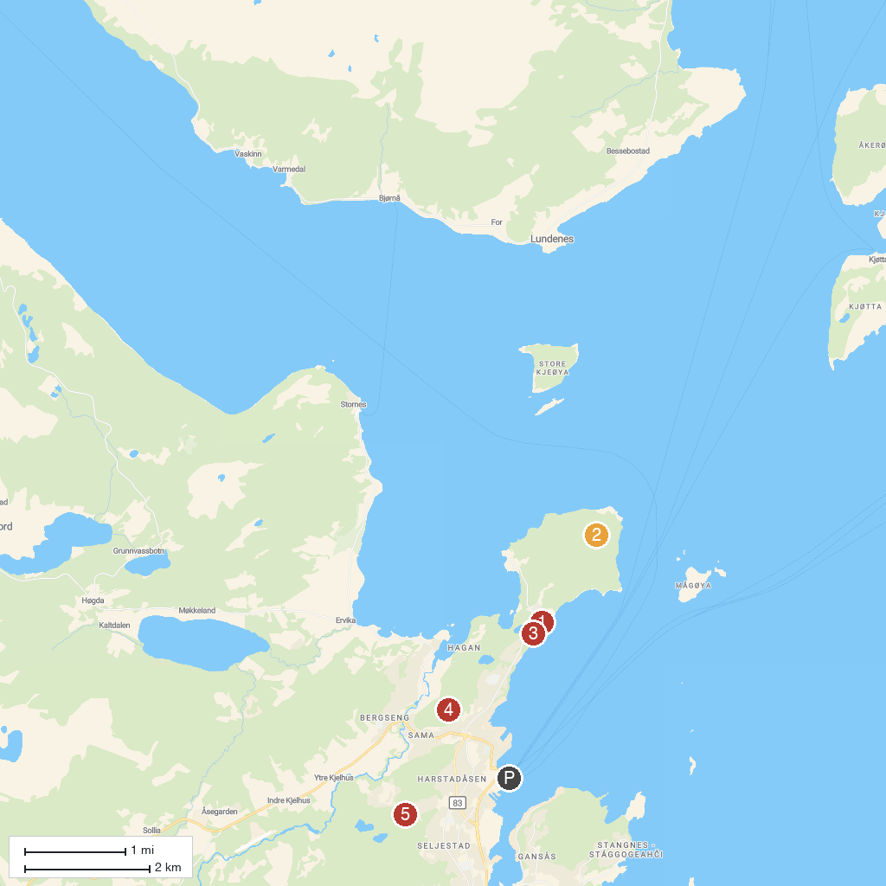
MAP KEY
1. Trondenes Church | 4. Tv-Tårnet
2. Adolfkanonen | 5. Folkeparken
3. Trondenes Historical Center
P. Cruise port / terminal
Map © MapTiler © OpenStreetMap contributors · cruiseports.org

