Happy Valley-Goose Bay, Labrador, Canada
This is Labrador's inland hub: a working port at Terrington Basin, a major RCAF base, and a gateway to Lake Melville, Indigenous culture, and vast boreal country. Expect practical shuttles rather than a cruise terminal, and a shore day that feels far from the usual circuit.
⚓ Working pier / possible tender · 🕒 Typical call: 6-8 hrs · 💵 Canadian Dollar (CAD) · 🗣️ English · 🌲 Labrador wilderness
✍️ MY DAY IN PORT (FILL IN)
Ship / Date
In port | arrive ______ · all aboard ______
Booked excursion
Notes / meeting point
GETTING ASHORE
- Docking: Terrington Basin working docks; smaller expedition ships may dock
- Walk to town: About 5-6 km; use the ship shuttle
- Best For: Military history, Indigenous culture, boreal walks
- Don't Miss: Labrador Military Museum and Birch Island trails
GETTING AROUND
- 🚕 Taxi: CAD – — Local taxis are available and can transport passengers from the pier to town. Estimated ~10 km ride, around 12 minutes.
- 📱 Rideshare: ✅ Uber
TOP THINGS TO DO
- Labrador Military Museum — Visit the museum at 5 Wing Goose Bay to understand the town's WWII origins, the Atlantic ferry route, Cold War air operations…
- Indigenous Culture Program — Cruise lines sometimes arrange performances, storytelling, craft demonstrations, or community visits highlighting Innu, Inuit…
- Birch Island Boardwalk & Boreal Forest — A low-key nature stop close to town, with boardwalks and trails through spruce, birch, wetlands, and Labrador plant life.
- North West River Scenic Outing — Drive about 35 km northeast on Route 520 to the historic community of North West River, with its white sandy beach on Lake…
- Mealy Mountains Flightseeing — On long calls, specialty operators may offer scenic flights toward Akami-Uapishkᵁ-KakKasuak-Mealy Mountains National Park…
BEST WALKS
- Birch Island Trail: 1-3 km | 45-90 min | Easy — Use the shuttle or a taxi to reach Birch Island, then follow the boardwalk and gravel paths through…
- Town Centre Stroll: 1.5 km | 30-45 min | Easy — If your shuttle drops near the commercial centre, walk between local shops and cafes around…
WEATHER · DAYLIGHT · MONEY
Month | High °F | Low °F | Rainy days
May | 48 | 31 | 13
Jul | 70 | 53 | 16
Sep | 59 | 45 | 15
Daylight: May 5:01AM–8:55PM · Jul 4:53AM–9:20PM · Sep 6:36AM–7:16PM
cruiseports.org/happy-valley-goose-bay-nl · Confirm terminal & all-aboard time with your ship

Happy Valley-Goose Bay, Labrador, Canada — Port Map
Red = walkable sights · Amber = excursions farther out · P = cruise terminal
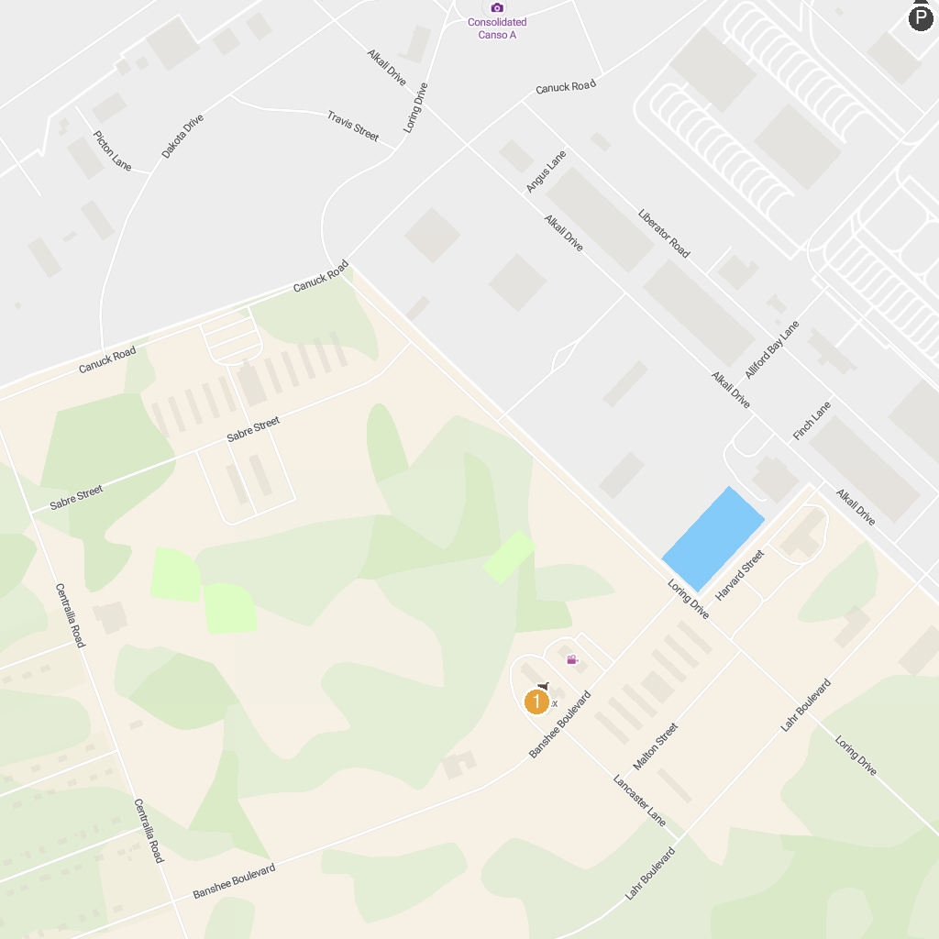
MAP KEY
1. Labrador Interpretation Centre | 2. Labrador Military Museum
P. Cruise port / terminal
Map © MapTiler © OpenStreetMap contributors · cruiseports.org

