Hanoi (Ha Long Bay), Vietnam
Your ship docks in spectacular Ha Long Bay — a UNESCO wonderland of limestone karsts rising from jade-green water. Hanoi's ancient streets and French-colonial quarter are 3 hours inland; the bay itself competes hard for your day.
⚓ Pier (Ha Long Int'l Cruise Terminal) · 🕒 Typical call: 8–12 hrs · 💵 Vietnamese Dong (VND) · 🗣️ Vietnamese · 🌏 UNESCO World Heritage
✍️ MY DAY IN PORT (FILL IN)
Ship / Date
In port | arrive ______ · all aboard ______
Booked excursion
Notes / meeting point
GETTING ASHORE
- Docking: Pier at Ha Long International Cruise Terminal (Hon Gai), Ha Long Bay — no tender
- Distance to Hanoi: 150 km (~3–3.5 hrs drive each way)
- Best for: Bay cruising, Vietnamese cuisine, colonial history
- Don't miss: Ha Long Bay junk boat OR Hoan Kiem Lake & Old Quarter
GETTING AROUND
- 🚕 Taxi: VND 1,800,000–2,000,000 (~USD 70–84) — Grab is the dominant ride-hailing app in Vietnam. App shows upfront pricing for GrabCar or GrabTaxi; useful for local tr
- 📱 Rideshare: ✅ Grab
- 🚌 Hop-on hop-off: ✅ City Sightseeing Ha Long
TOP THINGS TO DO
- Ha Long Bay Junk Boat Cruise — Sail among 1,600+ limestone karsts on a traditional junk.
- Hanoi Old Quarter & Hoa Lo Prison — The capital's maze of 36 historic trading streets, Hoan Kiem Lake with Ngoc Son Temple, and the sobering Hoa Lo Prison — 'the…
- Temple of Literature & Water Puppet Show — Van Mieu — Vietnam's 1,000-year-old first university — followed by a Thang Long Water Puppet Theatre performance.
- Kayaking the Ha Long Karsts — Paddle through sea caves, floating fishing villages, and towering limestone formations from Tuan Chau Marina near the port.
- Hanoi Street Food Walk — Pho bo at a sidewalk stall, bun cha grilled pork (the Obama–Bourdain dish at Bun Cha Huong Lien), banh mi, and egg coffee at Cafe…
BEST WALKS
- Hoan Kiem Lake Loop (Hanoi): 1.8 km loop • Easy • 30–40 min — The peaceful heart of Hanoi.
- Ha Long City Promenade: 2 km • Easy • 45 min — A flat walk along Ha Long's waterfront with bay views, souvenir shops, and cafes.
WEATHER · DAYLIGHT · MONEY
Month | High °F | Low °F | Rainy days
May | 90 | 79 | 12
Jul | 91 | 81 | 14
Sep | 87 | 78 | 19
Daylight: May 5:14AM–6:22PM · Jul 5:19AM–6:36PM · Sep 5:39AM–5:54PM
cruiseports.org/hanoi · Confirm terminal & all-aboard time with your ship

Hanoi (Ha Long Bay), Vietnam — Port Map
Red = walkable sights · Amber = excursions farther out · P = cruise terminal
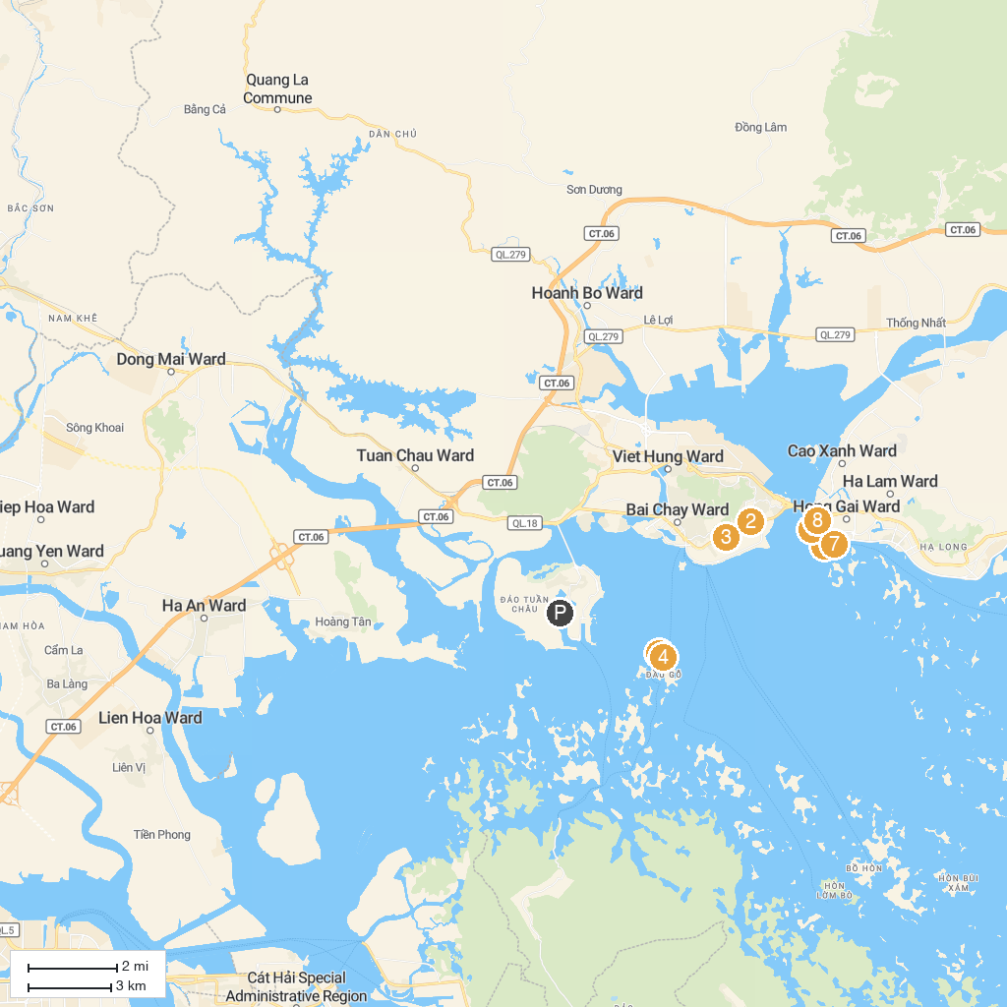
MAP KEY
1. Động Thiên Cung | 5. Tran Quoc Nghien Temple
2. Sun World Halong Park | 6. Công Ty Ninh Dương Story
3. Ocean Park | 7. Bài Thơ Mountain
4. Dau Go Cave | 8. Cầu Koi
P. Cruise port / terminal
Map © MapTiler © OpenStreetMap contributors · cruiseports.org

