Hannover, Lower Saxony, Germany
A canal city of royal pedigree — Baroque gardens rivaling Versailles, a painted red line guiding you through half-timbered streets, and a dome elevator that bends the rules of physics.
⚓ Pier (Mittellandkanal dock) · 🕒 Typical call: 8–10 hrs · 💶 Currency: Euro (€) · 🗣️ Language: German (English widely spoken)
✍️ MY DAY IN PORT (FILL IN)
Ship / Date
In port | arrive ______ · all aboard ______
Booked excursion
Notes / meeting point
GETTING ASHORE
- Docking: Pier on Mittellandkanal — no tendering
- Walk to centre: ~6–8 km from canal dock; U-Bahn ~20 min
- Best For: History, gardens, easy city walking
- Don't Miss: Herrenhausen Gardens & the Red Thread route
GETTING AROUND
- 🚕 Taxi: €10–€25 — Taxis are widely available throughout the city. Most tourist sites and the Hauptbahnhof area are within a €10–€20 ride o
- 📱 Rideshare: ✅ Uber, Bolt
- 🚌 Hop-on hop-off: ✅ · from €24
TOP THINGS TO DO
- Herrenhausen Baroque Gardens — One of Europe's finest Baroque garden complexes, laid out in the 17th century and inspired by Versailles.
- The Red Thread Walking Route — A 4.2 km red line painted on the city pavements links 36 historic sights — Old Town, the Nanas sculptures, Market Church, and more.
- New Town Hall & Dome Elevator — The 1913 Neues Rathaus houses four scale models showing Hannover from medieval times to WWII rubble to modern city.
- Eilenriede Urban Forest — Germany's largest urban forest and one of the largest in Europe — nearly twice the size of New York's Central Park — lies just…
- Hannover Markthalle (Market Hall) — The city's historic indoor market — 'the Belly of Hannover' — is packed with stalls selling local sausages, fresh cheeses…
BEST WALKS
- The Red Thread City Loop: 4.2 km • ~2–3 hrs • Easy — Follow the red line painted on the pavement from Hannover Hauptbahnhof through the Altstadt, past…
- Maschsee Lakeside Stroll: 3 km loop • ~1 hr • Easy — The Maschsee is a large man-made lake south of the city centre, ringed by a paved promenade.
WEATHER · DAYLIGHT · MONEY
Month | High °F | Low °F | Rainy days
May | 65 | 48 | 11
Jul | 75 | 58 | 12
Sep | 68 | 53 | 10
Daylight: May 5:25AM–9:10PM · Jul 5:17AM–9:35PM · Sep 6:55AM–7:35PM
cruiseports.org/hannover · Confirm terminal & all-aboard time with your ship

Hannover, Lower Saxony, Germany — Port Map
Red = walkable sights · Amber = excursions farther out · P = cruise terminal
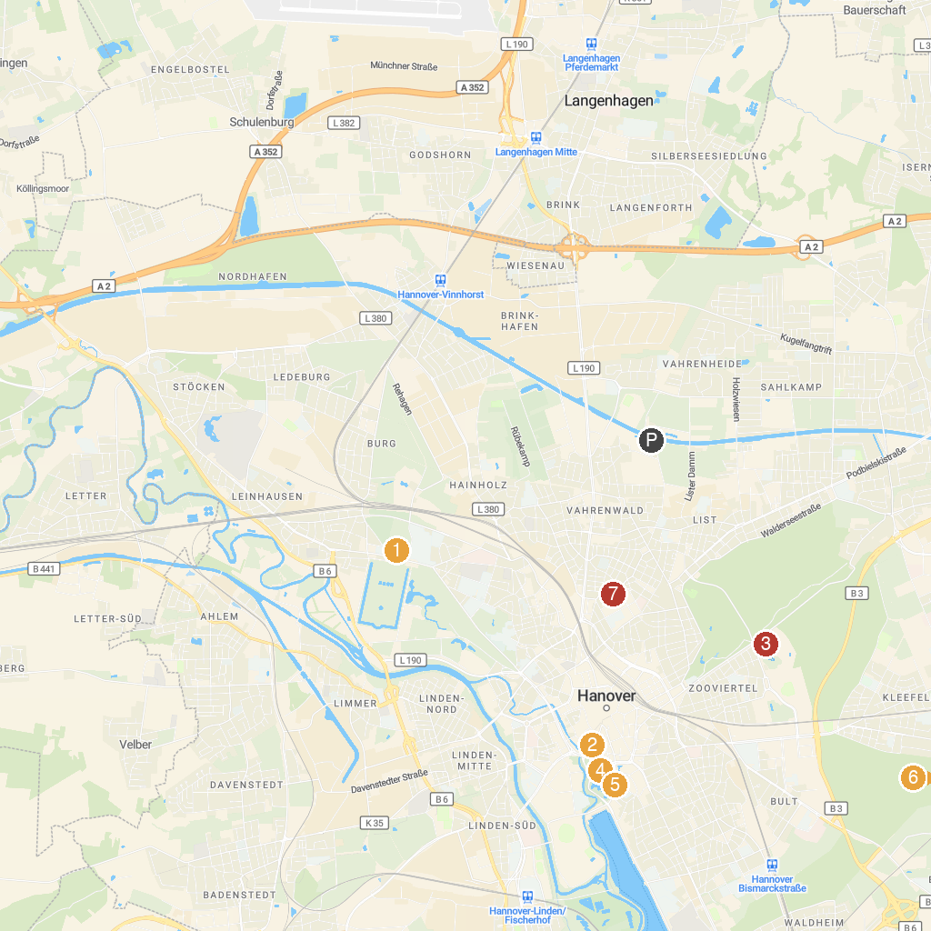
MAP KEY
1. SEA LIFE Hannover | 5. Landesmuseum Hannover
2. Markthalle Hannover | 6. Tiergarten Hanover
3. Erlebnis-Zoo Hannover | 7. World of Kitchen Exhibition
4. New Town Hall
P. Cruise port / terminal
Map © MapTiler © OpenStreetMap contributors · cruiseports.org

