Hannibal, Missouri, USA
Mark Twain's hometown on the mighty Mississippi. Whitewashed fences, river views, and 19th-century Americana await just steps from the dock.
⚓ Docked (riverside pier) · 🕒 Typical call: 6-8 hrs · 💵 USD · 🗣️ English · 📚 Mark Twain heritage
✍️ MY DAY IN PORT (FILL IN)
Ship / Date
In port | arrive ______ · all aboard ______
Booked excursion
Notes / meeting point
GETTING ASHORE
- Docking: Docked at north riverfront dock (Center Street Landing area) — no tender required
- Walk to center: 2-5 min walk from dock to Historic Main Street and Boyhood Home
- Best For: Literary history, American heritage, river scenery, easy walkable town
- Don't Miss: Mark Twain Boyhood Home & Museum, Tom & Huck Statue, Cardiff Hill Lighthouse
GETTING AROUND
- 🚕 Taxi: Meter / call ahead — Smiley's Taxi (573-603-4244) serves the Hannibal area. Best called in advance as cabs are limited in this small river to
- 📱 Rideshare: ✅ Uber
TOP THINGS TO DO
- Mark Twain Boyhood Home & Museum — Nine-property complex including Twain's actual boyhood home, the Becky Thatcher House, Huck Finn House, and a gallery with 15…
- Mark Twain Cave Tour — The National Natural Landmark that inspired the cave scenes in Tom Sawyer.
- Mark Twain Riverboat Cruise — 1-hour narrated sightseeing cruise on the Mississippi River departing from Center Street Landing.
- Jim's Journey: The Huck Finn Freedom Center — A moving museum dedicated to the real man who inspired the character of Jim in Huckleberry Finn, and to the broader African…
- Rockcliffe Mansion — A Gilded Age mansion built in 1900 with original furnishings and sweeping views of the Mississippi.
BEST WALKS
- Riverfront to Cardiff Hill Loop: 1.5 miles | Easy | 45-60 min — The classic Hannibal walk.
- Historic Main Street Stroll: 0.5 miles | Flat | 30 min — Walk the length of Main Street from the river end to Bird Street and back.
WEATHER · DAYLIGHT · MONEY
Month | High °F | Low °F | Rainy days
May | 75 | 57 | 14
Jul | 86 | 70 | 9
Sep | 80 | 63 | 6
Daylight: May 5:50AM–8:13PM · Jul 5:50AM–8:31PM · Sep 6:47AM–7:13PM
cruiseports.org/hannibal-mo · Confirm terminal & all-aboard time with your ship

Hannibal, Missouri, USA — Port Map
Red = walkable sights · Amber = excursions farther out · P = cruise terminal
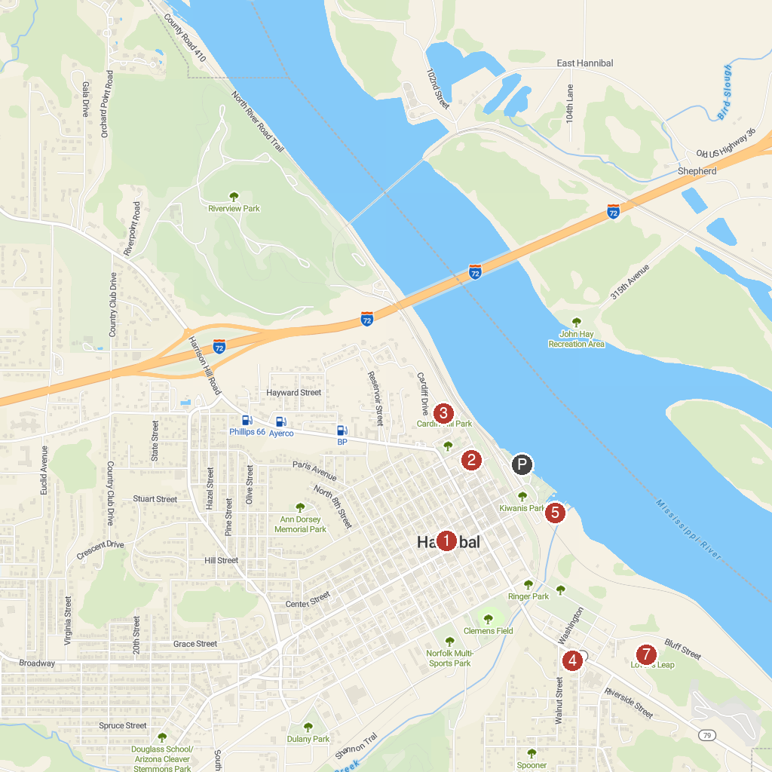
MAP KEY
1. Central Park | 5. Glascock’s Landing Nipper Park
2. Molly Brown Birthplace Museum | 6. Mark Twain Riverboat
3. Mark Twain Memorial Lighthouse | 7. Lovers' Leap
4. Haunted Hannibal Ghost Tours
P. Cruise port / terminal
Map © MapTiler © OpenStreetMap contributors · cruiseports.org

