Handa Island, Sutherland, Scotland
One of Britain's most spectacular seabird colonies, Handa Island is an uninhabited nature reserve off the wild northwest Scottish coast — a Zodiac wet-landing adventure with puffins, Great Skuas, and vertiginous sandstone cliffs.
⚓ Zodiac wet landing (no pier) · 🕒 Typical call: 4–6 hrs · 💷 GBP (no shops on island) · 🗣️ English / Scottish Gaelic · 🐦 Wildlife & nature reserve
✍️ MY DAY IN PORT (FILL IN)
Ship / Date
In port | arrive ______ · all aboard ______
Booked excursion
Notes / meeting point
GETTING ASHORE
- Docking: Zodiac wet landing on the south-shore beach (Tràigh an Teampaill) — ankle- to calf-deep water
- Walk to centre: 3.7-mile (6 km) circular loop; 2–2.5 hrs; no vehicles or roads
- Best For: Seabird photography, puffins, Great Skuas, dramatic sea stacks
- Don't Miss: The Great Stack of Handa — a sheer sandstone column crowded with guillemots and razorbills
GETTING AROUND
- 🚕 Taxi: Varies — From Tarbet, the nearest village is Scourie (~5 min drive north). Ullapool is ~1.5 hrs south. Pre-booked taxis from Lair
- 📱 Rideshare: ❌ not available
TOP THINGS TO DO
- Seabird Colony & Puffin Walk — The island's 3.7-mile circular trail passes through the heart of one of Europe's largest seabird colonies — over 100,000 birds in…
- The Great Stack of Handa — A colossal column of Torridonian sandstone separated from the main cliff by a narrow chasm, every ledge packed with nesting…
- Abandoned Village & Historic Graveyard — Near the landing beach lie the ruins of the old crofting village, lazy beds (traditional potato cultivation ridges), and a…
- White Sand Beaches — The shell-sand south-shore beach Tràigh an Teampaill is shockingly white and backed by turquoise water — with stunning views…
BEST WALKS
- Handa Island Circular Trail: 3.7 miles (6 km) · 2–2.5 hrs · Moderate · ~100 m elevation — From the landing beach, the path heads inland across heather moorland on a raised plastic-mesh…
WEATHER · DAYLIGHT · MONEY
Month | High °F | Low °F | Rainy days
May | 54 | 45 | 18
Jul | 60 | 53 | 22
Sep | 58 | 51 | 20
Daylight: May 4:54AM–9:41PM · Jul 4:39AM–10:13PM · Sep 6:50AM–7:39PM
cruiseports.org/handa-island-scotland · Confirm terminal & all-aboard time with your ship

Handa Island, Sutherland, Scotland — Port Map
Red = walkable sights · Amber = excursions farther out · P = cruise terminal
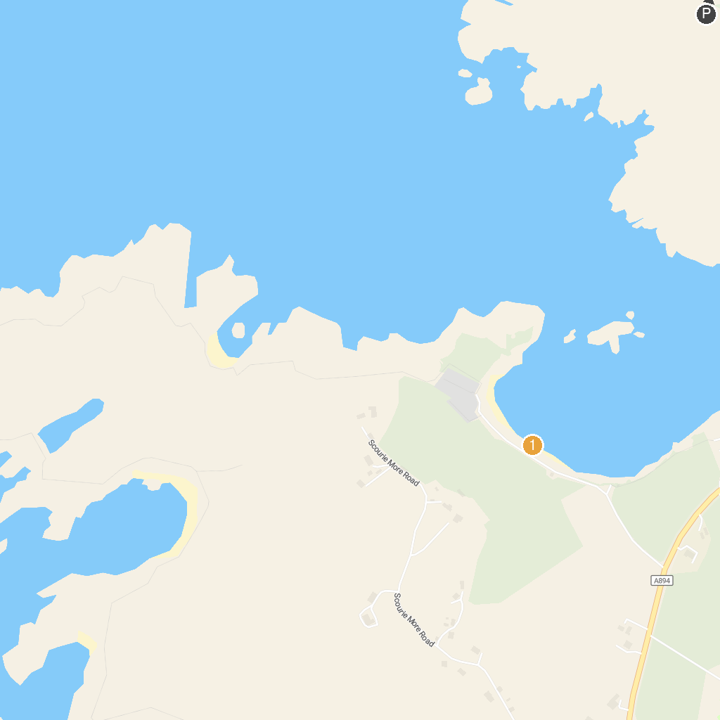
MAP KEY
1. Ardvreck Castle | 3. Scourie Beach
2. Visit Cape Wrath | 4. Drumbeg Viewpoint
P. Cruise port / terminal
Map © MapTiler © OpenStreetMap contributors · cruiseports.org

