Hamilton, Bermuda
Bermuda's pastel-painted capital parks cruise ships right on its doorstep. Step off the gangway and you're on Front Street — harbour breeze, colonial architecture, and pink-sand beaches just a ferry ride away.
⚓ Docked (Front Street Pier) · 🕒 Typical call: 8–10 hrs · 💵 Bermuda Dollar (= USD) · 🗣️ English
✍️ MY DAY IN PORT (FILL IN)
Ship / Date
In port | arrive ______ · all aboard ______
Booked excursion
Notes / meeting point
GETTING ASHORE
- Docking: Ships berth directly on Front Street in Hamilton city centre
- Walk to centre: You are already in the centre — shops and restaurants steps away
- Best For: Pink-sand beaches, history, snorkelling, and easy island exploring
- Don't Miss: Fort Hamilton's underground passages and Horseshoe Bay's pink sand
GETTING AROUND
- 🚕 Taxi: $9.20 first mile, $3.25/mile after (1–4 pax) — Government-regulated taxis wait on Front Street at the pier. Rates are metered; surcharges apply on Sundays, holidays, a
- 📱 Rideshare: ❌ not available
TOP THINGS TO DO
- Horseshoe Bay Beach — Bermuda's most famous stretch of pink sand and turquoise water.
- Fort Hamilton Walk — A 19th-century British fortification 15 minutes uphill from the pier.
- Crystal & Fantasy Caves — Two adjoining caverns in Hamilton Parish with crystal-clear underground pools, stalactites, and natural rock bridges.
- Historic St. George's — A UNESCO World Heritage town with cobblestone lanes, 17th-century churches, and Bermuda's original capital.
- Snorkelling & Water Sports — Bermuda's reefs host wreck dives, kayaking, and snorkelling.
BEST WALKS
- Front Street to Fort Hamilton: ~2 km · 30–40 min · moderate (uphill to fort) — Start at the cruise pier on Front Street, walk east past pastel shops and the Bermuda Historical…
- Hamilton Waterfront & City Hall Loop: ~1.5 km · 20–30 min · easy — From the pier, stroll along Front Street to the ferry terminal, cut up to City Hall and the Bermuda…
WEATHER · DAYLIGHT · MONEY
Month | High °F | Low °F | Rainy days
May | 76 | 65 | 10
Jul | 85 | 74 | 12
Sep | 84 | 73 | 10
Daylight: May 5:55AM–8:36PM · Jul 5:53AM–8:56PM · Sep 6:59AM–7:28PM
cruiseports.org/hamilton · Confirm terminal & all-aboard time with your ship

Hamilton, Bermuda — Port Map
Red = walkable sights · Amber = excursions farther out · P = cruise terminal
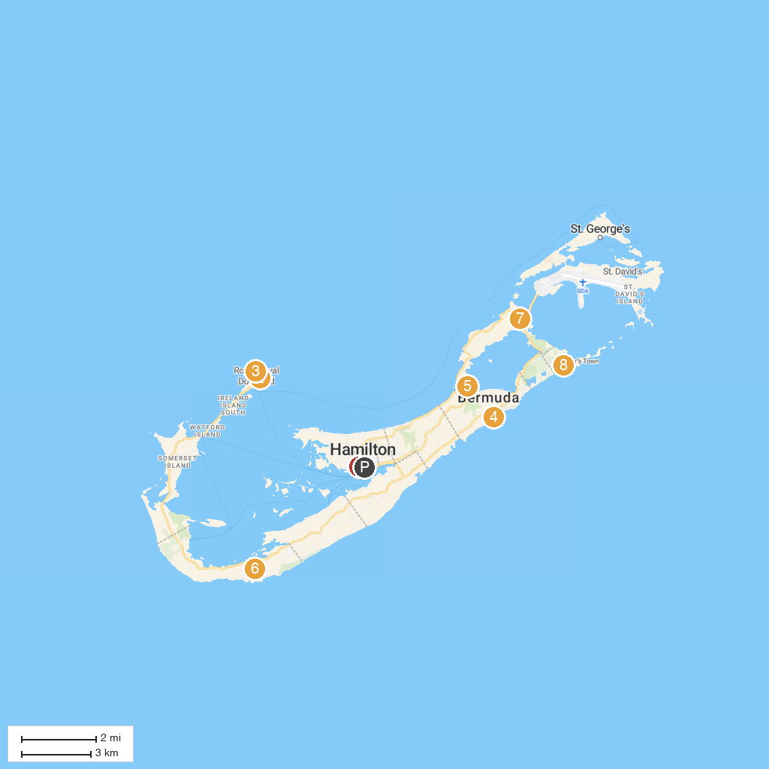
MAP KEY
1. Queen Elizabeth Par-La-Ville Sculpture Park | 5. Bermuda Aquarium, Museum & Zoo
2. Hartley's Helmet Diving | 6. Gibb's Hill Lighthouse
3. Snorkel Park | 7. Crystal and Fantasy Caves
4. Spittal Pond | 8. Mid Ocean Club
P. Cruise port / terminal
Map © MapTiler © OpenStreetMap contributors · cruiseports.org

