Hamilton Island, Queensland, Australia
A resort island at the heart of the Whitsundays, Hamilton Island is the jumping-off point for Whitehaven Beach's legendary silica sands and the living coral spectacle of the Great Barrier Reef.
⚓ Tender port · 🕒 Typical call: 7-9 hrs · 💵 AUD (Australian Dollar) · 🗣️ English
✍️ MY DAY IN PORT (FILL IN)
Ship / Date
In port | arrive ______ · all aboard ______
Booked excursion
Notes / meeting point
GETTING ASHORE
- Docking: Tender to Hamilton Island Marina
- Walk to centre: 2 min — Marina Village shops & restaurants are dockside
- Best For: Whitehaven Beach, reef snorkelling, island walks
- Don't Miss: Hill Inlet Lookout for the swirling turquoise-and-white sands
GETTING AROUND
- 🚕 Taxi: A–60/trip — Taxis are available on the island but pricey for short distances. Best reserved for accessibility needs or late-night re
- 📱 Rideshare: ❌ not available
TOP THINGS TO DO
- Whitehaven Beach & Hill Inlet Lookout — The Whitsundays' signature experience: silica sand so pure it squeaks underfoot, and Hill Inlet Lookout delivering the swirling…
- Great Barrier Reef Snorkel & Dive — Day trips to Hardy Reef and Reefworld pontoon put you over living coral gardens teeming with reef fish, turtles, and rays.
- Scenic Helicopter Flight over Heart Reef — A short scenic flight over the iconic heart-shaped coral formation and the reef from Hamilton Island Airport.
- Passage Peak Hike — A moderately challenging bush trail climbs to Passage Peak (234 m), Hamilton Island's highest point, rewarding hikers with…
- Catseye Beach Water Sports — Hamilton Island's main beach fronts the resort and offers kayaking, paddleboarding, catamaran sailing, and parasailing — all…
BEST WALKS
- Marina Village to Catseye Beach: 1.5 km · 20 min · Easy — A flat, signposted path leads from the Marina Village through resort grounds to Catseye Beach…
- Passage Peak Summit Trail: 5 km return · 2-3 hrs · Moderate — The island's signature hike follows a bush trail through eucalypt forest to Passage Peak at 234 m.
- One Tree Hill Lookout Stroll: 2 km · 30 min · Easy–Moderate — A short walk or buggy ride leads to One Tree Hill, a popular sunset viewpoint with 360° views over…
WEATHER · DAYLIGHT · MONEY
Month | High °F | Low °F | Rainy days
May | 75 | 71 | 13
Jul | 71 | 67 | 7
Sep | 75 | 70 | 6
Daylight: May 6:26AM–5:34PM · Jul 6:40AM–5:40PM · Sep 6:00AM–5:58PM
cruiseports.org/hamilton-island-qld · Confirm terminal & all-aboard time with your ship

Hamilton Island, Queensland, Australia — Port Map
Red = walkable sights · Amber = excursions farther out · P = cruise terminal
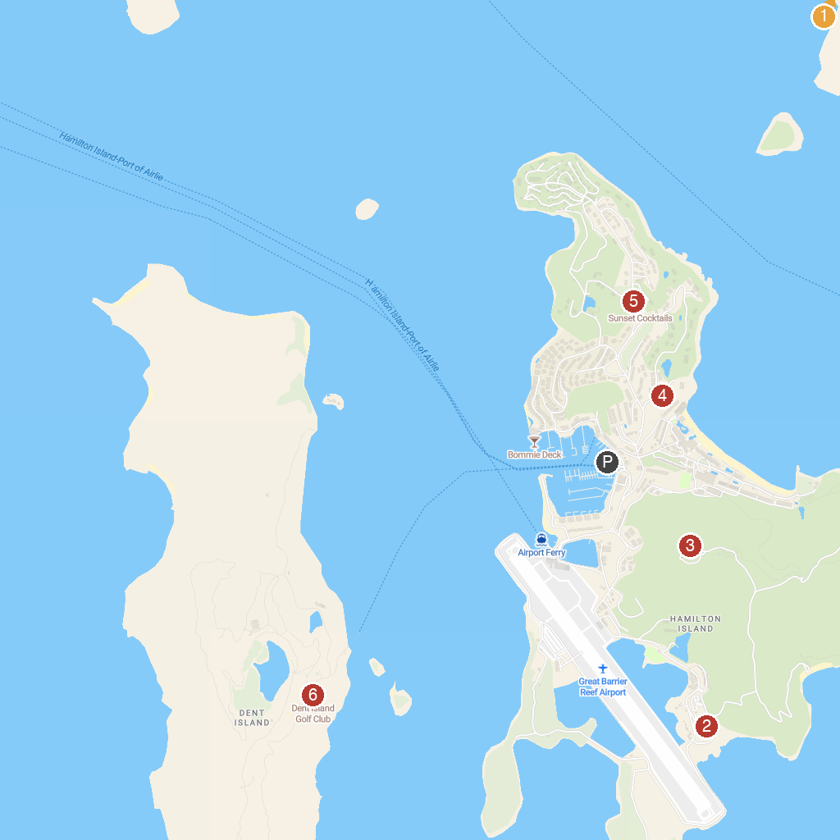
MAP KEY
1. Whitsunday Islands National Park | 5. Lookout at One Tree Hill
2. ATV Tours | 6. Hamilton Island Golf Club
3. Resort Lookout | 7. South Whitehaven lookout
4. All Saints Chapel
P. Cruise port / terminal
Map © MapTiler © OpenStreetMap contributors · cruiseports.org

