Hambantota, Sri Lanka
Sri Lanka's deep-water southern gateway — not much at the dock, but everything inland: leopards in Yala, elephant herds in Udawalawe, flamingos in Bundala, and ancient stupas rising from the jungle.
⚓ Docked (Magampura / Hambantota International Port) · 🕒 Typical call: 8–10 hrs · 💵 Sri Lankan Rupee (LKR) · 🗣️ Sinhala / Tamil
✍️ MY DAY IN PORT (FILL IN)
Ship / Date
In port | arrive ______ · all aboard ______
Booked excursion
Notes / meeting point
GETTING ASHORE
- Docking: Hambantota International Port (deep-water)
- Walk to center: Transfer needed — industrial port
- Best For: Safari · Wildlife · Ancient sites
- Don't Miss: Yala National Park (leopards)
GETTING AROUND
- 🚕 Taxi: LKR 800–1,500 (~$2–5 USD) — Taxis available at the port gate. Agree on fare before departing — metered service is rare. About 10 km to Hambantota ci
- 📱 Rideshare: ✅ PickMe
TOP THINGS TO DO
- Yala National Park Safari — Sri Lanka's most famous park and one of the world's highest densities of leopards.
- Udawalawe National Park — The best place in Sri Lanka to see large herds of wild elephants — hundreds live in the park year-round.
- Bundala National Park & Flamingos — A Ramsar wetland reserve on the coast east of Hambantota, famous for migratory flamingos, painted storks, and other water birds.
- Tissamaharama & Ancient Tanks — The ancient royal capital of southern Sri Lanka, with a great white dagoba (stupa), sacred elephant rides, and the vast Tissa…
- Kataragama Sacred Town — One of Sri Lanka's holiest pilgrimage sites, revered by Buddhists, Hindus, and Muslims alike.
BEST WALKS
- Hambantota Town & Blowhole: ~2 km · 1 hr · easy (transfer to town required) — If you have time between safaris, Hambantota town is a quiet fishing community.
WEATHER · DAYLIGHT · MONEY
Month | High °F | Low °F | Rainy days
May | 88 | 79 | 19
Jul | 89 | 78 | 12
Sep | 87 | 77 | 18
Daylight: May 5:50AM–6:13PM · Jul 5:58AM–6:24PM · Sep 5:56AM–6:05PM
cruiseports.org/hambantota · Confirm terminal & all-aboard time with your ship

Hambantota, Sri Lanka — Port Map
Red = walkable sights · Amber = excursions farther out · P = cruise terminal
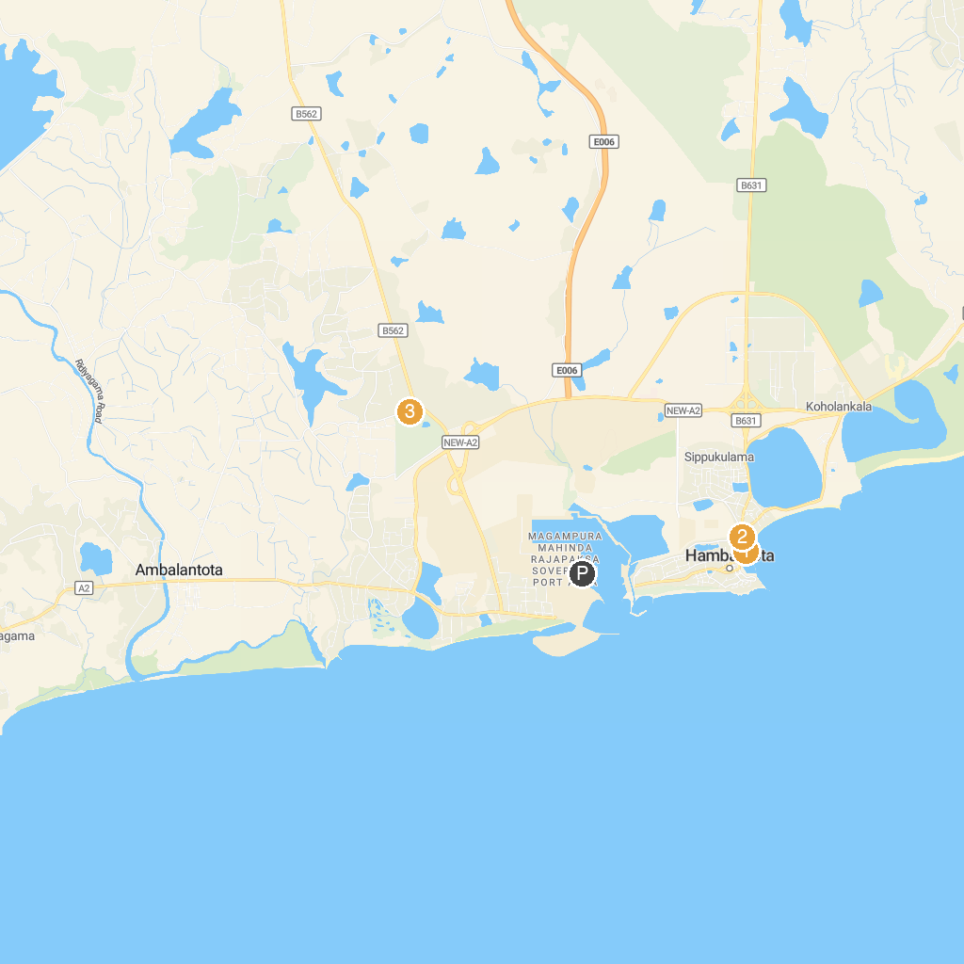
MAP KEY
1. Hambantota Beach | 3. Dry Zone Botanic Gardens, Hambantota
2. New Jummah Masjid පානුවල ජුම්මා පල්ලිය
P. Cruise port / terminal
Map © MapTiler © OpenStreetMap contributors · cruiseports.org

