Halong Bay, Quang Ninh, Vietnam
Nearly 2,000 limestone islands rise from emerald waters in one of the world's most dramatic seascapes. A day in Halong Bay is a journey through geological time — caves, kayaks, and silence broken only by waves.
⚓ Docked (Halong International Cruise Port) · 🕒 Typical call: 8-10 hrs · 💵 Vietnamese Dong (USD widely accepted) · 🗣️ Vietnamese
✍️ MY DAY IN PORT (FILL IN)
Ship / Date
In port | arrive ______ · all aboard ______
Booked excursion
Notes / meeting point
GETTING ASHORE
- Docking: Halong International Cruise Port (Sun Port), Bai Chay — direct berth, no tender required for most lines
- Walk to center: Bai Chay tourist strip is ~1 km from port; downtown Halong City requires a taxi (~15 min)
- Best For: Bay cruises, cave exploration, kayaking, scenic photography
- Don't Miss: Sung Sot (Surprise) Cave, Titop Island viewpoint, kayaking into Luon Cave lagoon
GETTING AROUND
- 🚕 Taxi: $3–9 USD — Metered taxis are widely available at all cruise ports. Fares vary by port: Sun Port to Bai Chay center is ~$3–5; Cai La
- 📱 Rideshare: ✅ Grab
- 🚌 Hop-on hop-off: ✅ City Sightseeing Ha Long
TOP THINGS TO DO
- Halong Bay Day Junk Cruise — The classic: board a traditional wooden junk for a half-day or full-day sail through the karst islands.
- Kayaking & Luon Cave Lagoon — Paddle through the low arch of Luon Cave into a hidden lagoon ringed by karst cliffs.
- Titop Island Hike & Swim — Climb 400+ steps to the summit of Titop Island for panoramic views of the bay, then cool off on the crescent beach below.
- Sung Sot (Surprise) Cave — One of Halong Bay's largest and most dramatic caves — two vast chambers filled with stalactites and stalagmites lit in color.
- Vung Vieng Floating Fishing Village — Row through a traditional floating village where families live year-round on the water, fishing with bamboo traps.
BEST WALKS
- Bai Chay Tourist Strip Stroll: 1.5 km · Flat · 20-30 min — Walk the beachside promenade of Bai Chay from near Sun Port to Bai Chay Beach.
- Quang Ninh Museum Visit: ~3 km from port by taxi · Easy — The striking black-glass Quang Ninh Museum (nicknamed the "Black Pearl," its facade evoking the…
WEATHER · DAYLIGHT · MONEY
Month | High °F | Low °F | Rainy days
May | 85 | 77 | 19
Jul | 88 | 80 | 24
Sep | 86 | 77 | 22
Daylight: May 5:14AM–6:21PM · Jul 5:19AM–6:36PM · Sep 5:39AM–5:54PM
cruiseports.org/halong-bay · Confirm terminal & all-aboard time with your ship

Halong Bay, Quang Ninh, Vietnam — Port Map
Red = walkable sights · Amber = excursions farther out · P = cruise terminal
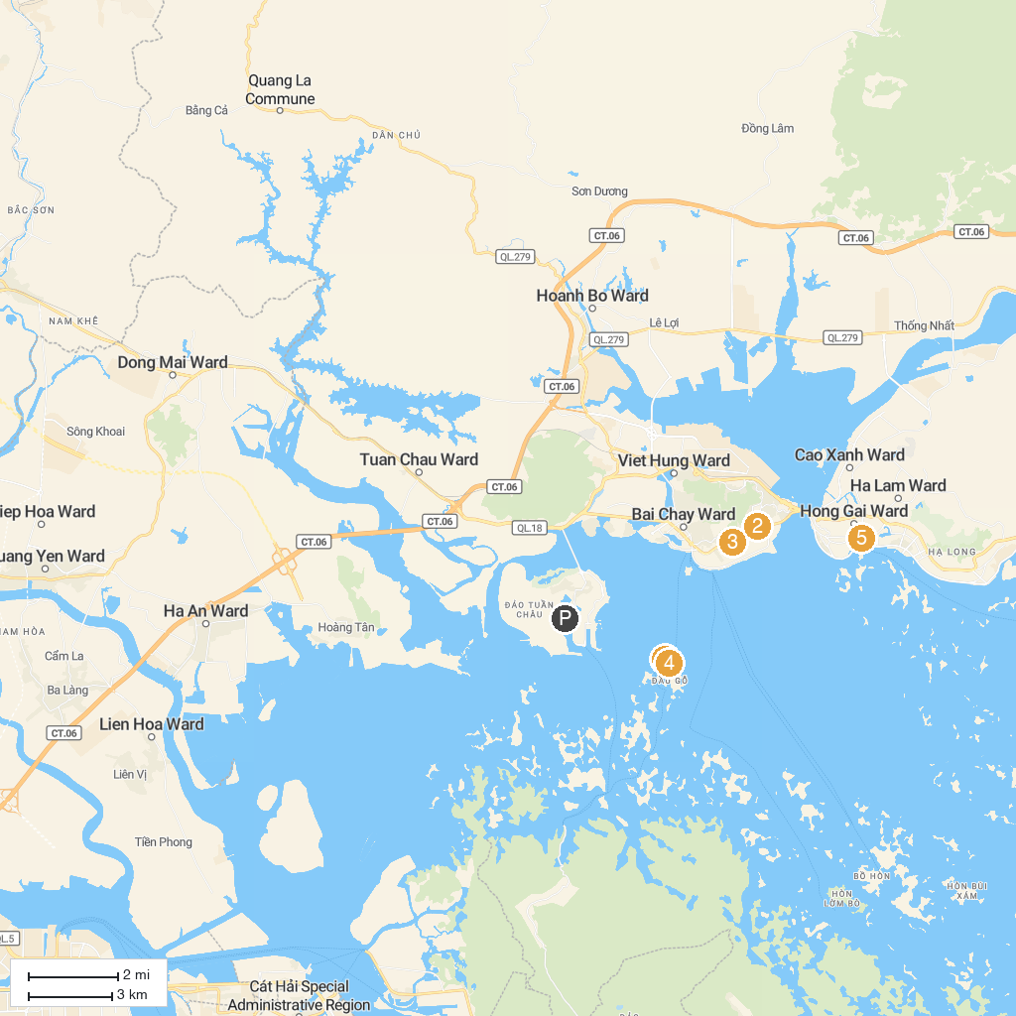
MAP KEY
1. Động Thiên Cung | 4. Dau Go Cave
2. Sun World Halong Park | 5. Clock Tower in a Roundabout
3. Ocean Park
P. Cruise port / terminal
Map © MapTiler © OpenStreetMap contributors · cruiseports.org

