Halki Island, Dodecanese, Greece
One of the smallest inhabited Dodecanese islands, Halki has no cars, no crowds, and water so clear it looks photoshopped. Small and boutique cruise ships call here for its unspoiled neoclassical harbour village of Nimborio and some of the calmest bays in the Aegean.
⚓ Small ships dock; larger vessels may tender · 🕒 Typical call: 5–8 hrs · 💶 Currency: Euro (€) · 🗣️ Language: Greek · 🚗 Car-free island
✍️ MY DAY IN PORT (FILL IN)
Ship / Date
In port | arrive ______ · all aboard ______
Booked excursion
Notes / meeting point
GETTING ASHORE
- Docking: Small ships dock at Nimborio pier; larger vessels anchor and tender into the village
- Walk to center: 0 min — tender/dock lands you in the heart of Nimborio
- Best For: Tranquil Greek village life, swimming, neoclassical architecture, easy hiking
- Don't Miss: Halki pasta (halkitika makaronia) and the pebble-mosaic courtyards of Agios Nikolaos church
GETTING AROUND
- 🚕 Taxi: €4–€20+ depending on destination — Only one or two taxis serve the island. Short hops to Pondamos beach start around €4; longer routes to Ftenayia or Chori
- 📱 Rideshare: ❌ not available
TOP THINGS TO DO
- Chorio Ghost Village & Crusader Castle — The island's medieval capital, built high on a hill to hide from pirates, was abandoned in the mid-20th century.
- Pondamos Beach Day — Halki's only sandy beach is a flat 10–15 minute walk west of the harbour.
- Ftenagia & Kania Cove Swim — Two pebble coves within walking distance of town.
- Boat Trip to Alimia Islet — Hire a local boat at the harbour to reach Alimia, an uninhabited neighbouring island with abandoned WWII Italian military ruins…
- Nimborio Village Walk & Church of Agios Nikolaos — Wander the pastel neoclassical mansions built with 19th-century sponge-diving wealth, then find the Church of Agios Nikolaos with…
BEST WALKS
- Nimborio Waterfront to Pondamos Beach: 1.2 km · 15 min · Easy · Paved path — Head west along the harbour front past the clock tower and tavernas, then follow the flat coastal…
- Town to Chorio & Castle of the Knights: 2.5 km · 45–60 min · Moderate (steady climb) · Bring water — From the church of Agios Nikolaos, follow the signed cobbled path uphill through terraced fields to…
WEATHER · DAYLIGHT · MONEY
Month | High °F | Low °F | Rainy days
May | 74 | 62 | 4
Jul | 86 | 75 | 1
Sep | 80 | 70 | 4
Daylight: May 6:03AM–8:08PM · Jul 6:04AM–8:26PM · Sep 6:52AM–7:16PM
cruiseports.org/halki-island · Confirm terminal & all-aboard time with your ship

Halki Island, Dodecanese, Greece — Port Map
Red = walkable sights · Amber = excursions farther out · P = cruise terminal
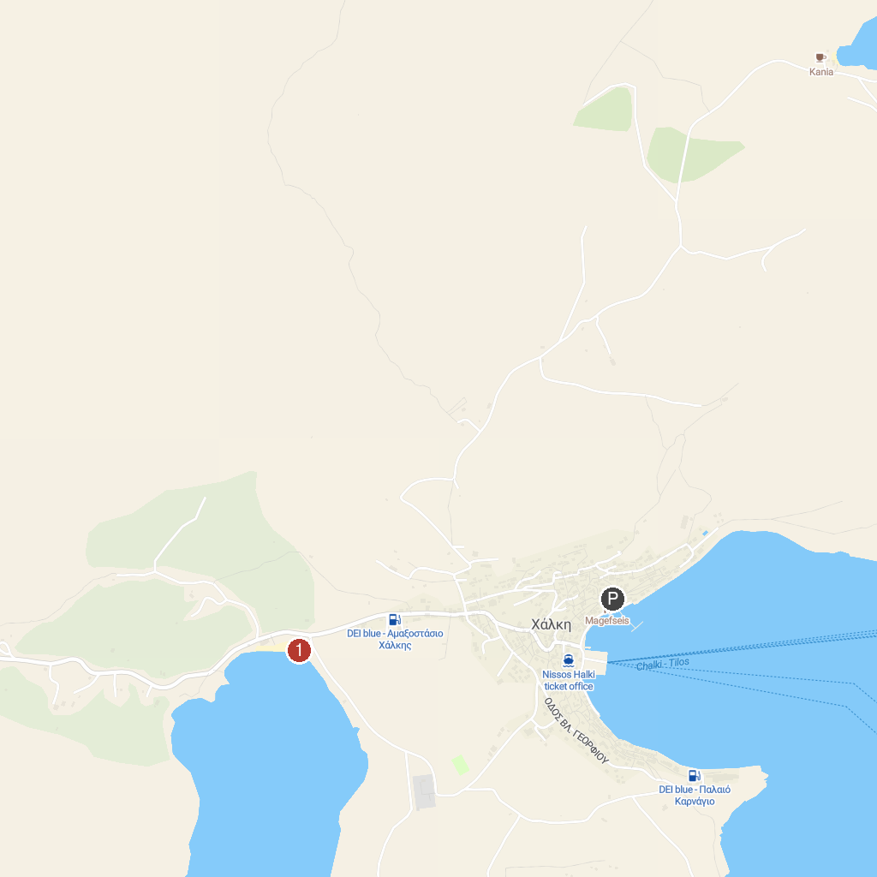
MAP KEY
1. Pondamos Beach | 2. Παραλία Ατάβυρος
P. Cruise port / terminal
Map © MapTiler © OpenStreetMap contributors · cruiseports.org

