Half Moon Caye, Lighthouse Reef, Belize
Belize's first nature reserve sits at the edge of Lighthouse Reef Atoll — a crescent of white sand ringed by living coral, home to ~4,000 red-footed boobies and some of the clearest water in the Caribbean. Expedition ships anchor offshore and tender in; crowds are minimal.
⚓ Tender only (no pier) · 🕒 Typical call: 5–7 hrs · 💵 Belize dollar (BZD); USD accepted · 🗣️ English (official) · 🌿 UNESCO World Heritage Site
✍️ MY DAY IN PORT (FILL IN)
Ship / Date
In port | arrive ______ · all aboard ______
Booked excursion
Notes / meeting point
GETTING ASHORE
- Docking: Tender/Zodiac to beach — expedition and small ships only; no cruise pier
- Entry Fee: BZ$20 (~US$10) national monument fee per person, collected on arrival
- Best For: Snorkeling, diving, wildlife watching (red-footed boobies, frigatebirds, sea turtles)
- Don't Miss: Booby colony observation tower and the Half Moon Caye Wall reef dive/snorkel
GETTING AROUND
- 🚕 Taxi: $200–300 USD per person (small-group charter); full private charters from ~$1,500/boat/day — Private or small-group boat charters can be arranged from Belize City to reach the atoll. Journey takes approximately 2–
TOP THINGS TO DO
- Red-Footed Booby Colony Walk — A short trail leads through the western littoral forest's ziricote thicket to the Belize Audubon Society observation platform…
- Half Moon Caye Wall Snorkel — The wall drops dramatically from the reef flat into deep blue just off the southern shore — eagle rays, sea turtles, schools of…
- Great Blue Hole Day Trip — The iconic UNESCO-listed Great Blue Hole lies about 10 km (6 mi) north of Half Moon Caye, near the center of Lighthouse Reef…
- Kayak & Sea Turtle Watch — Paddle the calm lagoon on the caye's leeward side and look for sea turtles resting or feeding on the grass beds.
BEST WALKS
- Ranger Station to Booby Colony Loop: ~1.5 km | Easy | 30–45 min — From the Belize Audubon Ranger Station, follow the sandy path west through coconut palms into the…
- Lighthouse & Beach Walk: ~0.5 km | Easy | 15–20 min — Walk from the ranger station along the beach to the lighthouse near the island's southeastern tip…
WEATHER · DAYLIGHT · MONEY
Month | High °F | Low °F | Rainy days
May | 83 | 81 | 9
Jul | 84 | 81 | 17
Sep | 85 | 81 | 22
Daylight: May 5:18AM–6:14PM · Jul 5:24AM–6:27PM · Sep 5:38AM–5:51PM
cruiseports.org/half-moon-caye-belize · Confirm terminal & all-aboard time with your ship

Half Moon Caye, Lighthouse Reef, Belize — Port Map
Red = walkable sights · Amber = excursions farther out · P = cruise terminal
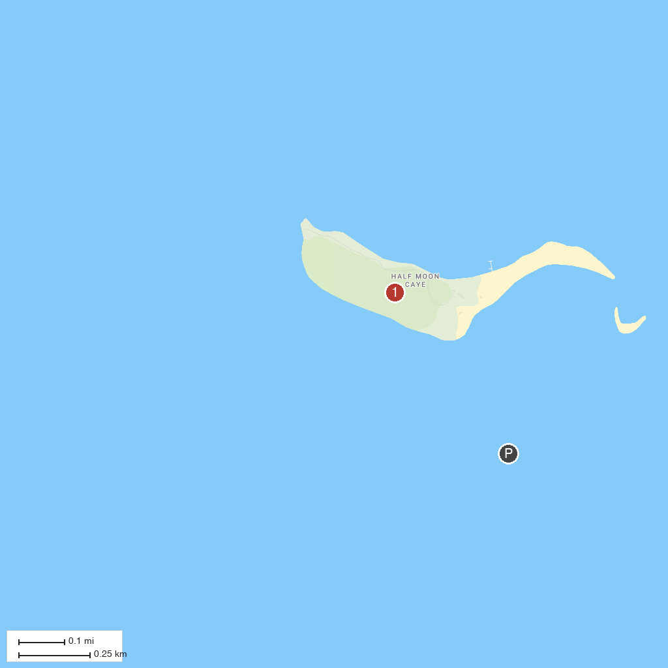
MAP KEY
1. Half Moon Caye | 2. Great Blue Hole
P. Cruise port / terminal
Map © MapTiler © OpenStreetMap contributors · cruiseports.org

