Hakodate, Hokkaido, Japan
One of Japan's first international ports, Hakodate blends Victorian-era consulates with Hokkaido seafood culture — all anchored by a star-shaped fort and summit views ranked among Japan's finest.
⚓ Pier (most ships) · 🕒 Typical call: 8-10 hrs · 💴 Japanese Yen (JPY) · 🗣️ Japanese
✍️ MY DAY IN PORT (FILL IN)
Ship / Date
In port | arrive ______ · all aboard ______
Booked excursion
Notes / meeting point
GETTING ASHORE
- Docking: Pier — Minatocho Wharf (large ships, 5 km from center) or Wakamatsu Wharf (small ships, walkable)
- Walk to center: Not walkable from Minatocho; free/paid shuttle to Hakodate Station
- Best For: History, seafood, panoramic views, Meiji-era architecture
- Don't Miss: Goryokaku star fort, Morning Market squid bowl, Mount Hakodate ropeway
GETTING AROUND
- 🚕 Taxi: ¥2,300–¥2,900 — Taxi from Minatocho Wharf to JR Hakodate Station (city center) takes about 5 minutes. Fixed-rate zones to Motomachi and
- 📱 Rideshare: ✅ Uber, GO
TOP THINGS TO DO
- Mount Hakodate Ropeway — Hakodate's summit view is ranked among Japan's top three.
- Goryokaku Fort & Tower — Japan's first Western-style (Vauban-style) star fortress, built 1857-1864 to defend Hokkaido.
- Hakodate Morning Market (Asaichi) — 250+ stalls of fresh Hokkaido seafood right beside the station.
- Motomachi Historic District — Wander Hakodate's Victorian-era hillside quarter: Russian Orthodox Church, Roman Catholic Church, Former British Consulate, and…
- Onuma Quasi-National Park — A scenic lake district 20 km north of Hakodate, with gentle walking trails, lake cruises, and views of the Komagatake volcano.
BEST WALKS
- Waterfront Loop: Station to Red Brick Warehouses: 2 km · 25 min · Flat — From Hakodate Station, browse the Morning Market stalls, then follow the harbor promenade south…
- Motomachi Slopes & Churches: 2.5 km · 40 min · Hilly — Tram to Jujigai stop, then climb through the old foreign settlement past churches and the Former…
WEATHER · DAYLIGHT · MONEY
Month | High °F | Low °F | Rainy days
May | 60 | 47 | 12
Jul | 73 | 64 | 12
Sep | 71 | 61 | 12
Daylight: May 4:17AM–6:49PM · Jul 4:15AM–7:10PM · Sep 5:17AM–5:46PM
cruiseports.org/hakodate · Confirm terminal & all-aboard time with your ship

Hakodate, Hokkaido, Japan — Port Map
Red = walkable sights · Amber = excursions farther out · P = cruise terminal
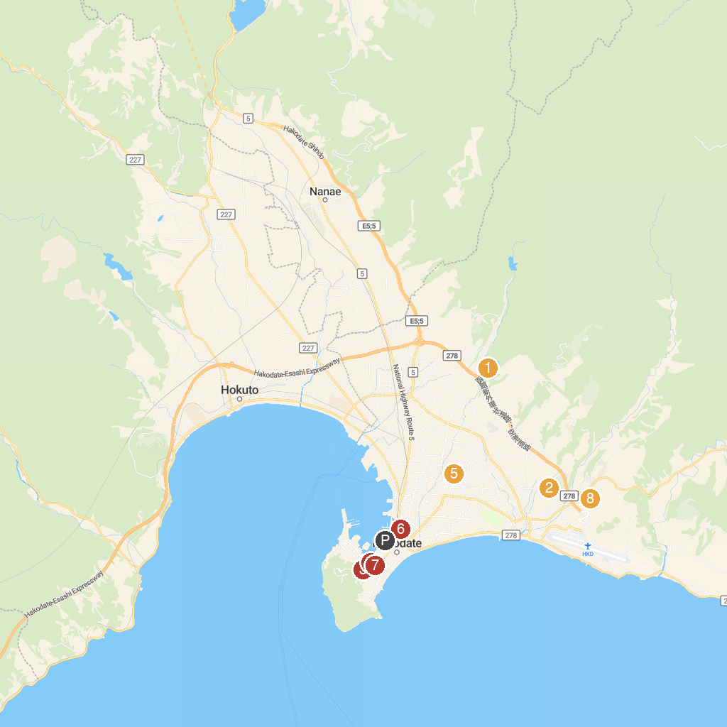
MAP KEY
1. Sasanagare Dam | 5. Goryōkaku Fort
2. Hakodate Kosetsuen | 6. Hijikata Toshizō Deathplace Monument
3. Hakodatesei John Church | 7. Sakamoto Ryoma Memorial Museum
4. The First Concrete Electricity Pole In Japan | 8. Our Lady of the Angels Trappistine Abbey
P. Cruise port / terminal
Map © MapTiler © OpenStreetMap contributors · cruiseports.org

