Fukuoka, Kyushu, Japan
Japan's gateway to Asia — Fukuoka packs world-class ramen, 1,000-year-old shrines, buzzing open-air yatai stalls, and effortless city transit into a perfect shore day.
⚓ Pier (Chuo Wharf — no tendering) · 🕒 Typical call: 8–10 hrs · 💴 Japanese Yen (JPY) · 🗣️ Japanese (English at tourist sites) · 🍜 Ramen capital of Japan
✍️ MY DAY IN PORT (FILL IN)
Ship / Date
In port | arrive ______ · all aboard ______
Booked excursion
Notes / meeting point
GETTING ASHORE
- Docking: Pier — Chuo Wharf Cruise Berth, Hakata Port
- Walk to center: Not walkable; ~3.5 km to Hakata Station — take shuttle or bus
- Best For: Food lovers, culture seekers, temple wanderers, shoppers
- Don't Miss: Tonkotsu ramen at Shin-Shin, Kushida Shrine, Ohori Park
GETTING AROUND
- 🚕 Taxi: ¥2,000–¥2,500 — Taxis queue outside the cruise terminal and reach Hakata Station or Tenjin in 15–30 minutes. Bring your destination writ
- 📱 Rideshare: ✅ Uber
TOP THINGS TO DO
- Kushida Shrine & Hakata Old Town — Fukuoka's most sacred Shinto shrine dates back to 757 AD.
- Tonkotsu Ramen & Hakata Street Food Tour — Fukuoka is the birthplace of tonkotsu ramen — rich pork-bone broth with thin firm noodles.
- Dazaifu Tenmangu Shrine Day Trip — One of Japan's most important shrines, dedicated to Tenjin the deity of learning, set in forested hills 30 min south by train.
- Fukuoka Tower & Momochihama Beach — Japan's tallest seaside tower (234 m) offers 360° panoramic views of Hakata Bay.
- Itoshima Peninsula & Sacred Ocean Torii — Head west to the Itoshima coast to see Sakurai Futamigaura — two sacred rocks joined by a Shinto rope in the sea, framed by a…
BEST WALKS
- Hakata Old Town Loop: 2.5 km · ~45 min · Easy — From Hakata Station, walk to Kushida Shrine (15 min), then on to Tochoji Temple and the Hakata…
- Ohori Park & Castle Ruins: 3 km loop · ~1 hr · Easy — Take a bus or subway to Ohori Park.
WEATHER · DAYLIGHT · MONEY
Month | High °F | Low °F | Rainy days
May | 73 | 60 | 10
Jul | 85 | 75 | 18
Sep | 80 | 70 | 16
Daylight: May 5:18AM–7:11PM · Jul 5:19AM–7:29PM · Sep 6:01AM–6:24PM
cruiseports.org/hakata-fukuoka-city · Confirm terminal & all-aboard time with your ship

Fukuoka, Kyushu, Japan — Port Map
Red = walkable sights · Amber = excursions farther out · P = cruise terminal
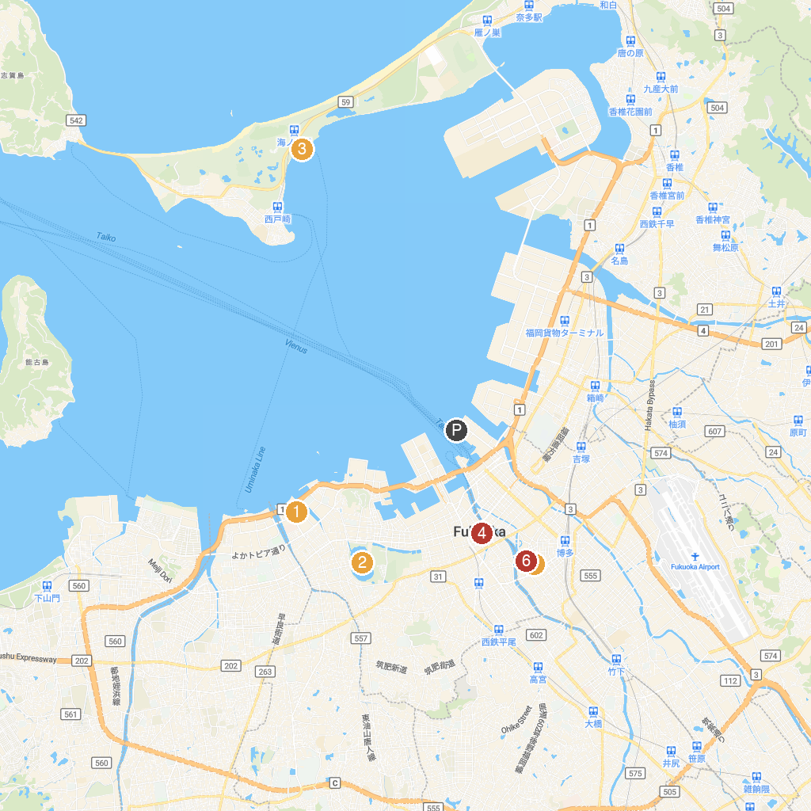
MAP KEY
1. Mizuho PayPay Dome FUKUOKA | 5. Nagatare Park
2. Ohori Park | 6. Sumiyoshi Shrine
3. Marine World | 7. Okita Central Park
4. Acros Fukuoka | 8. Tsurukame-yu
P. Cruise port / terminal
Map © MapTiler © OpenStreetMap contributors · cruiseports.org

