Haines, Alaska, USA
A quieter, less-touristed stop at the head of Lynn Canal — come for bald eagles by the hundred, a historic Army fort turned arts village, and mountain scenery with almost no crowds.
⚓ Docks (small pier at Lutak Inlet / Port Chilkoot) · 🕒 Typical call: 5–7 hrs · 💵 US Dollar (USD) · 🗣️ English · 🦅 World's largest bald eagle concentration
✍️ MY DAY IN PORT (FILL IN)
Ship / Date
In port | arrive ______ · all aboard ______
Booked excursion
Notes / meeting point
GETTING ASHORE
- Docking: Small dock (Lutak Inlet) — ~2 mi from town center; shuttle or walk
- Best For: Bald eagles · Hiking · History · Small-ship vibe
- Don't Miss: Chilkat Bald Eagle Preserve
- Currency: US Dollar — card accepted most places
GETTING AROUND
- 🚕 Taxi: Meter/negotiated — Local taxis (Haines Shuttle, A B Taxi, Anytime Taxi and Tours) operate in town. Confirm fare before boarding; no publish
TOP THINGS TO DO
- Chilkat Bald Eagle Preserve Tour — Guided van or float trip into the Chilkat River valley, home to the world's largest concentration of bald eagles — up to 3,000…
- Fort William H. Seward Walking Tour — Stroll the grounds of the first permanent U.S.
- Rafting the Chilkat River — Float gentle Class I–II sections of the Chilkat River through braided channels flanked by cottonwoods and mountains.
- Mount Riley or Battery Point Hike — Mount Riley (1,760 ft) offers panoramic views over Lynn Canal and the Chilkat Range on a well-marked trail from town.
- Sheldon Museum & Alaska Indian Arts — The Sheldon Museum on Main Street covers Haines and Tlingit history with artifacts and photographs.
BEST WALKS
- Fort Seward & Main Street Loop: 1.5 miles · Easy · 30–45 min — Walk from the dock area down to Fort Seward's parade ground, past the totem poles and the Alaska…
- Battery Point Trail: 4 miles round-trip · Easy · 1.5–2 hrs — A level trail along the shore of Lynn Canal with views of the water and surrounding peaks.
WEATHER · DAYLIGHT · MONEY
Month | High °F | Low °F | Rainy days
May | 53 | 41 | 15
Jul | 66 | 56 | 16
Sep | 57 | 47 | 20
Daylight: May 4:28AM–9:29PM · Jul 4:13AM–10:00PM · Sep 6:31AM–7:20PM
cruiseports.org/haines · Confirm terminal & all-aboard time with your ship

Haines, Alaska, USA — Port Map
Red = walkable sights · Amber = excursions farther out · P = cruise terminal
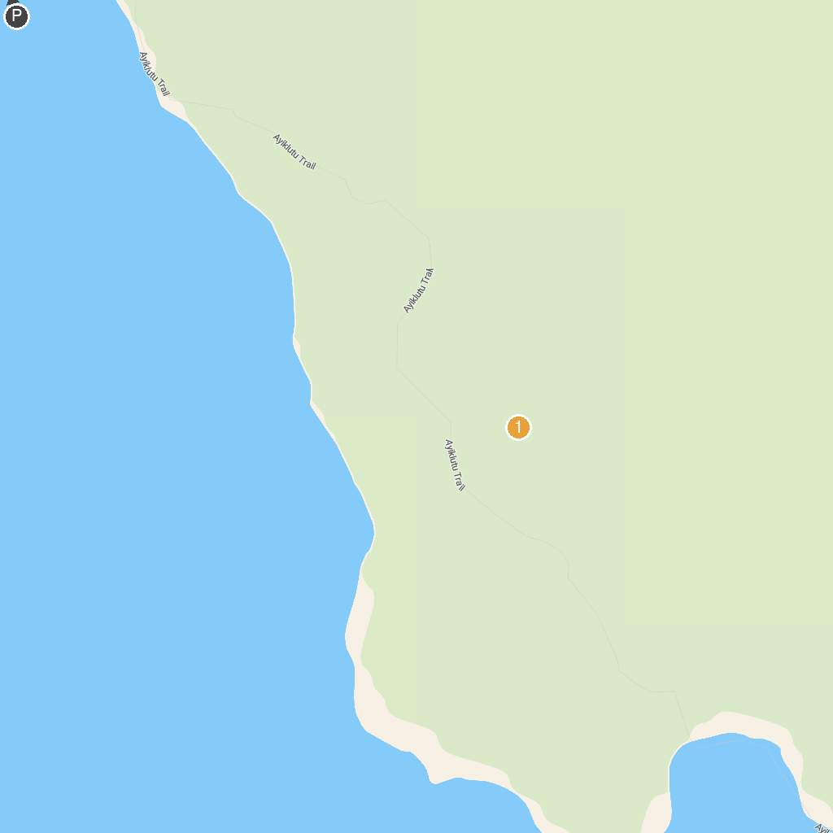
MAP KEY
1. American Bald Eagle Foundation | 3. Port Chilkoot Distillery
2. Chilkat State Park | 4. Hammer Museum
P. Cruise port / terminal
Map © MapTiler © OpenStreetMap contributors · cruiseports.org

