Haifa, Northern District, Israel
Built on the slopes of Mount Carmel above a deep-blue bay, Haifa is Israel's most visually dramatic city — home to the world headquarters of the Baha'i Faith, a UNESCO-listed terraced garden, and one of the most walkable cruise terminals in the Eastern Mediterranean.
⚓ Pier (docked — no tender) · 🕒 Typical call: 8-10 hrs · 💵 Israeli Shekel (ILS) — cards everywhere · 🗣️ Hebrew & Arabic; English widely spoken · ⚠️ Shabbat: trains stop Fri sunset–Sat sunset
✍️ MY DAY IN PORT (FILL IN)
Ship / Date
In port | arrive ______ · all aboard ______
Booked excursion
Notes / meeting point
GETTING ASHORE
- Docking: Docked at Haifa Port Cruise Terminal — no tender
- Walk to German Colony: 10–15 min flat walk along Ben Gurion Blvd
- Best For: Baha'i Gardens, Crusader history in Acre, Galilean day trips
- Don't Miss: Free guided descent of the 19-terrace Baha'i Gardens
GETTING AROUND
- 🚕 Taxi: ₪25–40 (~$8–11) — Licensed metered taxis wait outside the terminal. Short rides into the city center or up to the Baha'i Gardens cost roug
- 📱 Rideshare: ✅ Gett
TOP THINGS TO DO
- Baha'i Gardens — Free Guided Descent — Nineteen perfectly manicured terraces cascade down Mount Carmel to the golden-domed Shrine of the Báb — a UNESCO World Heritage…
- Acre (Akko) — Crusader City Day Trip — A UNESCO World Heritage walled city just 25 minutes by train.
- Nazareth — Galilee Biblical Sites — About twenty-five miles southeast, Nazareth is the childhood home of Jesus and Israel's largest Arab city.
- German Colony & Wadi Nisnas Walk — Walk straight out of the port to the German Colony's restored 19th-century Templer stone houses, now lined with cafes and…
- Carmel Center & Louis Promenade — Take the Carmelit funicular from Paris Square to the Carmel Center at the top of the mountain, then walk the Louis Promenade for…
BEST WALKS
- Port to German Colony & Baha'i Lower Gate: 1.5 km | ~20 min | Flat — Walk from the cruise terminal along Ben Gurion Boulevard through the heart of the German Colony — a…
- Wadi Nisnas Market Loop: 1 km loop | ~30 min | Flat — From the German Colony, dip into Wadi Nisnas — Haifa's Christian-Arab quarter known for its…
WEATHER · DAYLIGHT · MONEY
Month | High °F | Low °F | Rainy days
May | 76 | 64 | 3
Jul | 84 | 75 | 0
Sep | 84 | 75 | 1
Daylight: May 5:41AM–7:31PM · Jul 5:43AM–7:48PM · Sep 6:23AM–6:46PM
cruiseports.org/haifa · Confirm terminal & all-aboard time with your ship

Haifa, Northern District, Israel — Port Map
Red = walkable sights · Amber = excursions farther out · P = cruise terminal
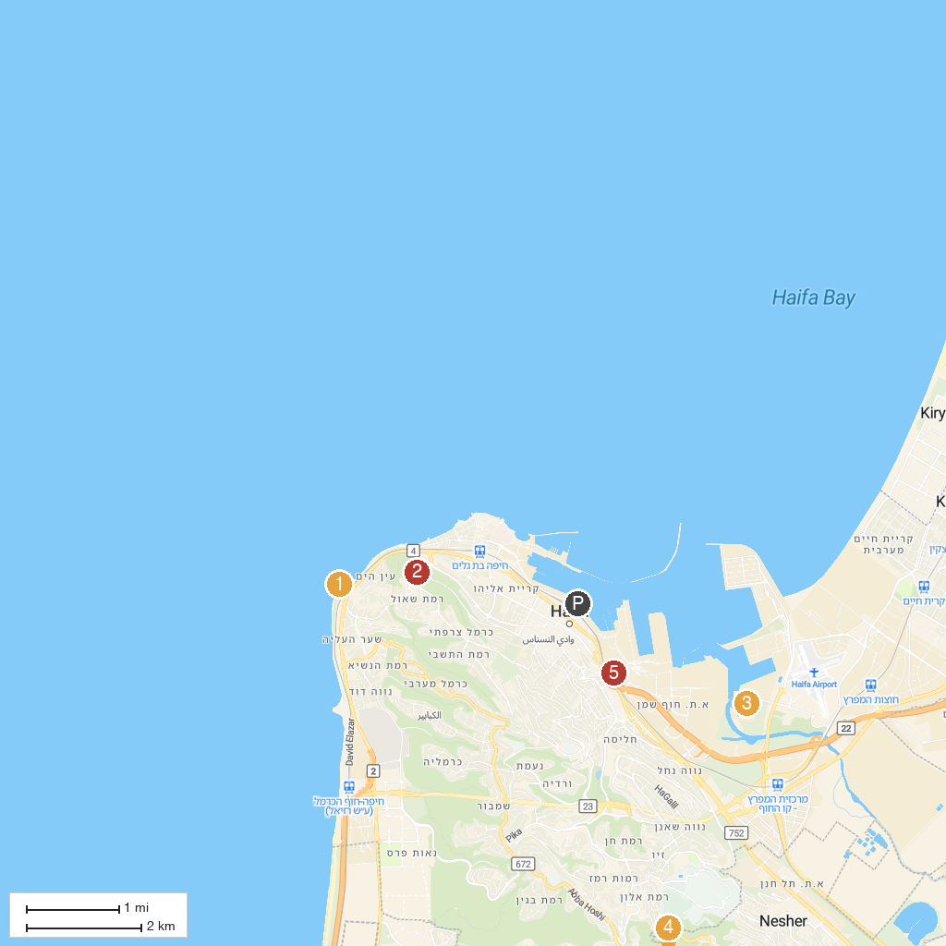
MAP KEY
1. Al-Jazzar Mosque | 5. Stella Maris Monastery
2. Tel Shikmona | 6. Kishon River Authority
3. Khan a-Shawarda | 7. Hai-Bar Nature Reserve
4. Khan of the Pillars | 8. The Israel Railway Museum
P. Cruise port / terminal
Map © MapTiler © OpenStreetMap contributors · cruiseports.org

