Hai Phong, Vietnam
Vietnam's Red Poinciana city is a working port and street-food paradise — the industrial gateway to Hanoi, the limestone karsts of Lan Ha Bay, and one of Southeast Asia's most authentic local dining scenes.
⚓ Pier (industrial dock — no walk-out) · 🕒 Typical call: 8-10 hrs · 💵 Vietnamese Dong (VND) · 🗣️ Vietnamese
✍️ MY DAY IN PORT (FILL IN)
Ship / Date
In port | arrive ______ · all aboard ______
Booked excursion
Notes / meeting point
GETTING ASHORE
- Docking: Alongside at Lach Huyen or Tan Vu — industrial piers, no walk-out; shuttle required
- Walk to center: Not walkable — 35–50 min by shuttle or Grab taxi to Hai Phong city center
- Best For: Hanoi day trips, Lan Ha Bay karst cruises, colonial architecture, street food
- Don't Miss: Bánh đa cua — Hai Phong's legendary crab noodle soup
GETTING AROUND
- 🚕 Taxi: ~$6–12 USD to city center — Mai Linh (green) and Hai Phong Taxi (grey/blue) are reputable local companies. Always insist on the meter. The industria
- 📱 Rideshare: ✅ Grab
TOP THINGS TO DO
- Hanoi Full-Day City Tour — Vietnam's ancient capital is 1.5–2 hours away — Hoan Kiem Lake, the Old Quarter, Ho Chi Minh Mausoleum complex, Temple of…
- Lan Ha Bay Boat Cruise — Lan Ha Bay is the quieter, equally spectacular neighbour to Halong Bay — limestone karsts, emerald water, floating fishing…
- Hai Phong City & Street Food Walk — Stay in the city and explore the French colonial Opera House, Tam Bac Lake, Le Chan Statue, and Hang Kenh Communal House with its…
- Du Hang Pagoda & Colonial Quarter — One of northern Vietnam's oldest Buddhist temples (17th century), with intricate woodcarvings, bronze relics, and a peaceful…
- Cat Ba Island & Cat Co Beaches — Cat Ba Island's Cat Co beaches offer white sand and clean emerald water backed by limestone cliffs — a genuine tropical beach…
BEST WALKS
- Colonial Heart Walk: 2 km · 45 min · Easy — From the Opera House, head south past the leafy plaza and along Dien Bien Phu Street to Tam Bac Lake.
- Temple & Pagoda Circuit: Short taxi + 1 km walking · Easy — Take a Grab to Du Hang Pagoda, explore the 17th-century grounds, then walk or taxi a short distance…
WEATHER · DAYLIGHT · MONEY
Month | High °F | Low °F | Rainy days
May | 81 | 67 | 24
Jul | 80 | 67 | 25
Sep | 77 | 65 | 25
Daylight: May 5:16AM–6:23PM · Jul 5:20AM–6:37PM · Sep 5:40AM–5:56PM
cruiseports.org/hai-phong · Confirm terminal & all-aboard time with your ship

Hai Phong, Vietnam — Port Map
Red = walkable sights · Amber = excursions farther out · P = cruise terminal
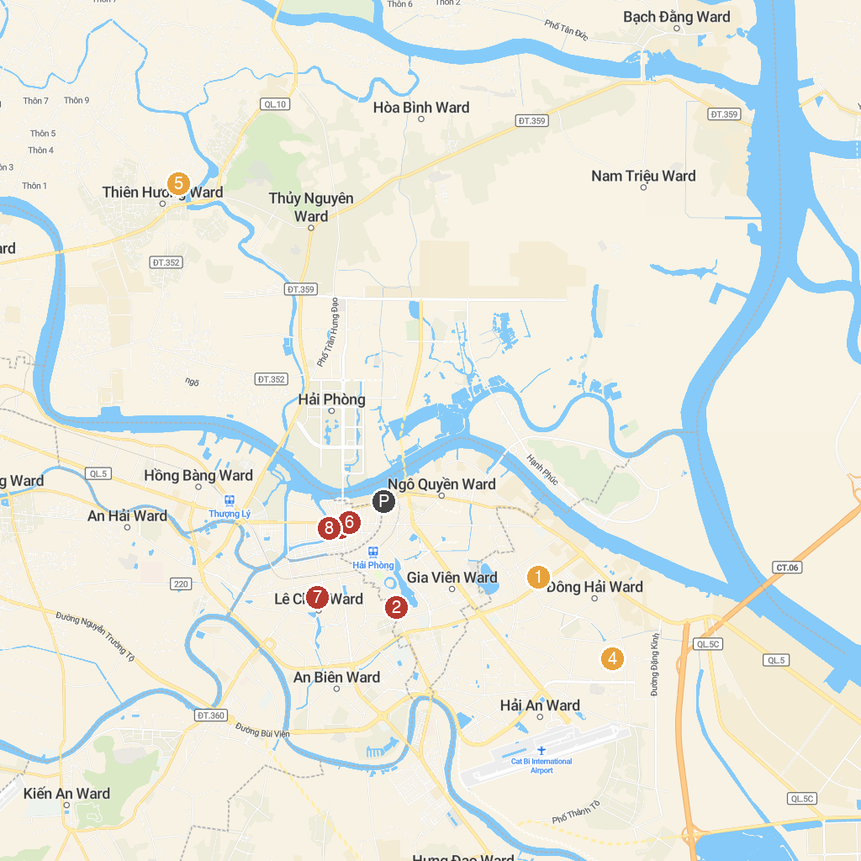
MAP KEY
1. Phu Xa Temple | 5. Chùa Trịnh Xá
2. Children's Cultural Palace in Hai Phong | 6. Hai Phong Museum
3. Cathedral of the Diocese of Hai Phong | 7. Du Hang Pagoda
4. Từ Lương Xâm | 8. Hải Phòng Graffiti Check-in
P. Cruise port / terminal
Map © MapTiler © OpenStreetMap contributors · cruiseports.org

