Haarlem, North Holland, Netherlands
Haarlem delivers everything Amsterdam promises—Golden Age canals, world-class museums, lively cafés—without the crowds. River cruise ships tie up right on the Spaarne River; ocean passengers arrive via a quick 15-minute train from Amsterdam Centraal.
⚓ River: pier on Spaarne River; Ocean: Amsterdam or IJmuiden · 🕒 Typical call: 8-10 hrs · 💶 Currency: Euro (card accepted everywhere) · 🗣️ Language: Dutch (English widely spoken)
✍️ MY DAY IN PORT (FILL IN)
Ship / Date
In port | arrive ______ · all aboard ______
Booked excursion
Notes / meeting point
GETTING ASHORE
- Docking: River cruise: Spaarne River quays (walk to center). Ocean: dock Amsterdam PTA or IJmuiden, then train/taxi.
- Walk to center: River cruise: 5-10 min flat walk. Ocean arrivals reach center ~30-45 min total.
- Best For: Dutch Golden Age art, hidden courtyard (hofje) hunting, Frans Hals Museum, local craft beer, beach day at Zandvoort
- Don't Miss: Jopenkerk brewery in a 1902 church; the Grote Markt on a Saturday market day; Corrie ten Boom House
GETTING AROUND
- 🚕 Taxi: ~€50–55 one-way — Taxis from IJmuiden Felison Cruise Terminal to Haarlem city center run approximately €50–55. Fares are metered; expect €
- 📱 Rideshare: ✅ Uber, Bolt
TOP THINGS TO DO
- Frans Hals Museum — The world's finest collection of Golden Age portrait paintings, housed in the 17th-century men's almshouse (Oudemannenhuis) whose…
- Corrie ten Boom House & Hiding Place — The Ten Boom family hid hundreds of Jewish people and resistance fighters behind a false wall in their watch shop during WWII.
- Teylers Museum — The oldest museum in the Netherlands (1784), frozen in time — fossils, coins, scientific instruments, and original drawings by…
- Jopenkerk Craft Brewery — A fully functioning brewery and grand café inside a soaring 1902 neo-Gothic church.
- Zandvoort Beach Day — Haarlem is the easiest gateway to the Dutch coast.
BEST WALKS
- Grote Markt to Spaarne River Loop: 1.5 km · ~30 min · Flat — Start at the Grote Markt, admire the medieval Stadhuis and the Grote Kerk (St.
- Hofjes Discovery Walk: 2 km · ~45 min · Flat — Wind through the backstreets between the Grote Markt and Frans Hals Museum hunting for hidden hofjes.
WEATHER · DAYLIGHT · MONEY
Month | High °F | Low °F | Rainy days
May | 61 | 49 | 10
Jul | 70 | 59 | 13
Sep | 66 | 56 | 11
Daylight: May 5:46AM–9:30PM · Jul 5:38AM–9:56PM · Sep 7:16AM–7:55PM
cruiseports.org/haarlem · Confirm terminal & all-aboard time with your ship

Haarlem, North Holland, Netherlands — Port Map
Red = walkable sights · Amber = excursions farther out · P = cruise terminal
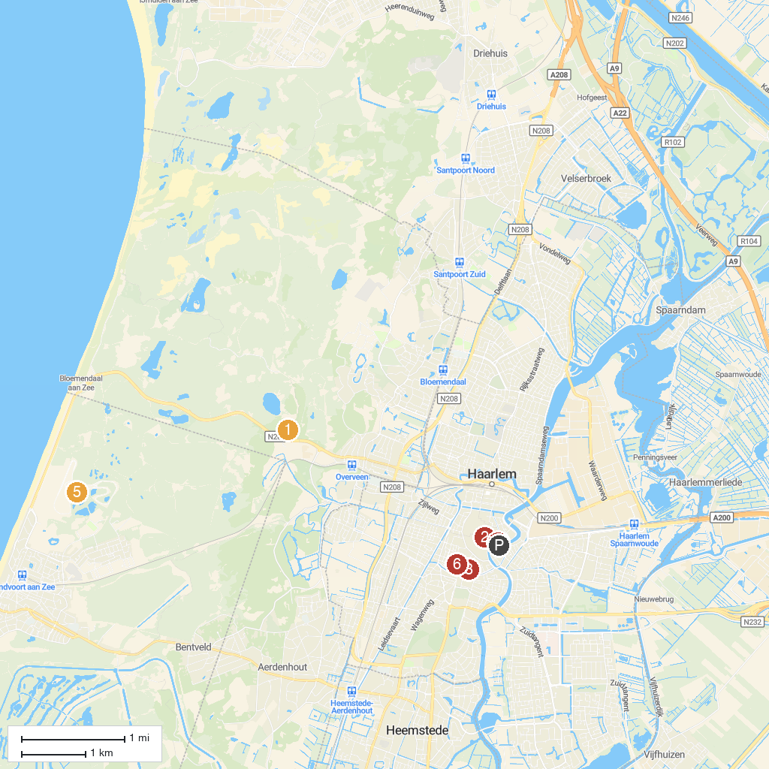
MAP KEY
1. Nationaal Park Zuid-Kennemerland | 5. Kasteel Keukenhof
2. Keukenhof | 6. Teylers Museum
3. The St. Bavo Church in Haarlem | 7. MASCOT Circuit Zandvoort
4. Frans Hals Museum | 8. Proveniershuis
P. Cruise port / terminal
Map © MapTiler © OpenStreetMap contributors · cruiseports.org

