Gythion, Peloponnese, Greece
The ancient port of Sparta sits at the edge of the wild Mani Peninsula — pastel neoclassical mansions line the harbor where legend says Paris and Helen spent their first night together before sailing to Troy.
⚓ Tender (large ships); some smaller vessels dock · 🕒 Typical call: 7–9 hrs · 💶 Currency: Euro (€) · 🗣️ Language: Greek (English widely spoken waterfront)
✍️ MY DAY IN PORT (FILL IN)
Ship / Date
In port | arrive ______ · all aboard ______
Booked excursion
Notes / meeting point
GETTING ASHORE
- Docking: Tender for large ships; vessels up to ~200 m may berth at quay
- Walk to center: Tender drops at harbor — town is immediately at hand
- Best For: History, scenic strolls, Byzantine ruins, day trips
- Don't Miss: Marathonisi islet & Mystras UNESCO ghost city
GETTING AROUND
- 🚕 Taxi: €5–€15 — Taxis wait near the port and are available for short trips or longer excursions. Fares are metered in town; agree on a p
TOP THINGS TO DO
- Mystras Byzantine Ghost City — A UNESCO World Heritage hilltop city that was once the second capital of the late Byzantine Empire.
- Diros Caves (Vlychada) — One of Europe's most spectacular water caves.
- Sparta & Archaeological Museum — Modern Sparta sits atop the ancient city.
- Mavrovouni Beach — A 5 km arc of golden sand and fine pebbles just south of town, with crystal-clear Laconian Gulf water.
- Marathonisi Islet & Mani Museum — Walk the 150-meter causeway to the pine-covered islet of Cranae — where myth says Paris and Helen of Troy spent their first night.
BEST WALKS
- Harbor Promenade to Marathonisi: 2.5 km round-trip · Flat · 40–60 min — Stroll the neoclassical waterfront past tavernas drying octopus in the sun, then cross the stone…
- Town & Roman Theater Walk: 2 km loop · Mostly flat, some gentle hills · 30–45 min — Head north along the waterfront and climb gently to the small but well-preserved 2nd-century Roman…
cruiseports.org/gythion · Confirm terminal & all-aboard time with your ship

Gythion, Peloponnese, Greece — Port Map
Red = walkable sights · Amber = excursions farther out · P = cruise terminal
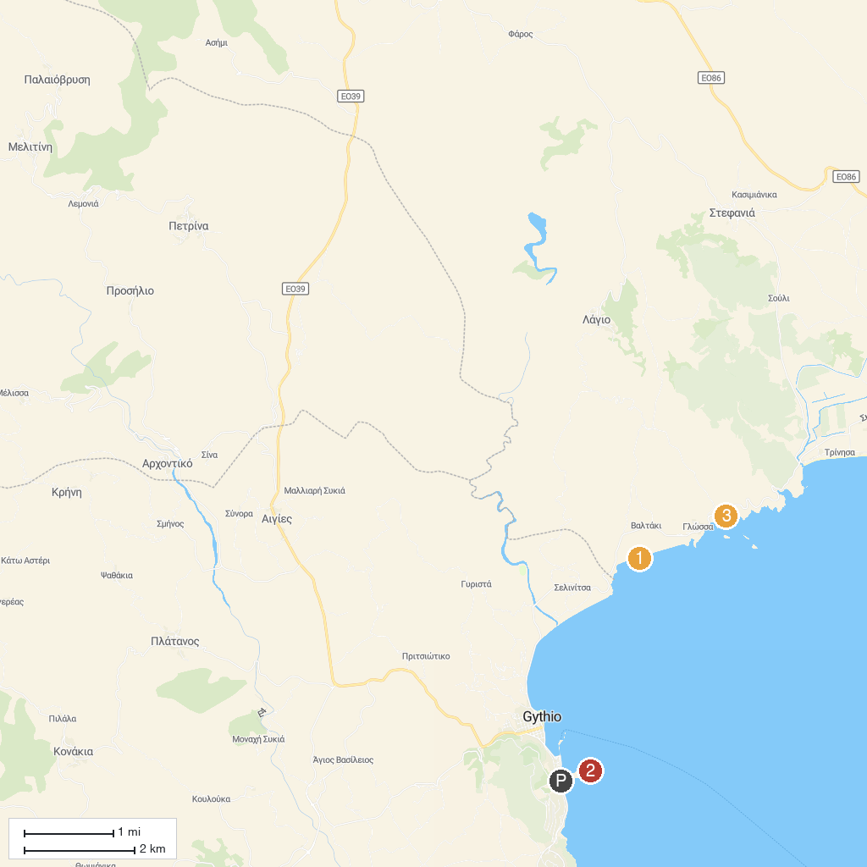
MAP KEY
1. Dimitrios Shipwreck | 3. Afroditi Beach
2. Gythio Lighthouse | 4. Kelefa Castle
P. Cruise port / terminal
Map © MapTiler © OpenStreetMap contributors · cruiseports.org

