Gustavia, St. Barthélemy, France
The Monaco of the Caribbean — a chic, Swedish-tinged French island where super-yachts crowd the harbor, duty-free boutiques line cobblestone streets, and pristine beaches wait just minutes away.
⚓ Tender port (no cruise pier) · 🕒 Typical call: 6–8 hrs · 💶 Currency: Euro (USD accepted) · 🗣️ Language: French (English widely spoken) · 🛍️ Duty-free shopping
✍️ MY DAY IN PORT (FILL IN)
Ship / Date
In port | arrive ______ · all aboard ______
Booked excursion
Notes / meeting point
GETTING ASHORE
- Docking: Tender only — ships anchor offshore; 10–15 min tender ride to Quai d'Honneur
- Walk to center: 0 min — tender drops you at the harbor heart of Gustavia
- Best For: Luxury shopping, harbor walks, Shell Beach, French dining
- Don't Miss: Fort Gustav panorama, Le Select bar (the 'Cheeseburger in Paradise' bar), Shell Beach
GETTING AROUND
- 🚕 Taxi: €20–€55 — Regulated taxis wait at the port for trips to beaches and island attractions. Fares vary by route; surcharges apply afte
- 📱 Rideshare: ❌ not available
TOP THINGS TO DO
- Shell Beach on Foot — A 10–15 minute walk from the tender dock leads to Anse de Grand Galet — a crescent of millions of tiny polished shells, calm…
- Colombier Beach by Catamaran — Colombier is a secluded marine reserve only reachable by a 30-min coastal hike or by boat.
- Fort Gustav & Lighthouse Views — Hike north of the harbor to the active lighthouse and ruins of Fort Gustav, built during Swedish rule.
- Mini Moke Island Tour — Rent an open-top Mini Moke or small 4x4 and wind through St.
- Gustavia Harbor Walk & Le Select — Stroll the U-shaped harbor past Swedish-era red-roofed warehouses and mega-yachts.
BEST WALKS
- Harbor Loop to Fort Karl: 1.5 km · 30–40 min · Easy–Moderate — Walk the full harbor crescent past luxury boutiques and super-yachts, then climb the wooden stairs…
- Quai to Shell Beach: 800 m · 10–15 min · Easy — Head south from the tender dock along the harbor edge and follow signs to Anse de Grand Galet…
WEATHER · DAYLIGHT · MONEY
Month | High °F | Low °F | Rainy days
May | 80 | 78 | 9
Jul | 82 | 80 | 13
Sep | 83 | 80 | 17
Daylight: May 5:38AM–6:36PM · Jul 5:44AM–6:50PM · Sep 5:59AM–6:13PM
cruiseports.org/gustavia-st-barths · Confirm terminal & all-aboard time with your ship

Gustavia, St. Barthélemy, France — Port Map
Red = walkable sights · Amber = excursions farther out · P = cruise terminal
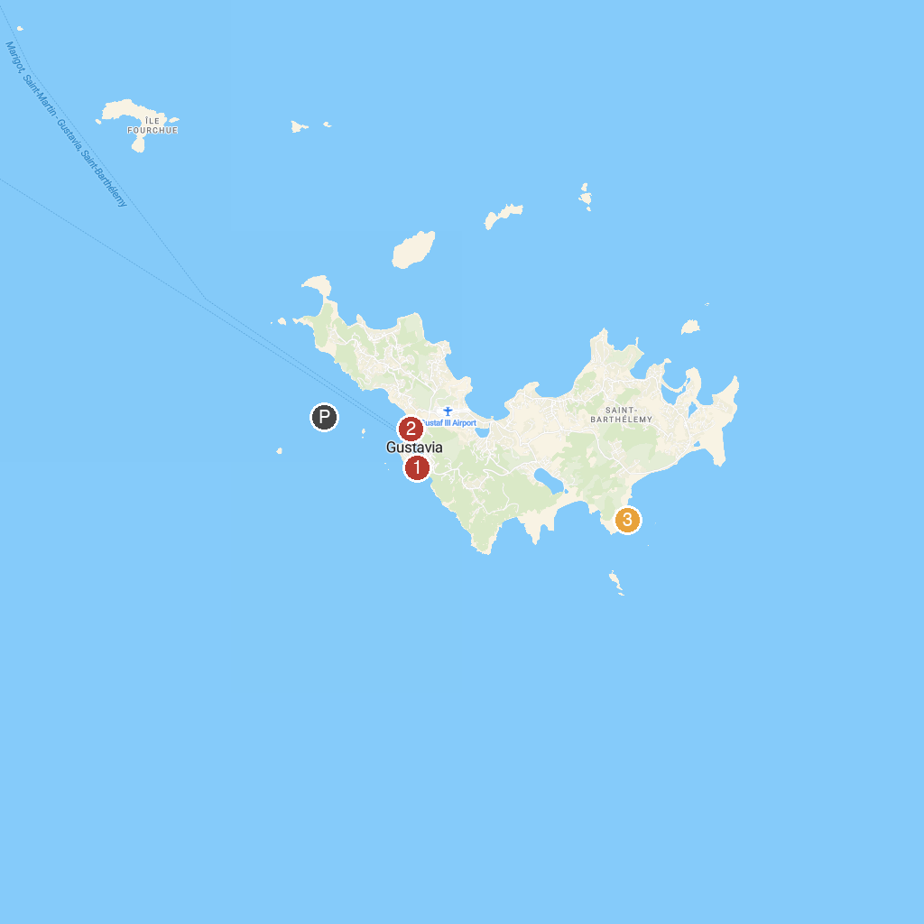
MAP KEY
1. Fort Karl | 3. Piscines Naturelles Grand Fond
2. Gustavia Lighthouse
P. Cruise port / terminal
Map © MapTiler © OpenStreetMap contributors · cruiseports.org

