Gulfport, Mississippi, USA
Mississippi's Secret Coast delivers Civil War history, pristine barrier island beaches, world-class seafood, and a waterfront park steps from the pier — all anchored by Southern hospitality.
⚓ Pier (docked) · 🕒 Typical call: 8-10 hrs · 💵 USD · 🗣️ English · 🌊 Barrier island beaches
✍️ MY DAY IN PORT (FILL IN)
Ship / Date
In port | arrive ______ · all aboard ______
Booked excursion
Notes / meeting point
GETTING ASHORE
- Docking: Pier — Port of Gulfport deepwater terminal; shuttle to Jones Park gate
- Walk to Center: ~0.4 mi / 8 min from port gate to downtown; shuttle from gangway to gate
- Best For: Ship Island day trip, Mississippi Aquarium, Gulf Coast seafood
- Don't Miss: Fort Massachusetts on Ship Island — Civil War brick fort on a pristine barrier island
GETTING AROUND
- 🚕 Taxi: $15–$25 — Taxis are available at the cruise terminal. A ride to downtown Gulfport or the beach strip runs roughly $15–$25; flat ra
- 📱 Rideshare: ✅ Uber, Lyft
TOP THINGS TO DO
- Ship Island Day Trip — Ferry 11 miles offshore to West Ship Island, part of the Gulf Islands National Seashore.
- Mississippi Aquarium — A world-class mostly outdoor aquarium steps from the port, featuring a 360° shark tunnel, dolphins, otters, and American…
- Fort Massachusetts Tour — On Ship Island, this intact masonry fort — begun in 1859 — housed Confederate and then Union troops.
- Downtown Gulfport & Fishbone Alley — Explore a revitalized historic downtown with murals, local art galleries, boutiques, and the Gulfport Museum of History in the…
- Gulfport Beach Stroll — A clean, wide white-sand beach runs along Highway 90 just minutes from the port.
BEST WALKS
- Jones Park to Downtown Loop: 1.2 miles · 25 min · Easy — From the port shuttle drop-off at Jones Park, walk past the lighthouse replica to the waterfront…
- Waterfront to Mississippi Aquarium: 0.5 miles · 10 min · Easy — A simple flat walk from Jones Park along the waterfront to the Mississippi Aquarium entrance on…
WEATHER · DAYLIGHT · MONEY
Month | High °F | Low °F | Rainy days
May | 80 | 69 | 12
Jul | 87 | 77 | 20
Sep | 84 | 73 | 14
Daylight: May 6:02AM–7:43PM · Jul 6:05AM–7:59PM · Sep 6:41AM–7:01PM
cruiseports.org/gulfport-ms · Confirm terminal & all-aboard time with your ship

Gulfport, Mississippi, USA — Port Map
Red = walkable sights · Amber = excursions farther out · P = cruise terminal
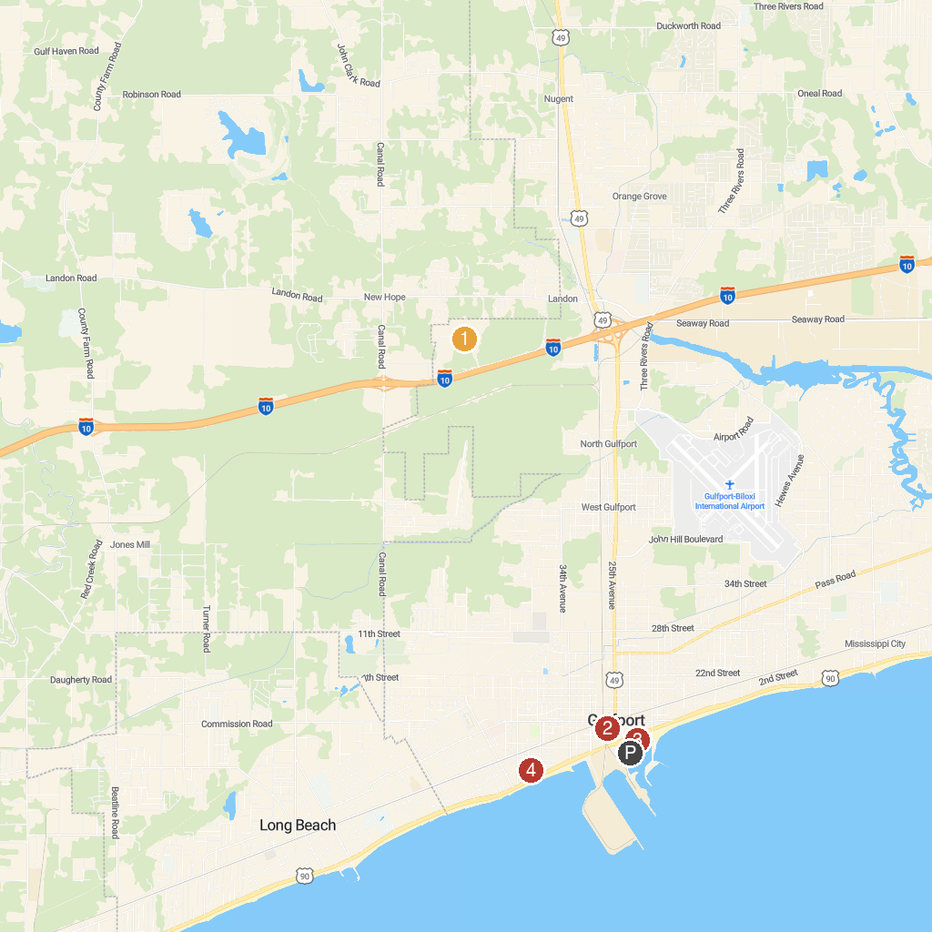
MAP KEY
1. Gulf Islands Waterpark | 5. Hiller Park
2. Fishbone Alley | 6. Mississippi Gulf Coast
3. Jones Park | 7. West Side Park
4. Popps Ferry Causeway Park
P. Cruise port / terminal
Map © MapTiler © OpenStreetMap contributors · cruiseports.org

