Gudvangen, Vestland, Norway
Tucked at the innermost point of the Nærøyfjord, Gudvangen is where sheer mountain walls rise 1,200 metres above mirror-still water — and where the Vikings never really left.
⚓ Tender port · 🕒 Typical call: 5–7 hrs · 💳 Cashless (NOK, cards everywhere) · 🗣️ Norwegian / English widely spoken · 🏔️ UNESCO World Heritage fjord
✍️ MY DAY IN PORT (FILL IN)
Ship / Date
In port | arrive ______ · all aboard ______
Booked excursion
Notes / meeting point
GETTING ASHORE
- Docking: Tender only — ships anchor in the fjord; pontoon pier in village centre
- Walk to centre: Tender lands steps from the Viking Valley and riverside path
- Best For: Fjord scenery, Viking culture, kayaking, Nærøyfjord boat trips
- Don't Miss: Njardarheimr Viking Valley & Kjelfossen waterfall views from shore
GETTING AROUND
- 🚕 Taxi: NOK 430–550 (~$40–$52 USD) — Taxi ride to Flåm takes ~17 minutes. Metered fares; rates higher on weekends and evenings. Pre-booked private transfers
TOP THINGS TO DO
- Njardarheimr Viking Valley — A living Viking settlement where re-enactors work, cook, and craft year-round using authentic Viking-age methods.
- Nærøyfjord Electric Catamaran to Flåm — Board a silent, zero-emission catamaran for a 2-hour glide through the UNESCO-listed Nærøyfjord — just 250 m wide at its…
- Nærøyfjord Kayak Tour — Guided kayak tours launch directly from the Gudvangen shoreline.
- Stalheim Hotel Viewpoint — A 15-minute taxi or bus ride leads to the historic Stalheim Hotel, perched above the Nærøydalen valley with one of the most…
- Flåm Railway Day Trip — Gudvangen is 20 minutes by bus through mountain tunnels from Flåm.
BEST WALKS
- Nærøydalselvi Riverside Stroll: 1–2 km | Flat | 20–40 min — Follow the crystal-clear Nærøydalselvi river as it flows into the fjord.
- Village Centre Loop: 0.5 km | Easy | 10–15 min — A quick orientation walk taking in the Gudvangen Fjordtell hotel (grass roofs, Viking-modern…
WEATHER · DAYLIGHT · MONEY
Month | High °F | Low °F | Rainy days
May | 54 | 44 | 16
Jul | 68 | 56 | 21
Sep | 60 | 51 | 17
Daylight: May 4:48AM–10:11PM · Jul 4:28AM–10:47PM · Sep 7:00AM–7:53PM
cruiseports.org/gudvangen · Confirm terminal & all-aboard time with your ship

Gudvangen, Vestland, Norway — Port Map
Red = walkable sights · Amber = excursions farther out · P = cruise terminal
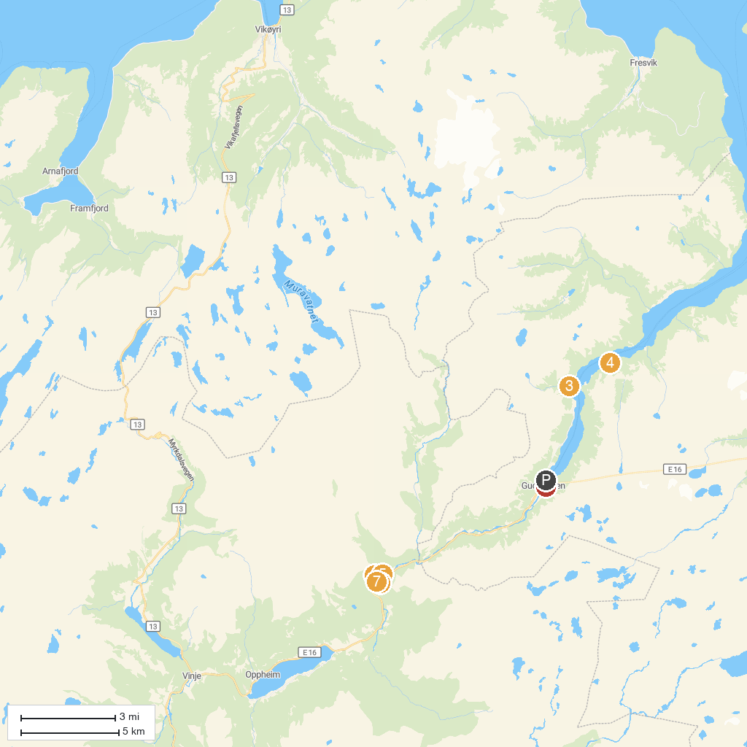
MAP KEY
1. Stalheim Fjord Og Fjellhytter | 5. Stalheimskleiva
2. Njardarheimr | 6. Stalheimfossen
3. Tuftefossen | 7. Stalheim Panoramic Terrace
4. Odnesfossen
P. Cruise port / terminal
Map © MapTiler © OpenStreetMap contributors · cruiseports.org

