Guaymas, Sonora, Mexico
Where the Sonoran Desert meets the sea — Guaymas delivers authentic Mexico, a one-of-a-kind pearl farm, and the resort shores of San Carlos just 20 minutes away.
⚓ Docked (commercial pier) · 🕒 Typical call: 7-9 hrs · 💵 Mexican Peso (USD accepted in San Carlos) · 🗣️ Spanish (limited English downtown)
✍️ MY DAY IN PORT (FILL IN)
Ship / Date
In port | arrive ______ · all aboard ______
Booked excursion
Notes / meeting point
GETTING ASHORE
- Docking: Commercial pier; shuttle to downtown (~10 min, often complimentary)
- Walk to center: Not walkable from pier — industrial port zone; take shuttle or taxi
- Best For: Seafood lovers, divers, nature seekers, those wanting non-touristy Mexico
- Don't Miss: Perlas del Mar de Cortez pearl farm tour and fresh camarones on the Malecón
GETTING AROUND
- 🚕 Taxi: $10–$15 USD one-way — Taxis wait at the port and are the most common way to reach downtown Guaymas, about a 10-minute drive. Always negotiate
- 📱 Rideshare: ✅ Uber, DiDi
TOP THINGS TO DO
- Perlas del Mar de Cortez Pearl Farm — The only active saltwater pearl farm in the Americas.
- San Carlos Mirador & Playa Los Algodones — Head 20 minutes to San Carlos for the Mirador Escénico — ranked by National Geographic as one of the Top 10 Ocean Views in the…
- Sea of Cortez Dive & Snorkel — Jacques Cousteau called this 'the aquarium of the world.' Dive sites include underwater caves, basalt walls, and wrecks like the…
- Nacapule Canyon Hike — Just outside Guaymas, Cañón del Nacapule is a lush tropical oasis tucked inside a dry canyon — a rare microclimate with palms…
- Downtown Guaymas Food & Malecón Walk — Take the shuttle downtown, stroll the renovated Malecón waterfront, and eat at the Mercado Municipal or a waterfront mariscos spot.
BEST WALKS
- Historic Downtown & Malecón Loop: 1.5 miles · Easy · 60–90 min — Start at Plaza de los Tres Presidentes with its large bronze statues of three Mexican presidents…
- Playa Miramar Beach Walk: 15 min by taxi · Easy · 1–2 hrs beach time — Playa Miramar is the closest swimming beach to the port — calm, clear turquoise water in a…
WEATHER · DAYLIGHT · MONEY
Month | High °F | Low °F | Rainy days
May | 86 | 69 | 0
Jul | 94 | 84 | 3
Sep | 92 | 80 | 6
Daylight: May 5:34AM–7:06PM · Jul 5:37AM–7:21PM · Sep 6:09AM–6:27PM
cruiseports.org/guaymas · Confirm terminal & all-aboard time with your ship

Guaymas, Sonora, Mexico — Port Map
Red = walkable sights · Amber = excursions farther out · P = cruise terminal
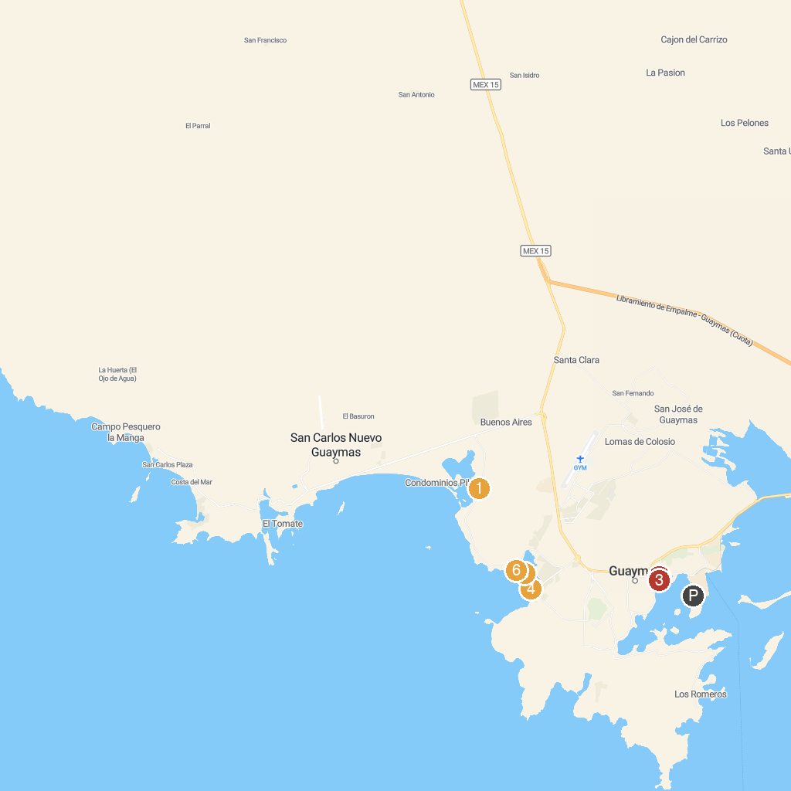
MAP KEY
1. Estero "El soldado" | 4. Playa Miramar, Guaymas, MX
2. Plaza of the Three Presidents | 5. Playa El Veneno, Guaymas, Sonora
3. Malecón Turistico | 6. Escollera Miramar
P. Cruise port / terminal
Map © MapTiler © OpenStreetMap contributors · cruiseports.org

