Guam, Mariana Islands, USA
America's westernmost territory, Guam blends ancient Chamorro traditions, Spanish colonial ruins, WWII memorials, and some of the Pacific's calmest reef-protected beaches — all priced in US dollars.
⚓ Pier (F1, Apra Harbor) · 🕒 Typical call: 8–10 hrs · 💵 USD — no sales tax, duty-free port · 🗣️ English & Chamorro · 🇺🇸 US territory — US CBP entry rules apply
✍️ MY DAY IN PORT (FILL IN)
Ship / Date
In port | arrive ______ · all aboard ______
Booked excursion
Notes / meeting point
GETTING ASHORE
- Docking: Pier — F1 Pier, Port Authority of Guam, Apra Harbor
- Walk to center: Not walkable — shuttle or taxi required to Tumon Bay (~20 min)
- Best For: Beaches, WWII history, Chamorro cuisine, duty-free shopping
- Don't Miss: Two Lovers Point overlook and Ypao Beach snorkeling
GETTING AROUND
- 🚕 Taxi: $20–$30 — Taxis meet ships at F1 Pier, Apra Harbor. Agree on fare before departing — zone-based pricing; Tumon Bay or Hagatna is r
- 📱 Rideshare: ❌ not available
TOP THINGS TO DO
- War in the Pacific National Historical Park — Seven distinct units tell the story of the 1944 liberation of Guam.
- Two Lovers Point (Puntan Dos Amantes) — Guam's most photographed landmark — a roughly 370-foot limestone cliff over Tumon Bay, named for the Chamorro legend of two…
- Tumon Bay Beach Day — Tumon's long white-sand beach fronts the main hotel strip and is free, public, and calm year-round behind a fringing reef.
- Valley of the Latte Adventure Park — A cultural eco-park in the south showcasing ancient Chamorro village life, latte stone replicas, boat rides, and water buffalo…
- Snorkeling & Diving Apra Harbor / Fish Eye Marine Park — Guam's reef-protected waters are legendary in the Pacific.
BEST WALKS
- Hagåtña History Loop: 1.5 miles • Easy • 60–90 min — From the Plaza de España ruins, walk past the restored Dulce Nombre de Maria Cathedral-Basilica…
- Tumon Bay Boardwalk: 1 mile • Easy • 30–45 min — Stroll the beachfront from the Westin south end to Ypao Beach Park, dipping into the water whenever…
WEATHER · DAYLIGHT · MONEY
Month | High °F | Low °F | Rainy days
May | 86 | 79 | 22
Jul | 85 | 78 | 29
Sep | 85 | 78 | 28
Daylight: May 5:55AM–6:40PM · Jul 6:02AM–6:52PM · Sep 6:10AM–6:22PM
cruiseports.org/guam-island-marianas · Confirm terminal & all-aboard time with your ship

Guam, Mariana Islands, USA — Port Map
Red = walkable sights · Amber = excursions farther out · P = cruise terminal
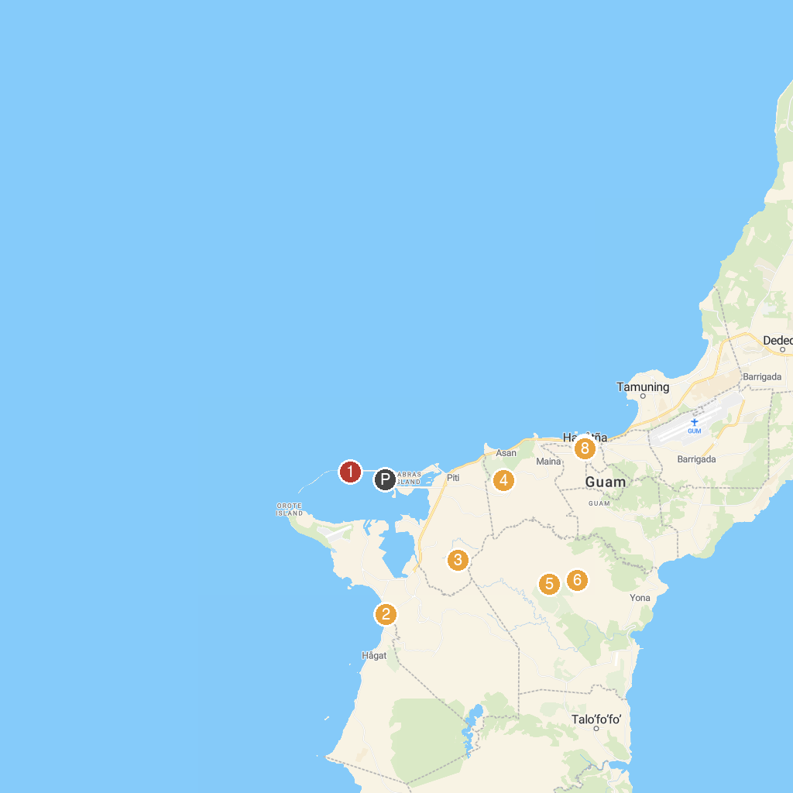
MAP KEY
1. Family Beach | 5. Leopalace Resort Country Club
2. 아파카 국립공원 | 6. Guam Adventures Off Road "Ranch" at LeoPalace
3. War in the Pacific National Historical Park | 7. Guam Museum (Department of Chamorro Affairs)
4. Asan Bay Overlook, War in The Pacific National Historical Park | 8. Plaza de España
P. Cruise port / terminal
Map © MapTiler © OpenStreetMap contributors · cruiseports.org

