Grundarfjordur, Snaefellsnes, Iceland
A small fishing village beneath Iceland's most-photographed mountain, Grundarfjordur delivers dramatic scenery and authentic Iceland — no tourist strip malls, no crowds.
⚓ Pier (small ships) or Tender (large ships) · 🕒 Typical call: 6-8 hrs · 💵 ISK / Cashless (cards everywhere) · 🗣️ Icelandic, English widely spoken · 🌋 Snaefellsnes Peninsula gateway
✍️ MY DAY IN PORT (FILL IN)
Ship / Date
In port | arrive ______ · all aboard ______
Booked excursion
Notes / meeting point
GETTING ASHORE
- Docking: Smaller ships dock at pier (max 240m); larger vessels anchor and tender ashore
- Walk to Kirkjufell: ~2.5 km (35–40 min) from the tender pier along a flat path
- Best For: Kirkjufell photos, whale watching, Snaefellsnes Peninsula tours
- Don't Miss: Kirkjufellsfoss waterfall with the mountain behind it — the classic shot
GETTING AROUND
- 🚕 Taxi: Varies (expensive) — Taxis are scarce in Grundarfjordur and unlikely to be waiting at the pier. Pre-booking in advance is strongly recommende
- 📱 Rideshare: ❌ not available
TOP THINGS TO DO
- Kirkjufell Mountain & Waterfall Walk — Walk the flat 2.5 km coastal path to Kirkjufellsfoss and Iceland's most-photographed mountain.
- Whale Watching from the Harbor — Láki Tours operates whale-watching boats directly from Grundarfjordur harbor.
- Snaefellsnes Peninsula Day Tour — A bus tour of 'Iceland in Miniature' — black pebble beach Djupalonsandur, the basalt arches at Arnarstapi, Saxholl volcanic…
- Vatnshellir Lava Cave — An 8,000-year-old lava tube inside Snaefellsjokull National Park.
- Sea Kayaking Under Kirkjufell — Guided sea kayaking departs near the harbor, letting you paddle through the calm fjord with the mountain towering overhead.
BEST WALKS
- Harbor to Kirkjufellsfoss: 5 km return · Flat · 70–80 min · Free — The main walk: follow the gravel/paved path alongside Route 54 from the harbor pontoon to…
- Town Stroll & Baejarfoss Waterfall: 1.5 km return · Easy · 30 min · Free — From the harbor, walk into town past the colorful houses and Grundarfjardarkirkja church, then…
WEATHER · DAYLIGHT · MONEY
Month | High °F | Low °F | Rainy days
May | 46 | 38 | 15
Jul | 55 | 47 | 13
Sep | 50 | 43 | 19
Daylight: Sep 6:55AM–7:58PM
cruiseports.org/grundarfjordur · Confirm terminal & all-aboard time with your ship

Grundarfjordur, Snaefellsnes, Iceland — Port Map
Red = walkable sights · Amber = excursions farther out · P = cruise terminal
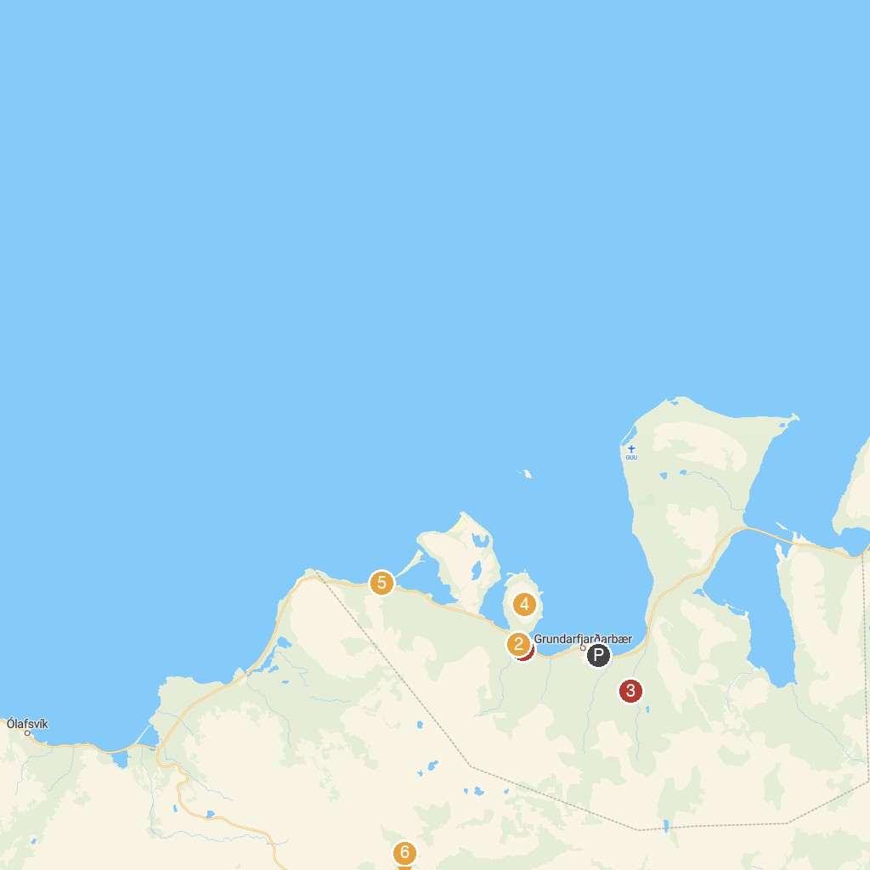
MAP KEY
1. Kirkjufell Waterfall Viewpoint | 4. Kirkjufell Mountain
2. Kirkjufellsfoss | 5. Giant Padlock
3. Grundarfoss | 6. Bjarnarfoss
P. Cruise port / terminal
Map © MapTiler © OpenStreetMap contributors · cruiseports.org

