Groningen, Groningen, Netherlands
Amsterdam without the crowds — Groningen's golden-brick canals, 500-year-old tower, and student-fuelled café scene reward any cruiser who makes the journey inland.
⚓ Docked — Eemshaven or Delfzijl pier · 🚌 ~40 min coach to city center · 🕒 Typical call: 8-10 hrs · 💶 Currency: Euro (€) — card-only common · 🗣️ Language: Dutch (English spoken universally)
✍️ MY DAY IN PORT (FILL IN)
Ship / Date
In port | arrive ______ · all aboard ______
Booked excursion
Notes / meeting point
GETTING ASHORE
- Docking: Deep-water pier at Eemshaven (~40 km north) or Delfzijl (~30 km east); coach transfer to city center
- Walk to Center: Not walkable from port — shuttle or taxi required; once in Groningen, everything is on foot or by bike
- Best For: History, architecture, Dutch food culture, canal strolls, the Groninger Museum
- Don't Miss: Climbing the Martinitoren for panoramic views, and tasting a Groninger Eierbal at a local snack bar
GETTING AROUND
- 🚕 Taxi: €85–€150 — Pre-booked taxis are the primary transfer from Eemshaven port to Groningen city center (~40 km). Fares vary by operator;
- 📱 Rideshare: ✅ Uber, Bolt
TOP THINGS TO DO
- Martinitoren Tower Climb — Ascend 251 steps inside "d'Olle Grieze" — Groningen's beloved 97-meter medieval tower — for sweeping views over the city rooftops…
- Groninger Museum — Designed by Alessandro Mendini, the museum itself is a modernist landmark sitting on its own island opposite the train station.
- Northern Maritime Museum — Tucked inside two medieval buildings in the old city, this museum traces northern Dutch seafaring and Hanseatic trade history…
- Prinsentuin (Prince's Garden) & Canal Walk — Groningen's hidden Renaissance garden behind the Prinsenhof hotel is a quiet escape — manicured roses, herb beds, and leafy…
- Groningen Food & Market Walk — Try the Groninger Eierbal (a whole hard-boiled egg encased in curried meat ragout, breaded and deep-fried — listed on the Dutch…
BEST WALKS
- Old City Circuit: 2.5 km · ~45 min · Easy · Flat — Start at Groningen Centraal station and cross to the Groninger Museum on its canal island.
- Prinsentuin & Dijksteeg: 1.5 km · ~30 min · Easy — A quieter loop through the south end of the old city.
WEATHER · DAYLIGHT · MONEY
Month | High °F | Low °F | Rainy days
May | 62 | 47 | 12
Jul | 71 | 57 | 14
Sep | 66 | 53 | 11
Daylight: May 5:34AM–9:26PM · Jul 5:25AM–9:52PM · Sep 7:08AM–7:48PM
cruiseports.org/groningen · Confirm terminal & all-aboard time with your ship

Groningen, Groningen, Netherlands — Port Map
Red = walkable sights · Amber = excursions farther out · P = cruise terminal
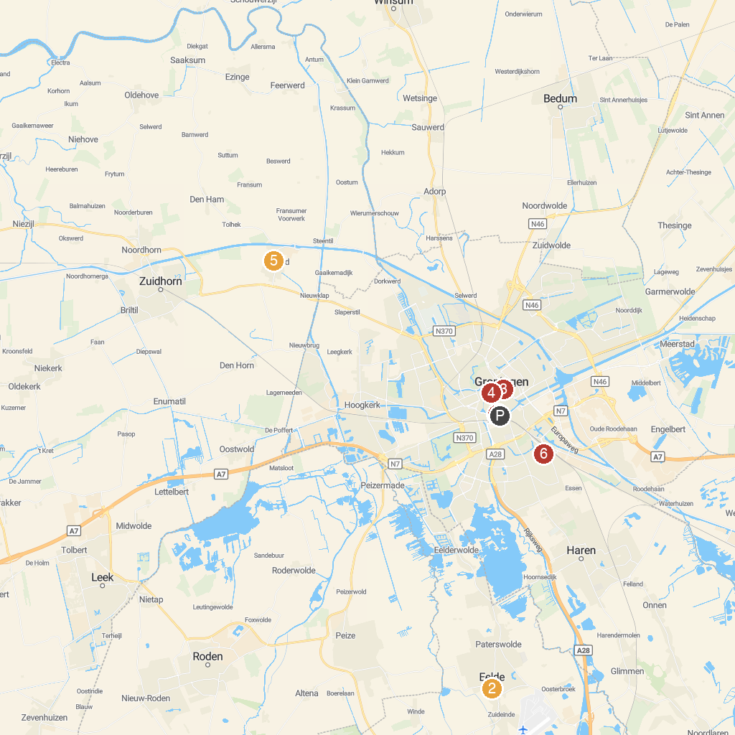
MAP KEY
1. Groninger Museum | 5. Kloostermuseum St. Bernardushof
2. Museum De Buitenplaats Eelde | 6. Park Groenestein
3. Martini Church | 7. Noordlaarderbos
4. University Museum
P. Cruise port / terminal
Map © MapTiler © OpenStreetMap contributors · cruiseports.org

