Grein, Upper Austria, Austria
One of the Danube's most captivating small towns, Grein packs a Renaissance castle, Europe's oldest functioning civic theater, and a legendary ice-cream cafe into a single cobbled hillside you can conquer in a morning.
⚓ Docked (riverside pier) · 🕒 Typical call: 4-6 hrs · 💶 Currency: Euro (€) · 🗣️ Language: German (English spoken) · 🚶 Very walkable town center
✍️ MY DAY IN PORT (FILL IN)
Ship / Date
In port | arrive ______ · all aboard ______
Booked excursion
Notes / meeting point
GETTING ASHORE
- Docking: Pier docked — ships berth directly at the riverside pier on the Danube, steps from Stadtplatz
- Walk to center: 2-3 min to Stadtplatz; 15-20 min (140+ steps) up to Greinburg Castle
- Best For: History buffs, culture lovers, easy strolling, and legendary Austrian ice cream
- Don't Miss: Guided tour of Stadttheater Grein (Austria's oldest civic theater, 1791) and Greinburg Castle
GETTING AROUND
- 🚕 Taxi: €15–€40 — Schönhofer Transport offers local taxi and minibus hire from Grein. Useful for excursions to Ybbs, Pöchlarn, or surround
TOP THINGS TO DO
- Greinburg Castle & Shipping Museum — Austria's oldest inhabited castle (built 1488-95) crowns the hill above town.
- Stadttheater Grein — Oldest Civic Theater in Austria — Built in 1791 inside the town hall's former granary, this 130-seat baroque theater is preserved almost entirely in its original…
- Danube Cycle Path Ride — Grein sits on one of Europe's finest cycling routes, the EuroVelo 6.
- Stillensteinklamm Gorge Hike — A marked, family-friendly trail leads from Grein into the Stillensteinklamm, a granite gorge carved by the Gießenbach stream…
- Linz Half-Day Excursion — Austria's third-largest city lies about 45 minutes by coach from Grein.
BEST WALKS
- Town Center & Castle Loop: 1.5-2 hrs | 2 km | Moderate (steep castle section) — From the pier, walk the Danube promenade to Stadtplatz and visit the historic theater in the town…
- Riverside Promenade Stroll: 30-45 min | 1 km | Easy — A flat walk along the Danube embankment from the pier, passing Schörgi Café with its award-winning…
WEATHER · DAYLIGHT · MONEY
Month | High °F | Low °F | Rainy days
May | 65 | 50 | 16
Jul | 78 | 61 | 13
Sep | 69 | 54 | 10
Daylight: May 5:21AM–8:33PM · Jul 5:16AM–8:56PM · Sep 6:37AM–7:12PM
cruiseports.org/grein · Confirm terminal & all-aboard time with your ship

Grein, Upper Austria, Austria — Port Map
Red = walkable sights · Amber = excursions farther out · P = cruise terminal
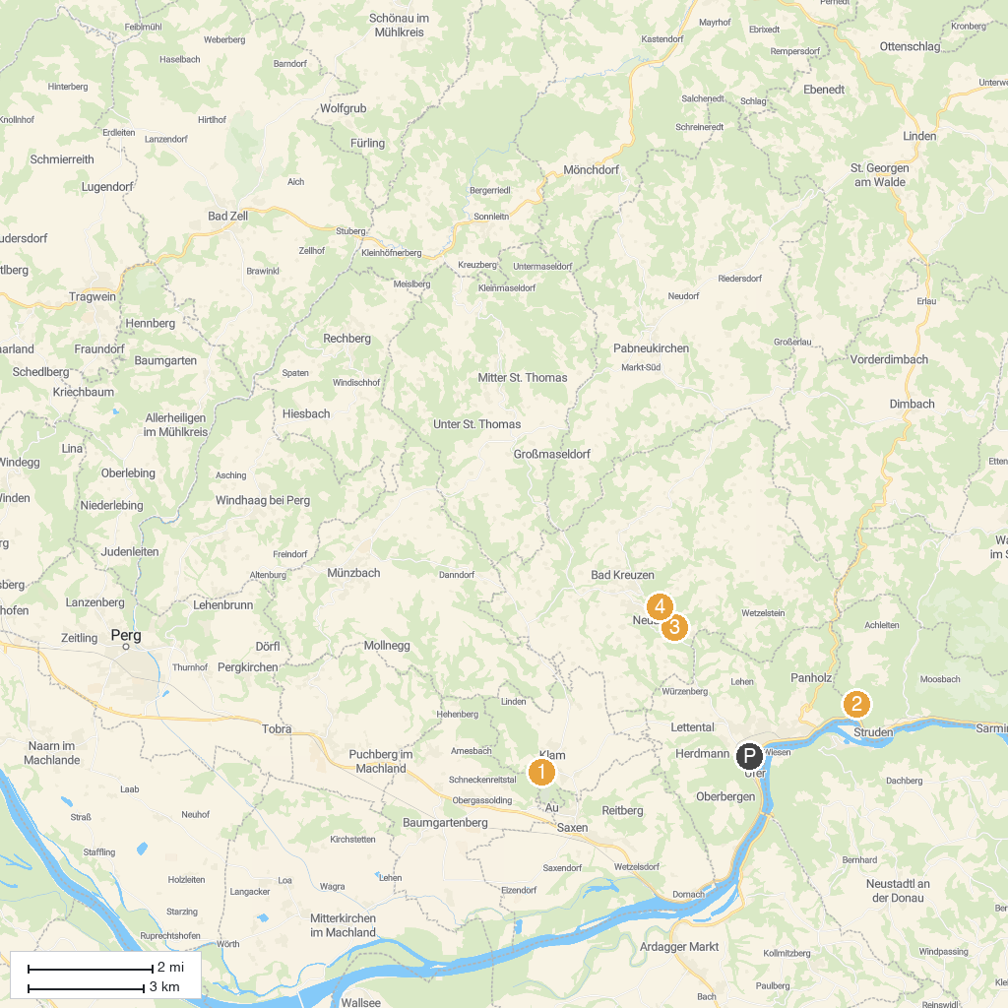
MAP KEY
1. Burg Clam | 3. Wolfsschlucht Bad Kreuzen
2. Stillensteinklamm | 4. Burg Kreuzen
P. Cruise port / terminal
Map © MapTiler © OpenStreetMap contributors · cruiseports.org

