Greifswald, Mecklenburg-Vorpommern, Germany
One of Germany's best-preserved medieval towns, Greifswald escaped WWII intact. Its Gothic brick spires, ivy-draped abbey ruins, and bustling museum harbor make for a genuinely rewarding Baltic shore day.
⚓ Pier (small ships dock at Wieck or Museumshafen) · 🕒 Typical call: 6-8 hrs · 💶 Currency: Euro (€) · 🗣️ Language: German (English widely spoken) · 🎨 Birthplace of Caspar David Friedrich
✍️ MY DAY IN PORT (FILL IN)
Ship / Date
In port | arrive ______ · all aboard ______
Booked excursion
Notes / meeting point
GETTING ASHORE
- Docking: Pier — small ships at Wieck or Museumshafen; large ships use Rostock/Warnemünde
- Walk to center: 5 min from Museumshafen; 5 km (~15 min by bus #2) from Wieck
- Best For: Medieval architecture, Romantic art, historic harbor, cycling
- Don't Miss: Eldena Abbey ruins, Museumshafen, St. Nikolai Cathedral, Marktplatz
GETTING AROUND
- 🚕 Taxi: €12–15 — Taxis wait at the Wieck harbor pier. The 5 km ride to the historic Old Town (Altstadt) takes about 10 minutes at regulat
TOP THINGS TO DO
- Medieval Old Town & Marktplatz — Explore one of Northern Germany's finest market squares, ringed by colorful gabled townhouses and anchored by a striking red…
- Caspar David Friedrich Trail — Visit the Caspar David Friedrich Center on the site of his birthplace, then head to the Pommersches Landesmuseum to see original…
- Eldena Abbey Ruins & Wieck — Stroll to the ivy-covered 12th-century Cistercian monastery ruins in Eldena — the subject of Friedrich's most famous paintings.
- Museumshafen (Museum Harbor) — Germany's largest museum harbor shelters more than 50 historic wooden sailing ships and fishing vessels.
- Baltic Fish & Local Flavors in Wieck — The fishing village of Wieck is the place for a classic Fischbrötchen — a crusty roll stuffed with fresh-caught Matjes herring.
BEST WALKS
- Old Town Loop: 1.5 km | 30-45 min | Easy | Free — Start at the Marktplatz, admire the Rathaus and market square, then visit St.
- Ryck Riverside Path to Wieck: 5 km one way | 75 min walk or 20 min cycle | Easy-moderate — Follow the scenic River Ryck path from the Museum Harbor downstream to the Wieck drawbridge and…
WEATHER · DAYLIGHT · MONEY
Month | High °F | Low °F | Rainy days
May | 61 | 48 | 10
Jul | 72 | 59 | 14
Sep | 66 | 54 | 10
Daylight: May 5:03AM–9:03PM · Jul 4:53AM–9:30PM · Sep 6:40AM–7:21PM
cruiseports.org/greifswald · Confirm terminal & all-aboard time with your ship

Greifswald, Mecklenburg-Vorpommern, Germany — Port Map
Red = walkable sights · Amber = excursions farther out · P = cruise terminal
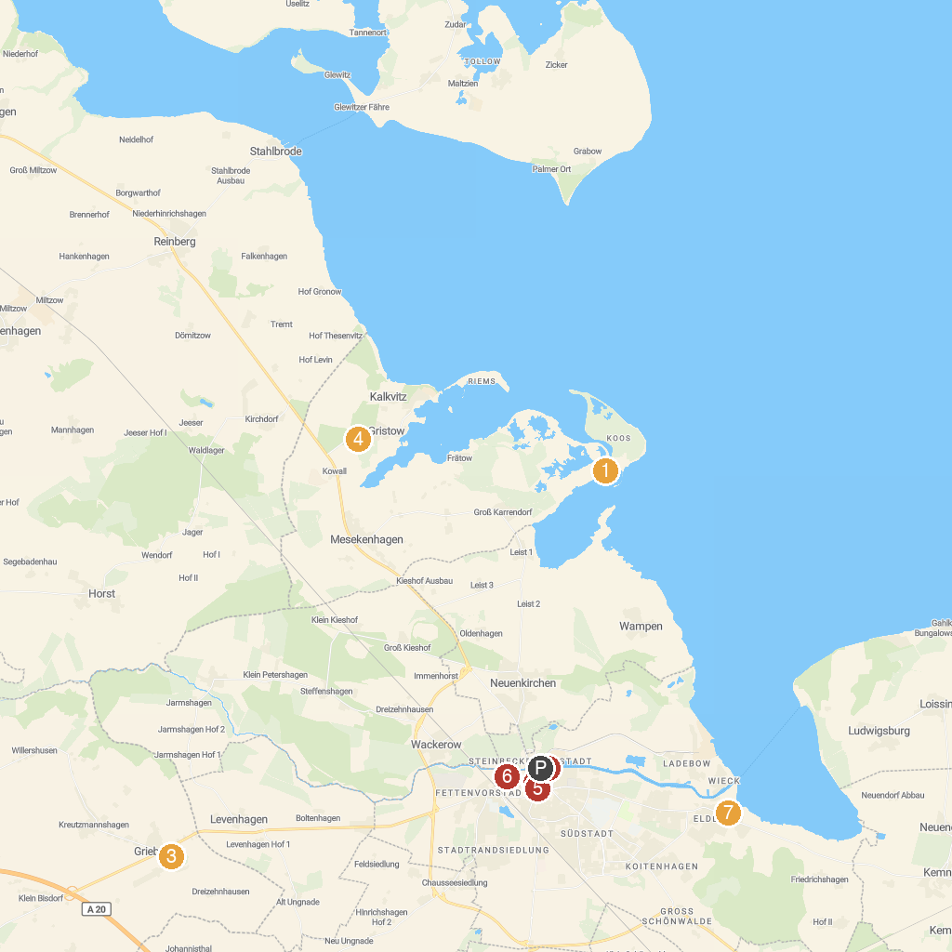
MAP KEY
1. Insel Koos, Kooser lake and Wampener reef | 5. Pommersches Landesmuseum
2. Marktplatz Greifswald | 6. Animal Park Greifswald
3. Barockschloss zu Griebenow e.V. | 7. Eldena Abbey
4. Naturerlebnis Park | 8. Museum harbour Greifswald
P. Cruise port / terminal
Map © MapTiler © OpenStreetMap contributors · cruiseports.org

