Greenock, Scotland, United Kingdom
Scotland's premier cruise gateway puts Glasgow's world-class museums, the bonnie banks of Loch Lomond, and Highland scenery within easy reach — and Greenock itself delivers a warm Scottish welcome with a live piper and panoramic Clyde views.
⚓ Pier (Greenock Ocean Terminal) · 🕒 Typical call: 8-10 hrs · 💷 British Pound Sterling (GBP) · 🗣️ English (Scottish) · 🏴󠁧󠁢󠁳󠁣󠁴󠁿 Gateway to Glasgow & Highlands
✍️ MY DAY IN PORT (FILL IN)
Ship / Date
In port | arrive ______ · all aboard ______
Booked excursion
Notes / meeting point
GETTING ASHORE
- Docking: Direct pier — Greenock Ocean Terminal (no tender)
- Walk to center: 10-15 min flat walk to Greenock town center
- Best For: Glasgow city day trips, Loch Lomond, Scotch whisky, history
- Don't Miss: Kelvingrove Museum (free), the pier pipe band farewell
GETTING AROUND
- 🚕 Taxi: £60–£100 one way — Door-to-door taxi to Glasgow city centre takes ~30–50 min depending on traffic. Pre-booked private transfers for groups
- 🚌 Hop-on hop-off: ✅ McGill's Buses
TOP THINGS TO DO
- Glasgow City Day Trip — DIY by Train — Take the ScotRail train to Glasgow Central and explore on foot.
- Loch Lomond & the Trossachs — Britain's largest freshwater loch is just 45 minutes from the port.
- Inveraray Castle & Argyll — The ancestral seat of the Duke of Argyll, Inveraray Castle is a fairytale turreted castle featured in Downton Abbey.
- McLean Museum & Greenock Local History — A free, fascinating museum celebrating Greenock's maritime and industrial past, including exhibits on James Watt (the steam…
- Scotch Whisky Tasting — Clydeside Distillery — Glasgow's only working waterfront distillery sits next to the Riverside Museum.
BEST WALKS
- Greenock Esplanade Waterfront Walk: 1.5 miles one-way · Flat · 30-45 min · Free — Starting from the cruise terminal, follow the Esplanade east along the Firth of Clyde.
- Glasgow Merchant City & Cathedral Walk: 1.5 miles loop · Easy · 45-60 min after train · Free — From Glasgow Central, walk north through the Merchant City to George Square, then up High Street to…
WEATHER · DAYLIGHT · MONEY
Month | High °F | Low °F | Rainy days
May | 57 | 45 | 16
Jul | 64 | 54 | 18
Sep | 60 | 51 | 16
Daylight: May 5:06AM–9:25PM · Jul 4:54AM–9:54PM · Sep 6:51AM–7:35PM
cruiseports.org/greenock-glasgow · Confirm terminal & all-aboard time with your ship

Greenock, Scotland, United Kingdom — Port Map
Red = walkable sights · Amber = excursions farther out · P = cruise terminal
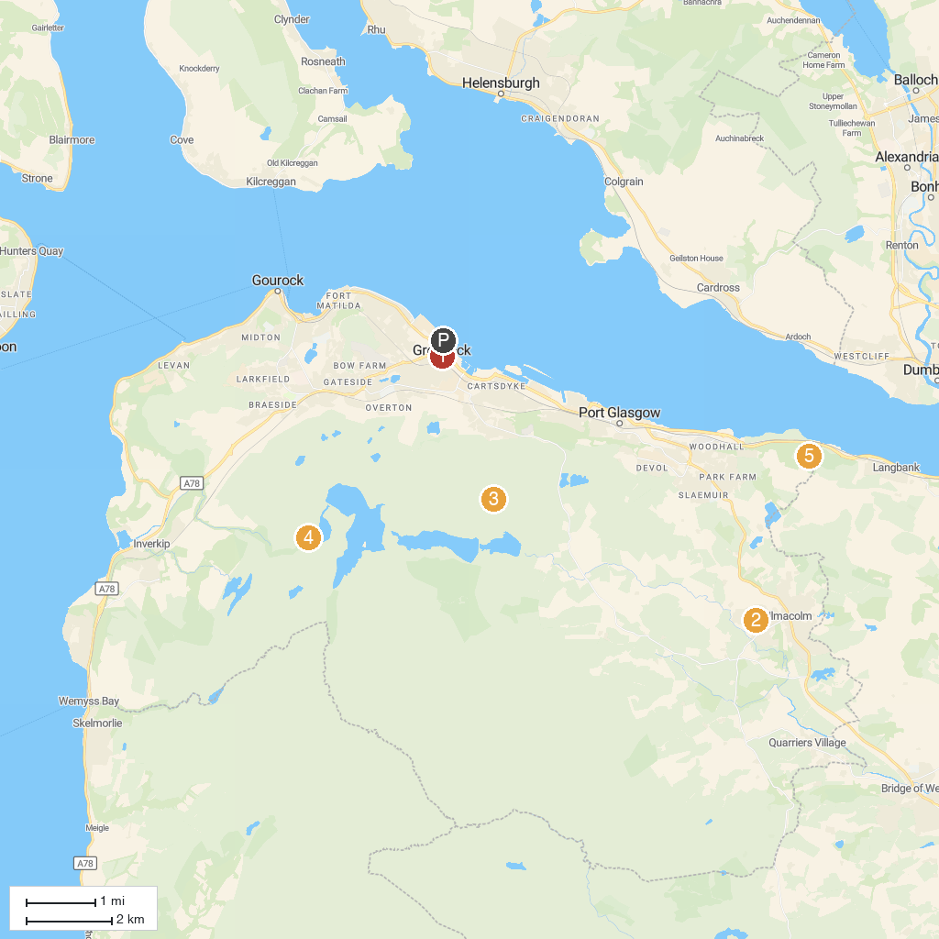
MAP KEY
1. Loch Lomond Golf Club | 5. Corlic Hill
2. Sweeney's Cruise Co Loch Lomond | 6. Greenock Cut Visitor Centre
3. Scottish Fire and Rescue Service Museum and Heritage Centre | 7. Dumbarton Castle
4. Birkmyre Park | 8. Finlaystone Country Park
P. Cruise port / terminal
Map © MapTiler © OpenStreetMap contributors · cruiseports.org

