Green Bay, Wisconsin, USA
America's smallest big-league city delivers big Midwestern heart. Dock on the Fox River, walk to Lambeau Field, eat squeaky cheese curds, and discover why Packer fans own the most storied franchise in the NFL.
⚓ Pier (Fox River, Leicht Memorial Park) · 🕒 Typical call: 8–10 hrs · 💵 USD · 🗣️ English · 🏈 Packer Country
✍️ MY DAY IN PORT (FILL IN)
Ship / Date
In port | arrive ______ · all aboard ______
Booked excursion
Notes / meeting point
GETTING ASHORE
- Docking: Pier — Leicht Memorial Park on the Fox River; ships dock alongside, no tendering
- Walk to center: ~5 min to CityDeck & Broadway District; Lambeau Field ~3 miles (rideshare recommended)
- Best For: Sports history, Great Lakes freshwater cruising, Midwest food culture
- Don't Miss: Lambeau Field tour & Packers Hall of Fame, Bay Beach Amusement Park (25¢ rides!), squeaky cheese curds
GETTING AROUND
- 🚕 Taxi: $9–$15 — Local taxis available citywide. Base fare ~$1.50 plus ~$1.60/km; downtown from the port area is typically 3–5 miles.
- 📱 Rideshare: ✅ Uber, Lyft
TOP THINGS TO DO
- Lambeau Field Tour & Packers Hall of Fame — Walk the same tunnel as NFL players, stand on the legendary frozen tundra, and explore 15,000 sq ft of Packers history.
- Heritage Hill State Historical Park — 56 acres of living history with 26 authentic buildings spanning Wisconsin's fur trade, frontier military, pioneer, and…
- National Railroad Museum — One of the oldest and largest railroad museums in the US.
- Bay Beach Wildlife Sanctuary — 600-acre urban wildlife refuge with free admission.
- Door County Day Trip — About an hour from the dock, Door County is the 'Cape Cod of the Midwest' — limestone bluffs, cherry orchards, historic…
BEST WALKS
- CityDeck & Broadway District Stroll: 1–2 hrs | Flat | Free — From Leicht Memorial Park, walk south along the Fox River to the CityDeck boardwalk, cross Ray…
- National Railroad Museum & Bay Beach Loop: 3–4 hrs | Easy | Rideshare to start — Rideshare to the National Railroad Museum, walk through the exhibits, then continue to Bay Beach…
WEATHER · DAYLIGHT · MONEY
Month | High °F | Low °F | Rainy days
May | 67 | 48 | 11
Jul | 81 | 63 | 11
Sep | 72 | 56 | 10
Daylight: May 5:24AM–8:13PM · Jul 5:22AM–8:33PM · Sep 6:31AM–7:01PM
cruiseports.org/green-bay-wi · Confirm terminal & all-aboard time with your ship

Green Bay, Wisconsin, USA — Port Map
Red = walkable sights · Amber = excursions farther out · P = cruise terminal
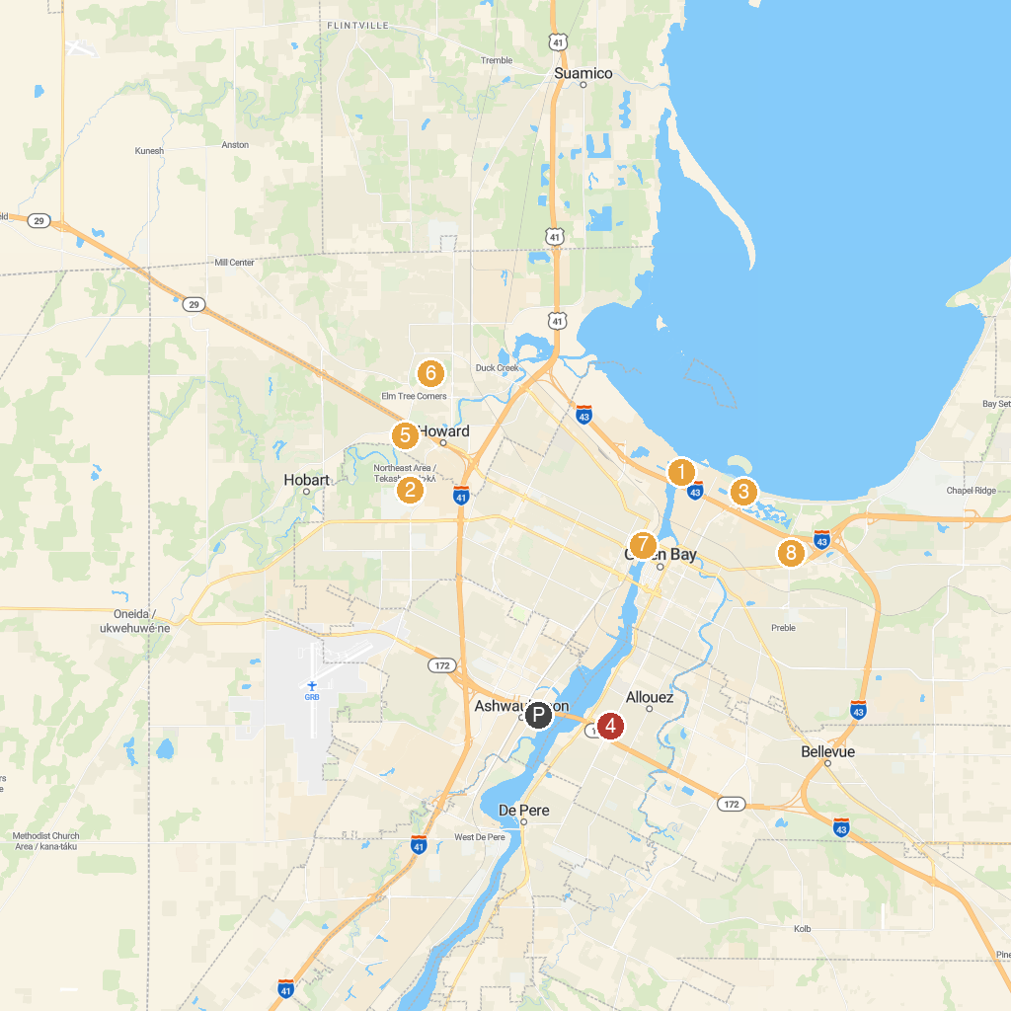
MAP KEY
1. Grassy Island Range Light Front | 5. Pamperin Park
2. Green Bay Botanical Garden | 6. Meadowbrook Park
3. The Children's Museum of Green Bay | 7. Neville Public Museum
4. Heritage Hill State Historical Park | 8. Kennedy Park
P. Cruise port / terminal
Map © MapTiler © OpenStreetMap contributors · cruiseports.org

