Great Stirrup Cay, Berry Islands, Bahamas
The original cruise line private island — 268 acres of turquoise Bahamian water, powdery beaches, and a laid-back vibe that feels worlds away from the megaship parks. Norwegian Cruise Line has owned it since 1977, and a major $150M upgrade is underway.
⚓ Tendering now; new two-berth pier reopens late July 2026 · 🕒 Typical call: 7–9 hrs · 💵 USD accepted everywhere; drinks on Free at Sea package · 🗣️ English · 🏖️ NCL / Oceania / Regent exclusive
✍️ MY DAY IN PORT (FILL IN)
Ship / Date
In port | arrive ______ · all aboard ______
Booked excursion
Notes / meeting point
GETTING ASHORE
- Docking: Tender only as of mid-2026. The first pier opened Dec 28, 2025 (Norwegian Getaway docked first), but it closed April 1, 2026 so the permanent two-berth pier can be finished — reopening expected late July 2026.
- Walk to beach: 3–5 min from the tender marina to Bertram's Beach; free tram loops the island
- Best For: Beach days, snorkeling, water sports, families, first-time Bahamas visitors
- Don't Miss: Abaco Taco bar and the underwater snorkel trail with shipwrecks and a sunken piano
GETTING AROUND
TOP THINGS TO DO
- Zip Line Over the Beach — A multi-station zip line course that sends you flying over the beach and turquoise water.
- Underwater Snorkel Trail — Rent gear and explore a purpose-built snorkel trail with artificial shipwrecks, sea creature statues, and a sunken piano.
- Silver Cove Villa or Classic Cabana — Classic Beach Cabanas seat up to 6 and include water, towels, and food service.
- Wave Runners & Parasailing — Guided wave runner tours circle the Berry Islands with wide-open Caribbean views, while parasailing flights deliver panoramic…
- Kayak & Stand-Up Paddleboard — Hourly rentals to explore the calm coastline at your own pace.
BEST WALKS
- Marina to Bertram's Beach: 5 min · Flat · Paved path — The main artery from the pier/tender dock to the heart of the island.
- Bertram's Beach to Silver Cove: 15–20 min · Easy · Beach path — Follow the shoreline west past Cabana Beach and Fiesta Beach to reach Silver Cove — the quiet…
WEATHER · DAYLIGHT · MONEY
Month | High °F | Low °F | Rainy days
May | 79 | 76 | 13
Jul | 84 | 81 | 16
Sep | 84 | 81 | 16
Daylight: May 6:25AM–7:50PM · Jul 6:29AM–8:05PM · Sep 6:57AM–7:15PM
cruiseports.org/great-stirrup-cay · Confirm terminal & all-aboard time with your ship

Great Stirrup Cay, Berry Islands, Bahamas — Port Map
Red = walkable sights · Amber = excursions farther out · P = cruise terminal
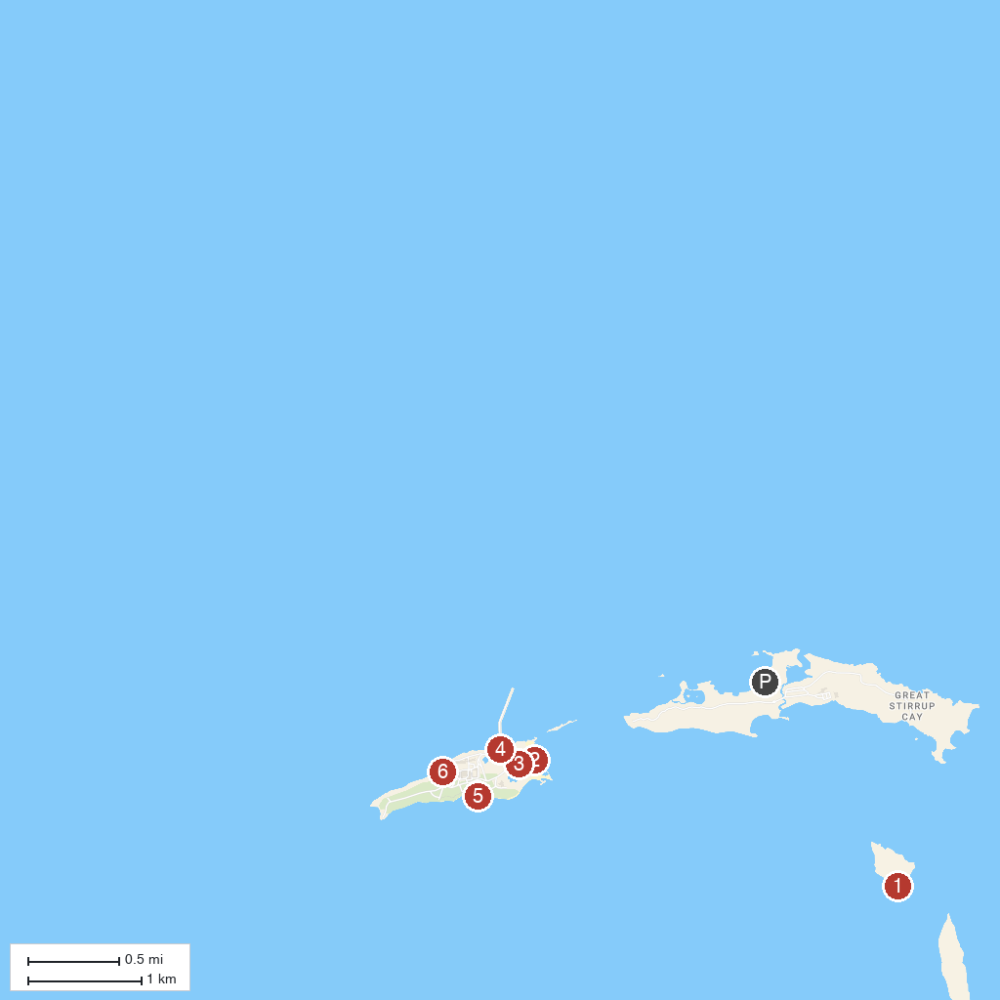
MAP KEY
1. Swim With The Pigs | 4. Perfect Day at CocoCay - Royal Caribbean International
2. Chill Island Beach | 5. South Beach
3. Harbor Beach at Coco Cay | 6. Hideaway Beach at CocoCay
P. Cruise port / terminal
Map © MapTiler © OpenStreetMap contributors · cruiseports.org

