Great Lakes, USA & Canada
Five connected freshwater seas stretching 750 miles from Chicago to the St. Lawrence — the Great Lakes offer an utterly unique cruise experience through historic canal locks, remote island wilderness, and classic American and Canadian cities.
⚓ Docked at major ports · 🕒 Itineraries: 7–15 nights (May–October) · 💵 USD & CAD · 🗣️ English (French in Quebec)
✍️ MY DAY IN PORT (FILL IN)
Ship / Date
In port | arrive ______ · all aboard ______
Booked excursion
Notes / meeting point
GETTING ASHORE
- Docking: Docked at city piers in Chicago, Toronto, Milwaukee, Cleveland, Duluth and others; occasional tender at smaller stops
- Season: Late May through early October only — short season, ships sell out a year in advance
- Best For: History buffs, nature lovers, North America fans seeking something different from ocean cruising
- Don't Miss: Mackinac Island (no cars allowed), the Soo Locks transit, and the Welland Canal passage
GETTING AROUND
- 🚕 Taxi: $8–25 USD — Uber and Lyft cover all major US ports. Short rides in Duluth or Milwaukee run $8–12; longer cross-city trips in Chicago
- 📱 Rideshare: ✅ Uber, Lyft
- 🚌 Hop-on hop-off: ✅
TOP THINGS TO DO
- Mackinac Island Carriage & Fudge Tour — No cars have been allowed on Mackinac Island since 1898 — you explore by horse-drawn carriage, bicycle, or on foot.
- Soo Locks Observation & Canal Tour — Watch massive freighters rise or fall 21 feet through the Soo Locks at Sault Ste.
- Georgian Bay Island Wilderness — Viking itineraries often include anchored calls in Georgian Bay — 30,000 islands of windswept pink granite, clear freshwater, and…
- Chicago Architecture River Cruise — The Chicago Architecture Center's 90-minute river cruise is one of the best city tours in the world — skyscraper by skyscraper…
- Niagara Falls from Port Colborne — Viking and Victory itineraries call at Port Colborne, Ontario — gateway to Niagara Falls, about 20 miles away.
BEST WALKS
- Chicago Lakefront Trail from Navy Pier: 3–5 miles · Easy · 1.5–2.5 hrs — Head south from Navy Pier along the paved lakefront path toward Millennium Park and the Museum…
- Mackinac Island Town & Fort Loop: 2–3 miles · Moderate (uphill to fort) · 1.5 hrs — From the ferry dock, walk Main Street past fudge shops and Victorian hotels to Fort Mackinac at the…
WEATHER · DAYLIGHT · MONEY
Month | High °F | Low °F | Rainy days
May | 66 | 50 | 13
Jul | 80 | 66 | 12
Sep | 74 | 61 | 10
Daylight: May 5:30AM–8:04PM · Jul 5:29AM–8:23PM · Sep 6:31AM–6:59PM
cruiseports.org/great-lakes · Confirm terminal & all-aboard time with your ship

Great Lakes, USA & Canada — Port Map
Red = walkable sights · Amber = excursions farther out · P = cruise terminal
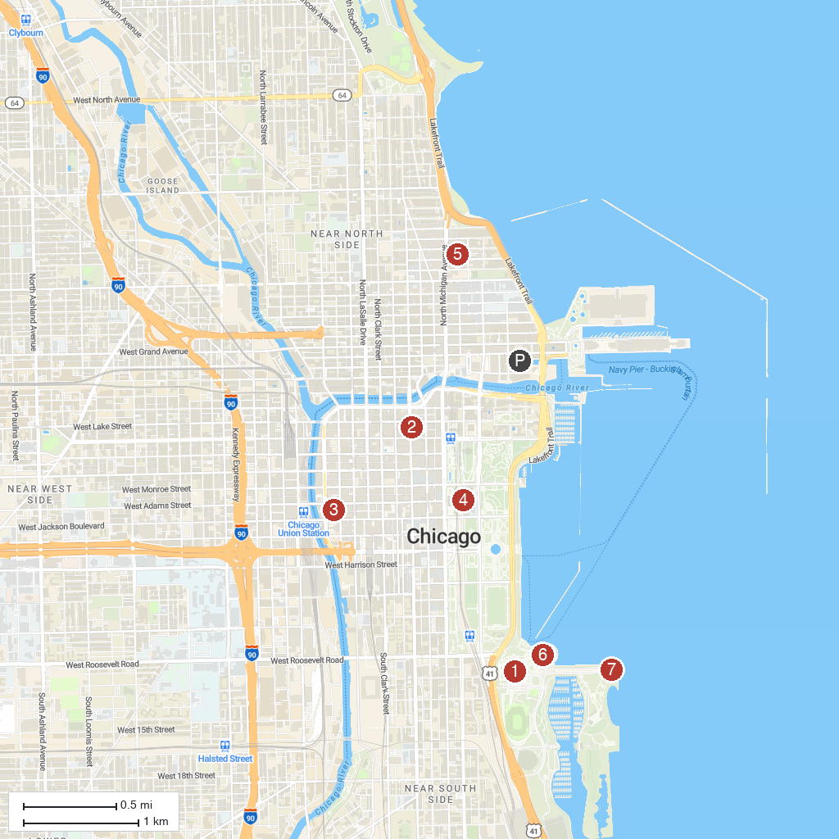
MAP KEY
1. Field Museum | 5. 875 North Michigan Avenue
2. The Chicago Theatre | 6. Shedd Aquarium
3. Willis Tower | 7. Adler Planetarium
4. The Art Institute of Chicago
P. Cruise port / terminal
Map © MapTiler © OpenStreetMap contributors · cruiseports.org

