Great Harbour Cay, Berry Islands, Bahamas
One of the Bahamas' best-kept secrets, Great Harbour Cay delivers mile-long empty beaches, a 1960s jet-set past, and some of the finest bonefishing flats in the Caribbean — all with barely another tourist in sight.
⚓ Tender port · 🕒 Typical call: 6-8 hrs · 💵 USD / Bahamian Dollar · 🗣️ English · 🏝️ Small-ship & luxury lines only
✍️ MY DAY IN PORT (FILL IN)
Ship / Date
In port | arrive ______ · all aboard ______
Booked excursion
Notes / meeting point
GETTING ASHORE
- Docking: Tender only — ships anchor offshore
- Walk to center: 5 min to Bullock's Harbour village from marina dock
- Best For: Deserted beaches, bonefishing, snorkeling, digital detox
- Don't Miss: Sugar Beach caves and the island's 7-mile beach crescent
GETTING AROUND
- 🚕 Taxi: Negotiated — Unmetered local taxis may be available when tender boats arrive at the marina. Agree on fare before boarding; contact Gr
TOP THINGS TO DO
- Bardot Beach Day — A long crescent of powder-white sand along the island's roughly 7 miles of beach, said locally to be where Brigitte Bardot swam…
- Hoffman's Cay Blue Hole — A short boat ride south, Hoffman's Cay features a dramatic blue hole roughly 600 feet across with a 20-foot cliff for jumping.
- Bonefishing the Berry Flats — The Berry Islands are legendary among fly-fishers.
- Shark Creek Mangrove Tour — A winding tidal creek at the island's south end, nursery to baby sharks, sea turtles, eagle rays, and juvenile fish.
- Sugar Beach & the Old Golf Ruins — Sugar Beach's limestone cliffs hide sea caves to explore at low tide.
BEST WALKS
- Bullock's Harbour Village Stroll: 0.5 miles · 15-20 min · Easy — Walk from the marina through Great Harbour Cay's main settlement — colourful houses, friendly…
- Marina to Bardot Beach: 0.8 miles · 20 min · Easy (or golf cart) — A flat paved road leads from the marina to the closest stretch of the famous Bardot Beach.
WEATHER · DAYLIGHT · MONEY
Month | High °F | Low °F | Rainy days
May | 79 | 76 | 13
Jul | 84 | 81 | 16
Sep | 84 | 81 | 16
Daylight: May 6:25AM–7:49PM · Jul 6:29AM–8:04PM · Sep 6:57AM–7:14PM
cruiseports.org/great-harbour-cay-bahamas · Confirm terminal & all-aboard time with your ship

Great Harbour Cay, Berry Islands, Bahamas — Port Map
Red = walkable sights · Amber = excursions farther out · P = cruise terminal
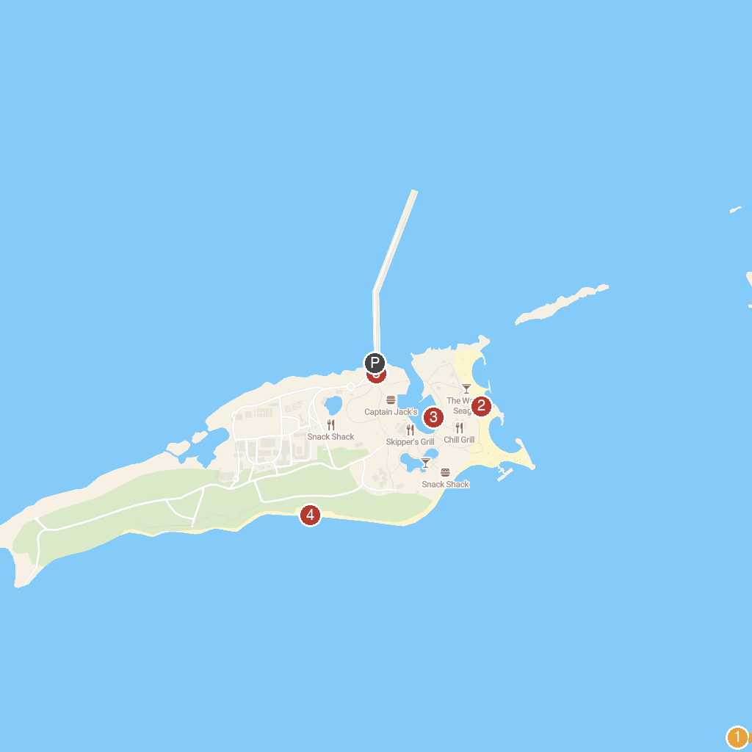
MAP KEY
1. Swim With The Pigs | 4. South Beach
2. Chill Island Beach | 5. Perfect Day at CocoCay - Royal Caribbean International
3. Harbor Beach at Coco Cay
P. Cruise port / terminal
Map © MapTiler © OpenStreetMap contributors · cruiseports.org

