Great Barrier Reef, Coral Sea, Australia
There's no pier, no town, no shopping street — just 2,300 kilometres of living coral and the clearest water you've ever snorkelled in. Your ship anchors in the open Coral Sea and the reef does the rest.
⚓ Tender (open-sea anchorage) · 🕒 Typical call: 6-8 hrs · 💵 AUD — cards accepted on pontoons · 🗣️ English · 🐠 UNESCO World Heritage Site
✍️ MY DAY IN PORT (FILL IN)
Ship / Date
In port | arrive ______ · all aboard ______
Booked excursion
Notes / meeting point
GETTING ASHORE
- Docking: Anchor at sea — tender to reef pontoon
- Walk to centre: N/A — floating pontoon only, no shore
- Best For: Snorkelling, scuba diving, underwater viewing
- Don't Miss: Semi-submersible tour & helicopter over Heart Reef
GETTING AROUND
TOP THINGS TO DO
- Guided Snorkel Safari — A marine biologist leads a small group along the outer reef wall, pointing out clownfish, giant clams, Maori wrasse, and (in…
- Introductory Scuba Dive — No certification required.
- Scenic Helicopter Flight — A 10-minute flight over the outer reef reveals the full scale of the coral system from above, including Heart Reef — a naturally…
- Semi-Submersible Coral Viewing — A small glass-sided vessel dips below the waterline to give a fish-eye view of the reef without getting wet — ideal for…
- Certified Scuba Dive — Qualified divers can do a guided dive to 18 metres on the outer reef slope.
BEST WALKS
- Pontoon Exploration: Self-guided · Flat · 10 min — Walk the pontoon levels: upper sun deck, shaded dining area, underwater observatory stairs, and…
WEATHER · DAYLIGHT · MONEY
Month | High °F | Low °F | Rainy days
May | 75 | 68 | 10
Jul | 71 | 63 | 6
Sep | 76 | 67 | 4
Daylight: May 6:26AM–5:35PM · Jul 6:40AM–5:41PM · Sep 6:01AM–5:59PM
cruiseports.org/great-barrier-reef · Confirm terminal & all-aboard time with your ship

Great Barrier Reef, Coral Sea, Australia — Port Map
Red = walkable sights · Amber = excursions farther out · P = cruise terminal
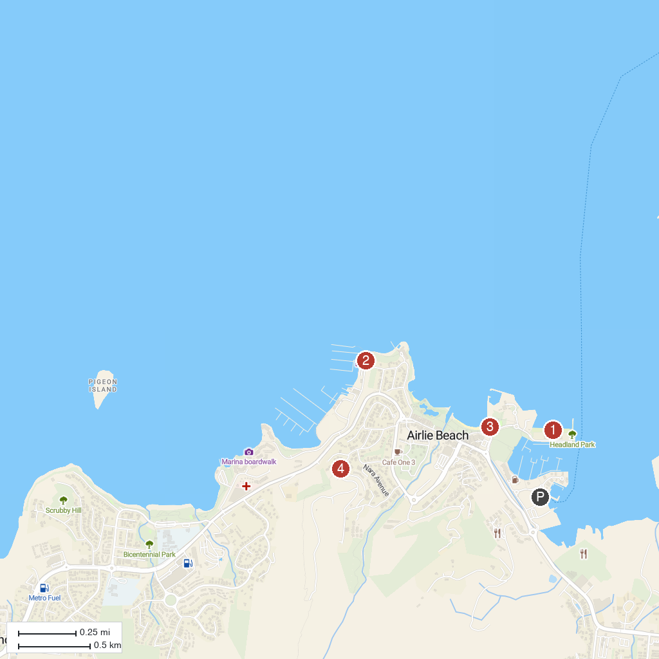
MAP KEY
1. Boathaven Beach | 4. Honeyeater Lookout Trail
2. Providence Whitsunday Sailing | 5. Cruise Whitsundays
3. Whitsunday Saturday Markets
P. Cruise port / terminal
Map © MapTiler © OpenStreetMap contributors · cruiseports.org

