Grand Turk, Turks and Caicos Islands
Seven miles of turquoise-fringed limestone, where a sheer 7,000-foot wall drops just offshore and wild donkeys roam cobblestone streets laid down by 18th-century salt rakers.
⚓ Pier (Grand Turk Cruise Center) · 🕒 Typical call: 7–9 hrs · 💵 USD · 🗣️ English · 🚗 Drive on the left
✍️ MY DAY IN PORT (FILL IN)
Ship / Date
In port | arrive ______ · all aboard ______
Booked excursion
Notes / meeting point
GETTING ASHORE
- Docking: Pier — up to 3 ships simultaneously at Grand Turk Cruise Center
- Walk to town: Cockburn Town is ~3 miles north; taxi or golf cart recommended
- Best For: Wall diving, snorkeling, beaches, colonial history
- Don't Miss: Governor's Beach and the Turks & Caicos National Museum
GETTING AROUND
- 🚕 Taxi: $8–$12/person — Government-set fares; shared vans are the primary transport from the cruise center to Cockburn Town (~15 min). Taxis are
- 📱 Rideshare: ❌ not available
TOP THINGS TO DO
- Wall Dive or Snorkel at The Edge — Grand Turk's signature attraction: a sand shelf at 30–40 ft that plummets 7,000 ft into the Columbus Passage.
- Gibbs Cay Stingray Encounter — A short boat ride to an uninhabited cay where wild southern stingrays glide up to meet you in waist-deep water.
- Cockburn Town & National Museum — Walk or taxi to the sleepy colonial capital — 18th-century Bermudian buildings, red British phone booths, and roaming wild donkeys.
- Governor's Beach — A 20-minute walk or 5-minute taxi north of the cruise center, Governor's Beach offers wide powdery sand and calm shallow…
- Golf Cart Island Loop — Rent a golf cart and drive the full length of the island: cruise center, Governor's Beach, Cockburn Town, the lighthouse at North…
BEST WALKS
- Cruise Center to Governor's Beach: ~1 mile north | 20 min | Flat & easy — Head north along the beach from the cruise center past Jack's Shack beach bar to Governor's Beach…
- Cockburn Town Front Street Walk: Short loop | 1–2 hrs | Best with taxi to town — Taxi to Cockburn Town and walk Front Street and Duke Street past the painted Bermudian salt-era…
WEATHER · DAYLIGHT · MONEY
Month | High °F | Low °F | Rainy days
May | 80 | 78 | 11
Jul | 83 | 81 | 9
Sep | 84 | 81 | 14
Daylight: May 6:06AM–7:15PM · Jul 6:11AM–7:29PM · Sep 6:31AM–6:47PM
cruiseports.org/grand-turk-island · Confirm terminal & all-aboard time with your ship

Grand Turk, Turks and Caicos Islands — Port Map
Red = walkable sights · Amber = excursions farther out · P = cruise terminal
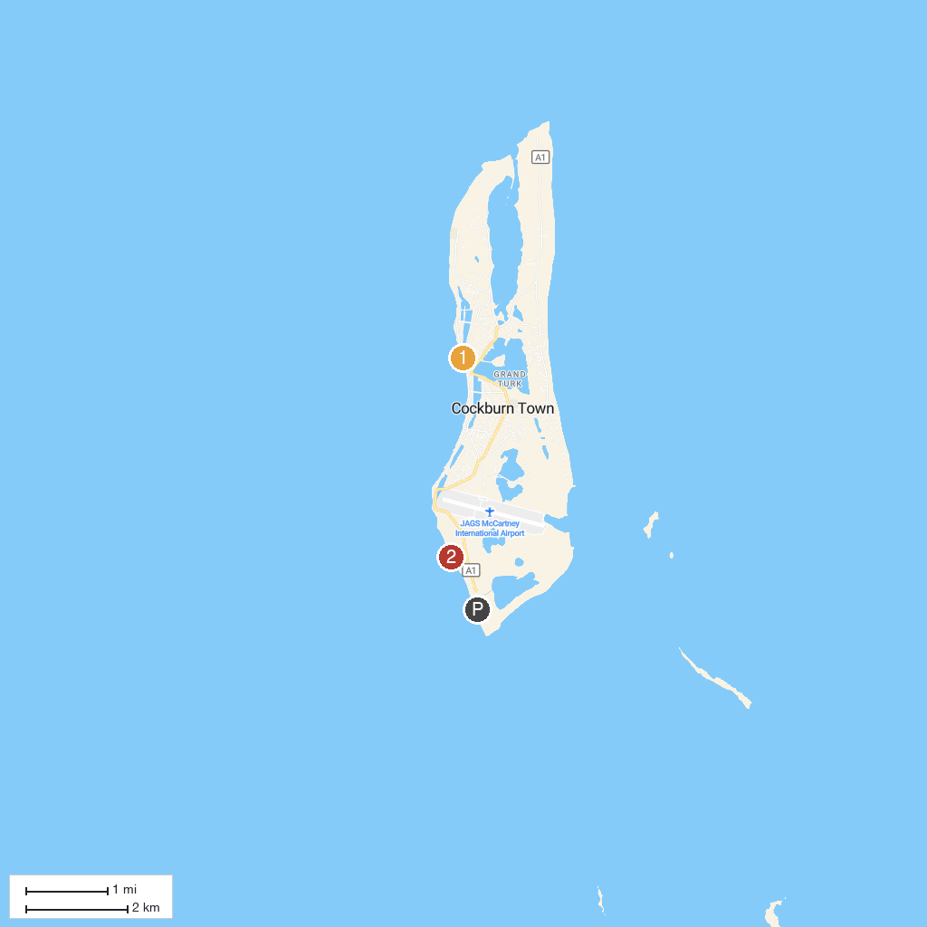
MAP KEY
1. Turks and Caicos National Museum | 2. Governor’s Beach
P. Cruise port / terminal
Map © MapTiler © OpenStreetMap contributors · cruiseports.org

