Gozo Island, Malta
Malta's quieter sister island moves at its own unhurried pace — where temples older than Stonehenge stand beside baroque church domes, red-sand beaches meet crystal-clear coves, and the scent of wood-fired bread drifts through limestone villages.
⚓ Tender port · 🕒 Typical call: 6–8 hrs · 💶 Euro (€) · 🗣️ Maltese & English
✍️ MY DAY IN PORT (FILL IN)
Ship / Date
In port | arrive ______ · all aboard ______
Booked excursion
Notes / meeting point
GETTING ASHORE
- Docking: Tender to Mgarr Harbour quay
- Walk to center: ~30 min uphill to Victoria; taxis/HOHO at pier
- Best For: History, beaches, local food
- Don't Miss: Ggantija temples (3600 BC) & Victoria Citadel ramparts
GETTING AROUND
- 🚕 Taxi: €12–20 to Victoria — Official taxis wait at Mġarr Harbour. The 6 km ride to Victoria (Rabat), the island capital, takes about 10–15 minutes.
- 📱 Rideshare: ✅ Bolt, Uber, eCabs
- 🚌 Hop-on hop-off: ✅
TOP THINGS TO DO
- Ggantija Temples & Xaghra Village — The UNESCO-listed Ggantija megalithic temples (3600 BC) are among the oldest free-standing stone structures on Earth — older than…
- Victoria Citadel (Cittadella) & Ramparts — The medieval walled hilltop city at the heart of Gozo is free to enter.
- Dwejra Bay, Inland Sea & Blue Hole — Though the Azure Window arch collapsed in 2017, Dwejra remains spectacular.
- Ramla Bay — Red Sand Beach — Gozo's premier beach is famous for its rich, reddish-gold sand — rare in the Mediterranean.
- Gozitan Food & Market Tour — Gozo's food culture is distinctly its own: wood-fired ftira flatbreads topped with local sheep's milk cheese (gbejniet)…
BEST WALKS
- Mgarr to Victoria (Rabat) Citadel Walk: 4 km · 1.5–2 hrs · Uphill · Moderate — A steady uphill walk from the ferry port through the village of Ghajnsielem and up to the walled…
- Marsalforn Seafront & Salt Pans: 3 km · 1 hr · Flat · Easy — A flat coastal promenade stroll from the resort town of Marsalforn westward along 350-year-old…
WEATHER · DAYLIGHT · MONEY
Month | High °F | Low °F | Rainy days
May | 67 | 63 | 3
Jul | 80 | 76 | 0
Sep | 79 | 75 | 4
Daylight: May 5:57AM–8:01PM · Jul 5:57AM–8:19PM · Sep 6:45AM–7:09PM
cruiseports.org/gozo-island · Confirm terminal & all-aboard time with your ship

Gozo Island, Malta — Port Map
Red = walkable sights · Amber = excursions farther out · P = cruise terminal
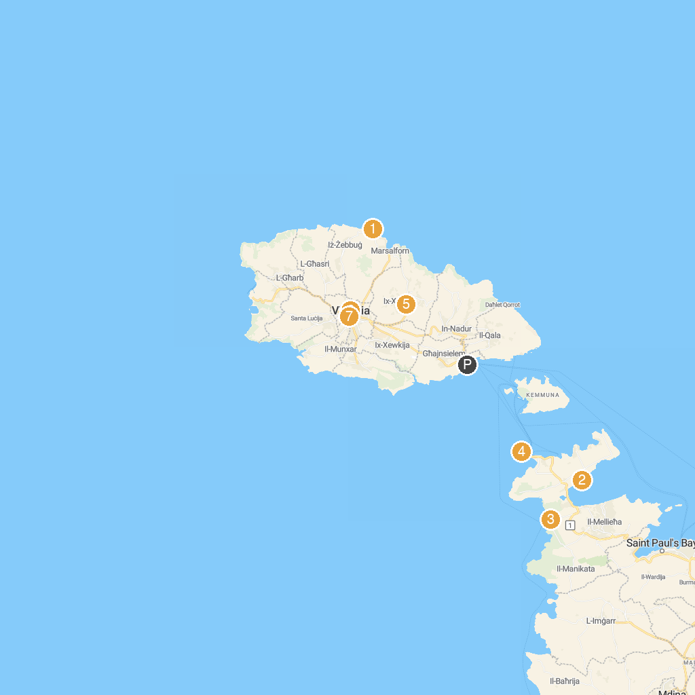
MAP KEY
1. Qolla l-Bajda Battery | 5. Ġgantija Archaeological Park
2. WWII Beach Post - Ta' l-Imgharqa | 6. Gran Castello Historic House
3. Popeye Village | 7. Il-Ħaġar Gozo Museum
4. P29 Wreck
P. Cruise port / terminal
Map © MapTiler © OpenStreetMap contributors · cruiseports.org

