Gothenburg, Västra Götaland, Sweden
Sweden's second city brings Dutch-style canals, cobblestone Haga lanes, and some of Scandinavia's best seafood to the cruise visitor — all wrapped in a refreshingly unpretentious west-coast vibe.
⚓ Pier (no tender) · 🕒 Typical call: 8–10 hrs · 💵 SEK — but almost fully cashless (cards/contactless) · 🗣️ Swedish / English widely spoken · 🌊 Northern Europe
✍️ MY DAY IN PORT (FILL IN)
Ship / Date
In port | arrive ______ · all aboard ______
Booked excursion
Notes / meeting point
GETTING ASHORE
- Docking: Pier — Amerikaterminalen (central) or Arendal/Skandia (outer, shuttle provided)
- Walk to center: 5–20 min from Amerikaterminalen; shuttle from outer terminals
- Best For: City culture, seafood, canals, architecture, Liseberg
- Don't Miss: Giant cinnamon bun at Café Husaren, Paddan canal boat, Skansen Kronan views
GETTING AROUND
- 🚕 Taxi: SEK 100–450 (~$9–43 USD) — Fare varies greatly by terminal. America/Frihamnen terminals (1–2.5 km) run SEK 100–170; Arendal Terminal (12–13 km) run
- 📱 Rideshare: ✅ Uber, Bolt
- 🚌 Hop-on hop-off: ✅ Stromma / City Sightseeing
TOP THINGS TO DO
- Paddan Canal Boat Tour — Flat-bottomed Paddan boats glide through the 17th-century moat canals and out into the harbor.
- Haga District Walk — Gothenburg's oldest suburb is a living museum of 19th-century timber houses along cobblestone Haga Nygata.
- Liseberg Amusement Park — Scandinavia's largest amusement park blends world-class wooden roller coasters, beautifully landscaped gardens, and live…
- World of Volvo — Opened 2024 in a spectacular circular wooden building near Liseberg, this interactive museum traces Volvo's history from Sweden's…
- Southern Archipelago Islands — Take Tram 11 to Saltholmen, then a public ferry (covered by your transit pass) to car-free islands like Vrångö (sandy beaches…
BEST WALKS
- Haga to City Center Loop: 2–3 km · ~45 min · Easy — From Haga Nygata, walk north past Skansen Kronan fortress for panoramic views, then descend into…
- Waterfront & Canal Walk: 2 km · ~30 min · Easy — Follow the Göta River waterfront from the Opera House to Feskekôrka (the Gothic-looking fish…
WEATHER · DAYLIGHT · MONEY
Month | High °F | Low °F | Rainy days
May | 60 | 45 | 12
Jul | 69 | 57 | 16
Sep | 62 | 52 | 13
Daylight: May 4:49AM–9:28PM · Jul 4:35AM–9:59PM · Sep 6:42AM–7:30PM
cruiseports.org/goteborg · Confirm terminal & all-aboard time with your ship

Gothenburg, Västra Götaland, Sweden — Port Map
Red = walkable sights · Amber = excursions farther out · P = cruise terminal
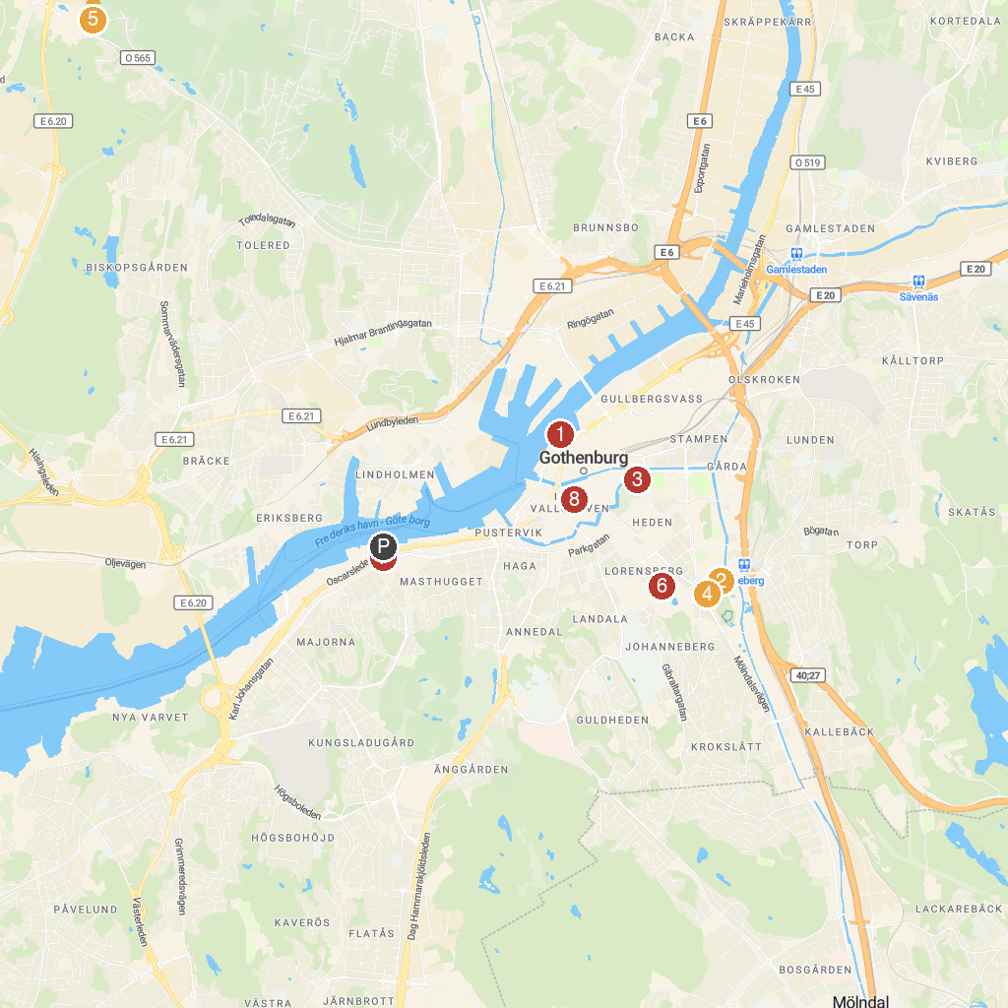
MAP KEY
1. Göteborgsoperan | 5. Aeroseum
2. Liseberg | 6. Gothenburg Museum of Art
3. Trädgårdsföreningen (The Garden Society) | 7. Maritime Museum & Aquarium
4. Universeum | 8. Gothenburg Cathedral
P. Cruise port / terminal
Map © MapTiler © OpenStreetMap contributors · cruiseports.org

