Gorinchem, South Holland, Netherlands
One of the Netherlands' best-kept secrets: a perfectly intact 16th-century fortified city at the confluence of the Linge and Merwede rivers, where the ship docks at the historic Water Gate and the entire walled old town is yours on foot.
⚓ Pier — direct dock, no tender · 🕒 Typical call: 6–8 hrs · 💶 Euro (€) — Netherlands is nearly cashless · 🗣️ Dutch (English widely spoken) · 🏰 UNESCO World Heritage Waterline
✍️ MY DAY IN PORT (FILL IN)
Ship / Date
In port | arrive ______ · all aboard ______
Booked excursion
Notes / meeting point
GETTING ASHORE
- Docking: Buiten de Waterpoort pier; walk through the historic Water Gate directly into the old town
- Walk to Centre: 3 min to Lingehaven harbour; 7–10 min to Grote Markt
- Best For: Rampart walks, historic fortifications, ferry trip to Slot Loevestein castle
- Don't Miss: Walking the full star-shaped rampart circuit and the Riveer ferry to Loevestein Castle
GETTING AROUND
- 🚕 Taxi: €15–€20 — Taxis are available near the port for the very short ride into town, though walking is far more practical given the prox
- 📱 Rideshare: ✅ Uber
TOP THINGS TO DO
- Walk the Star-Shaped Ramparts — Gorinchem's 5 km star-shaped earthen fortification walls are almost entirely intact — a rarity in Europe.
- Slot Loevestein Castle — A 14th-century castle perched at the confluence of the Maas and Waal rivers, famous as the prison from which scholar Hugo de…
- Gorcums Museum & Grote Markt — The city's main museum sits in the former Town Hall on the central square, covering Gorinchem's history as a fortified trading…
- Ferry to Woudrichem — Cross the river on the Riveer water taxi to Woudrichem (Woerkum), a tiny fortified town directly opposite Gorinchem.
- Windmill Walk & Moat Circuit — The two historic flour windmills — De Hoop and Nooit Volmaakt — stand on the ramparts and are open when the blue flag flies.
BEST WALKS
- Rampart & Windmill Circuit: 5 km · ~1.5 hrs · Flat · Free — Walk the full star-shaped fortification walls from the Water Gate, past De Hoop and Nooit Volmaakt…
- Old Town Canal Loop: 2 km · ~45 min · Flat · Free — A short loop through the historic centre: from the Water Gate along the Lingehaven canal with its…
WEATHER · DAYLIGHT · MONEY
Month | High °F | Low °F | Rainy days
May | 64 | 49 | 11
Jul | 72 | 59 | 13
Sep | 67 | 54 | 10
Daylight: May 5:47AM–9:26PM · Jul 5:39AM–9:52PM · Sep 7:15AM–7:54PM
cruiseports.org/gorinchem · Confirm terminal & all-aboard time with your ship

Gorinchem, South Holland, Netherlands — Port Map
Red = walkable sights · Amber = excursions farther out · P = cruise terminal
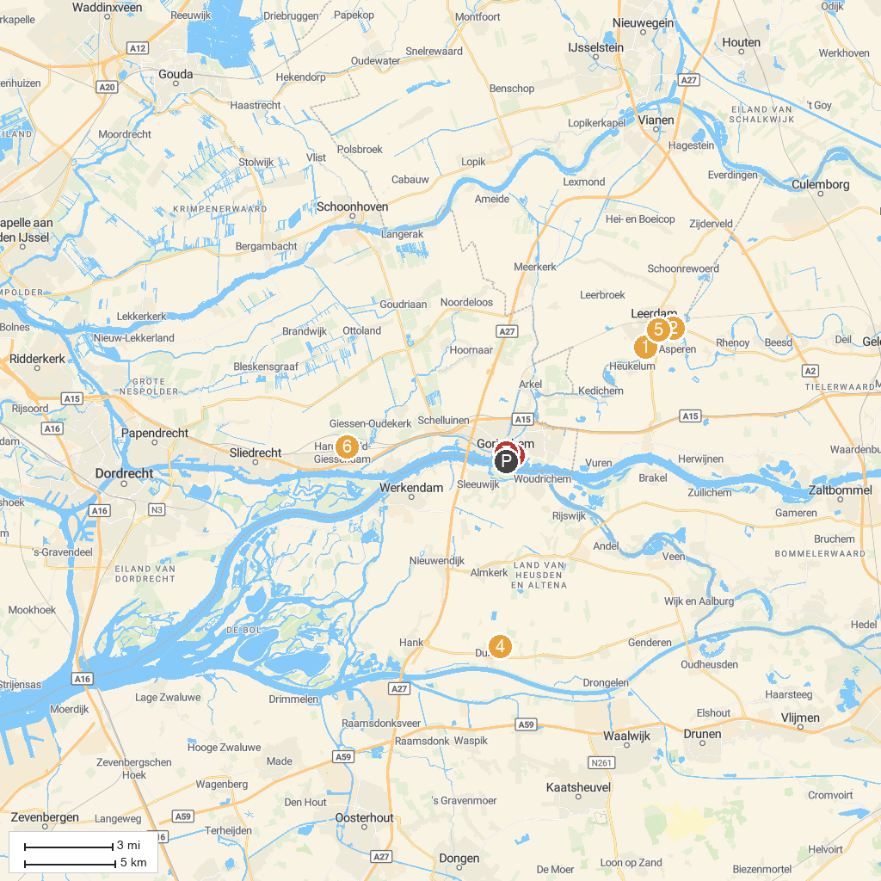
MAP KEY
1. Nationaal Glasmuseum | 5. Castle Dussen
2. Aqua Zoo Leerdam | 6. The Glassworks Leerdam
3. Nationaal Park De Biesbosch | 7. Museum De Koperen Knop
4. Dalempoort | 8. Gorcums Museum
P. Cruise port / terminal
Map © MapTiler © OpenStreetMap contributors · cruiseports.org

