Golfo Aranci, Sardinia, Italy
A former fishing village on Sardinia's northeast coast, Golfo Aranci punches above its size with five beaches steps from the pier, dolphin-watching excursions, and quick access to the glamour of the Costa Smeralda.
⚓ Docked (pier) · 🕒 Typical call: 7-9 hrs · 💶 Euro (€) · 🗣️ Italian
✍️ MY DAY IN PORT (FILL IN)
Ship / Date
In port | arrive ______ · all aboard ______
Booked excursion
Notes / meeting point
GETTING ASHORE
- Docking: Pier — most ships dock directly; very large vessels may tender
- Walk to center: 5 min to town, 5-10 min to nearest beach
- Best For: Beaches, boat trips, Costa Smeralda day excursions
- Don't Miss: Dolphin-watching cruise & Cala Moresca beach hike
GETTING AROUND
- 🚕 Taxi: €5–€10 local; €45–€55 to Olbia — Local taxis are available near the port for short trips. Pre-booked private transfers offer fixed rates to Olbia or the
- 📱 Rideshare: ✅ Uber
TOP THINGS TO DO
- Dolphin-Watching Boat Trip — Eco-boats patrol the waters around Figarolo Island where bottlenose dolphins are regularly spotted.
- La Maddalena Archipelago Day Trip — Boat excursion to this protected national park reveals deserted beaches, pink sands of Budelli, and crystalline coves around…
- Costa Smeralda & Porto Cervo — A 40-minute drive north delivers you to the world's most glamorous yacht harbour.
- Capo Figari Hike & Lighthouse — Trail up the headland above town leads to a working lighthouse with sweeping views over the gulf, Tavolara Island, and the…
- Tavolara & Molara Island Snorkel — Boat trips south to the dramatic limestone tower of Tavolara and the pristine natural pools of Molara combine swimming stops with…
BEST WALKS
- Seafront Promenade & Town Beaches: 1.5 km · Flat · 20 min one-way — Stroll from the port along the promenade past Prima Spiaggia (most central) all the way to Quinta…
- Capo Figari Trail to the Lighthouse: 5 km return · Moderate · 2-2.5 hrs — Follow signs from Cala Moresca up through Mediterranean scrub to the Capo Figari lighthouse.
WEATHER · DAYLIGHT · MONEY
Month | High °F | Low °F | Rainy days
May | 71 | 58 | 7
Jul | 88 | 72 | 1
Sep | 80 | 67 | 5
Daylight: May 6:03AM–8:32PM · Jul 6:02AM–8:52PM · Sep 7:02AM–7:30PM
cruiseports.org/golfo-aranci · Confirm terminal & all-aboard time with your ship

Golfo Aranci, Sardinia, Italy — Port Map
Red = walkable sights · Amber = excursions farther out · P = cruise terminal
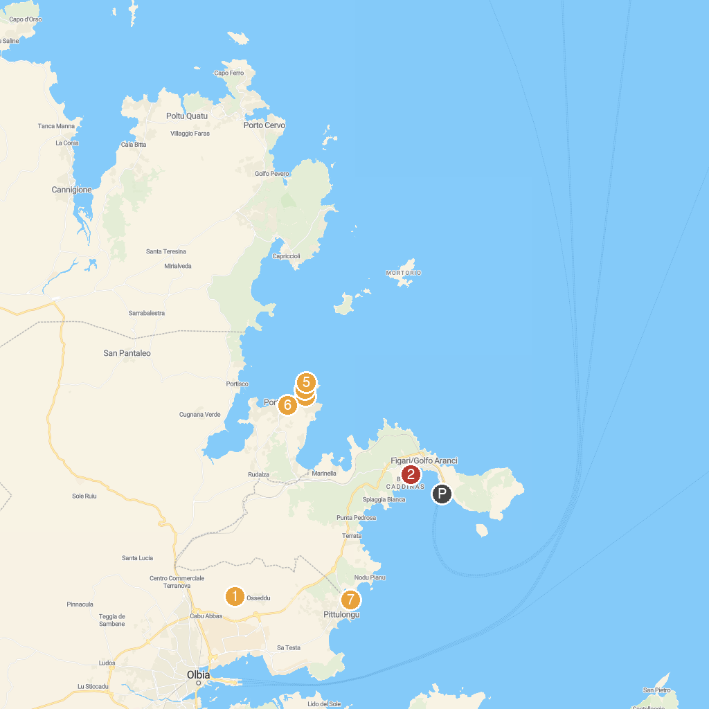
MAP KEY
1. Nuraghe Riu Mulinu Cabu Abbas | 5. Spiaggia Hruska
2. Quinta Spiaggia | 6. San Lorenzo Church
3. Spiaggia Alghe | 7. Spiaggia di Bados
4. Spiaggia di Shirley Bassey
P. Cruise port / terminal
Map © MapTiler © OpenStreetMap contributors · cruiseports.org

