Glengarriff, County Cork, Ireland
Warmed by the Gulf Stream, this tiny Cork village punches well above its weight — subtropical gardens on an island in the bay, a resident seal colony, and ancient Irish oak woods all within minutes of the tender pier.
⚓ Tender port (no pier) · 🕒 Typical call: 6–8 hrs · 💶 Currency: Euro (€) · 🗣️ Language: English (Irish on signs)
✍️ MY DAY IN PORT (FILL IN)
Ship / Date
In port | arrive ______ · all aboard ______
Booked excursion
Notes / meeting point
GETTING ASHORE
- Docking: Tender — ships anchor in Bantry Bay; boats to Glengarriff Pier
- Walk to village: 5–10 min from tender pier to village centre
- Best For: Garinish Island gardens, seal watching, woodland walks
- Don't Miss: Ferry to Garinish Island — book the earliest tender to fit it in
GETTING AROUND
- 🚕 Taxi: €27–€35 to Bantry — Local taxi services (Billy Downey Cabs, Donal Harrington) serve Glengarriff and the surrounding area. Bantry (~17 km) is
TOP THINGS TO DO
- Garinish Island (Ilnacullin) Gardens — Board the Blue Pool Ferry or Harbour Queen for a 15-min crossing to this world-famous island garden.
- Bantry House & Gardens — A 15-minute drive brings you to one of Ireland's great 18th-century stately homes.
- Caha Pass Mountain Drive — Hire a driver or join a tour for the spectacular road over the Caha Mountains toward Kenmare.
- Glengarriff Woods Nature Reserve — One of Ireland's best-preserved ancient oak forests, a 20-minute walk or short taxi ride from the pier.
- Blue Pool & Village Wander — The Blue Pool is a magical tidal inlet right behind the village where river meets sea — perfect for a short woodland walk and…
BEST WALKS
- Tender Pier to Village & Blue Pool Loop: 1.5 km · 20–30 min · Easy · Free — From the tender pier, walk into the village past craft shops and pubs, then follow the signs to the…
- Glengarriff Woods Nature Reserve: 2–4 km · 1–1.5 hrs · Easy to moderate · Free — A short taxi or 20-min walk from the village brings you to ancient sessile oak woodland with…
WEATHER · DAYLIGHT · MONEY
Month | High °F | Low °F | Rainy days
May | 60 | 47 | 16
Jul | 66 | 55 | 17
Sep | 63 | 52 | 16
Daylight: May 5:45AM–9:24PM · Jul 5:38AM–9:49PM · Sep 7:13AM–7:52PM
cruiseports.org/glengarriff · Confirm terminal & all-aboard time with your ship

Glengarriff, County Cork, Ireland — Port Map
Red = walkable sights · Amber = excursions farther out · P = cruise terminal
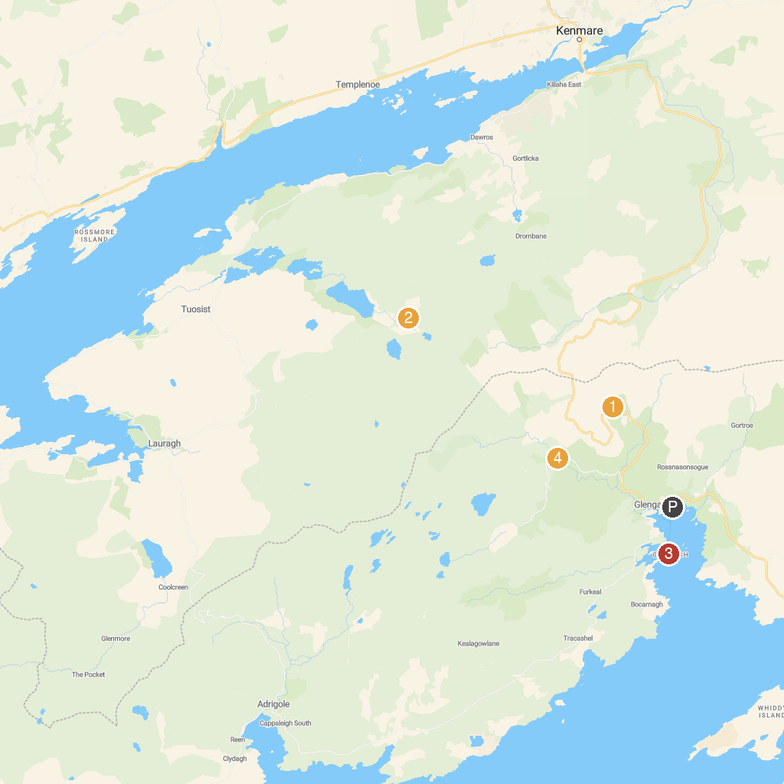
MAP KEY
1. The Ewe Experience | 4. Garinish Island (Oileán Garinis)
2. Gleninchaquin Park | 5. Pooleen Wood
3. Carnegie Arts Centre
P. Cruise port / terminal
Map © MapTiler © OpenStreetMap contributors · cruiseports.org

