Gladstone, Queensland, Australia
A hardworking harbour city with a world-class waterfront precinct and one of Australia's best Great Barrier Reef day-trip launchpads right at its doorstep.
⚓ Pier (docked) · 🚌 Free shuttle to city · 🕒 Typical call: 8–10 hrs · 💵 AUD — card accepted everywhere · 🗣️ English
✍️ MY DAY IN PORT (FILL IN)
Ship / Date
In port | arrive ______ · all aboard ______
Booked excursion
Notes / meeting point
GETTING ASHORE
- Docking: Pier — Auckland Point Wharf (Berths 1 or 3); free shuttle to East Shores & CBD (port is active industrial, no pedestrian access)
- Walk to centre: 5-min free shuttle; East Shores Precinct is the main drop-off, CBD a further 5-min walk uphill
- Best For: Great Barrier Reef day trips, waterfront parks, fresh seafood (Queensland Mud Crabs)
- Don't Miss: Feast on East Markets on cruise days, HMAS Gladstone II patrol boat tour, Heron Island reef day trip (ferry from Gladstone Marina)
GETTING AROUND
- 🚕 Taxi: AUD $6–15 — Taxis are available at the terminal. The city center is under 5 km away; most rides run AUD $6–15 depending on exact des
- 📱 Rideshare: ✅ Uber
- 🚌 Hop-on hop-off: ✅
TOP THINGS TO DO
- Heron Island — Great Barrier Reef — Heron Island is a coral cay on the Southern Great Barrier Reef reached by the Heron Islander ferry from Gladstone Marina (about…
- Quoin Island Turtle Rehabilitation Centre — A short ferry ride to a private island in Gladstone Harbour with a turtle rehabilitation centre where rescued and injured sea…
- HMAS Gladstone II Guided Tour — Step aboard a decommissioned Royal Australian Navy Fremantle Class patrol boat permanently berthed at East Shores.
- Gladstone Tondoon Botanic Gardens — 83 hectares of tropical and subtropical plants from North Queensland, with peaceful lagoons, a Japanese Tea Garden, and shaded…
- Harbour & Industrial Port Cruise — A 2-hour guided boat tour of one of Australia's largest commodity ports — spot dolphins, turtles, and dugongs against a backdrop…
BEST WALKS
- East Shores Waterfront Stroll: 1–2 km · Flat · 30–45 mins — From the shuttle drop-off at East Shores, walk the waterfront boardwalk past the water play park…
- CBD & Auckland Hill Lookout: 2 km · Moderate (hill climb) · 45–60 mins — Walk from East Shores up to Goondoon Street for cafes and the Gladstone Regional Art Gallery &…
WEATHER · DAYLIGHT · MONEY
Month | High °F | Low °F | Rainy days
May | 76 | 62 | 5
Jul | 72 | 55 | 4
Sep | 77 | 61 | 4
Daylight: May 6:22AM–5:20PM · Jul 6:37AM–5:24PM · Sep 5:52AM–5:48PM
cruiseports.org/gladstone-qld · Confirm terminal & all-aboard time with your ship

Gladstone, Queensland, Australia — Port Map
Red = walkable sights · Amber = excursions farther out · P = cruise terminal
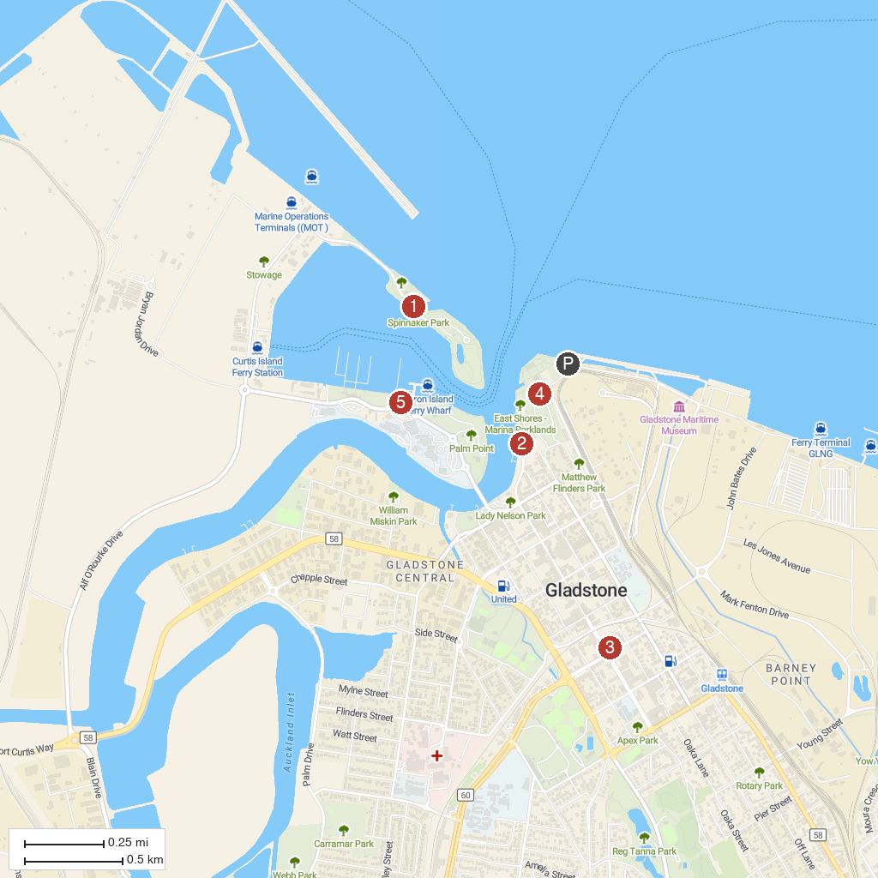
MAP KEY
1. Spinnaker Park | 4. Gladstone Regional Art Gallery and Museum
2. East Shores | 5. William Golding Memorial Lookout
3. Boyne Tannum HookUp | 6. Heron Island Ferry Terminal
P. Cruise port / terminal
Map © MapTiler © OpenStreetMap contributors · cruiseports.org

