Giurgiulești, Cahul District, Moldova
Europe's least-visited country has one port — and it's here, at the precise spot where Moldova, Romania, and Ukraine converge on the Danube. Industrial by nature, extraordinary by geography.
⚓ Pier (direct docking) · 🕒 Typical call: 6-8 hrs · 💵 Moldovan Leu (MDL) · 🗣️ Romanian & Russian
✍️ MY DAY IN PORT (FILL IN)
Ship / Date
In port | arrive ______ · all aboard ______
Booked excursion
Notes / meeting point
GETTING ASHORE
- Docking: Pier at Giurgiulești International Free Port (GIFP) — ships dock directly
- Walk to center: ~1.5 km to Giurgiulești village; free roaming in the port zone is restricted
- Best For: Geopolitical curiosity, Moldovan wine & food, Lower Prut wetlands, river scenery
- Don't Miss: Lake Beleu pelican colony, Cahul spa town, tripoint border view, plăcinte pastries
GETTING AROUND
- 🚕 Taxi: $12–$15 USD — Galați is the nearest city, about 15 km across the Romanian border. Local taxis make this short run; confirm border-cros
TOP THINGS TO DO
- Lake Beleu & Lower Prut UNESCO Biosphere Reserve — About 25 minutes north, Lake Beleu is a stunning wetland reserve home to vast flocks of Dalmatian pelicans, white herons…
- Văleni Folk Village & Eurovision Fame — The village of Văleni, home to the famous grandmother who performed with Zdob și Zdub at Eurovision 2005, welcomes visitors with…
- Cahul Spa Town — About an hour north (~50 km), Cahul is known for its thermal mineral springs and Soviet-era sanatoriums now repurposed for…
- Gagauzia — Orthodox Turkic Autonomous Region — A remarkable cultural anomaly: the Gagauz people are Orthodox Christian and Turkic-speaking.
- Trajan's Wall Wine Region Tasting — The Valul lui Traian wine region surrounding the port produces robust reds — Cabernet Sauvignon, Merlot, Rara Neagră, and Saperavi.
BEST WALKS
- Giurgiulești Village Stroll: 1.5 km · Easy · Flat — From the port gate, the village of Giurgiulești is a short drive or a flat 15-minute walk along the…
WEATHER · DAYLIGHT · MONEY
Month | High °F | Low °F | Rainy days
May | 72 | 55 | 10
Jul | 85 | 67 | 7
Sep | 77 | 59 | 4
Daylight: May 5:36AM–8:30PM · Jul 5:33AM–8:52PM · Sep 6:45AM–7:17PM
cruiseports.org/giurgiulesti · Confirm terminal & all-aboard time with your ship

Giurgiulești, Cahul District, Moldova — Port Map
Red = walkable sights · Amber = excursions farther out · P = cruise terminal
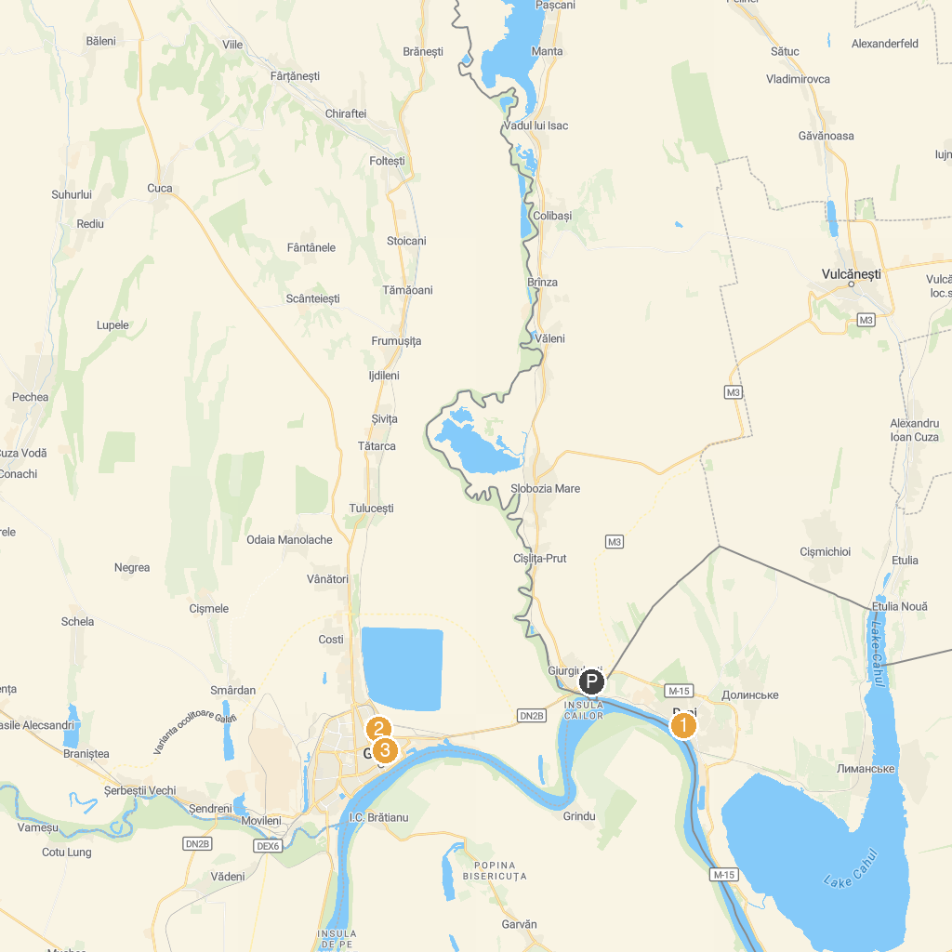
MAP KEY
1. House Museum Collections | 4. Grădina Publică
2. Propeller Monument | 5. Cuza Voda Memorial House
3. Tsentr Kulʹtury I Dozvillya Reniysʹkoyi Misʹkoyi Rady | 6. The Episcopal Palace
P. Cruise port / terminal
Map © MapTiler © OpenStreetMap contributors · cruiseports.org

