Gisborne, North Island, New Zealand
Where New Zealand's history began — first landfall for Captain Cook, first land to greet each sunrise, and a sun-drenched coast of surf, wine, and deep Māori culture.
⚓ Tender port · 🕒 Typical call: 7-9 hrs · 💵 NZD (cards widely accepted) · 🗣️ English & Māori · 🌊 Poverty Bay, East Cape
✍️ MY DAY IN PORT (FILL IN)
Ship / Date
In port | arrive ______ · all aboard ______
Booked excursion
Notes / meeting point
GETTING ASHORE
- Docking: Tender — ships anchor in Poverty Bay; tenders to inner harbour
- Walk to centre: ~15 min / 1.2 km along the Tūranganui River from tender pier
- Best For: Māori culture, surf beaches, wine tours, Cook history
- Don't Miss: Kaiti Hill views & Captain Cook landing site
GETTING AROUND
- 🚕 Taxi: NZD 10–15 — Taxis typically meet ships at the port. Short ride to city center; Gisborne Taxi Society and Driving Miss Daisy are the
- 📱 Rideshare: ✅ Uber
TOP THINGS TO DO
- Dive Tatapouri Reef Ecology Tour — Wade onto a coastal reef at low tide and hand-feed wild stingrays and eagle rays — Gisborne's most distinctive experience.
- Kaiti Hill & Cook Landing Site — Climb or taxi to Titirangi (Kaiti Hill) for 360° views of Poverty Bay and your ship.
- Tairāwhiti Museum — One of New Zealand's best regional museums — Māori taonga (treasures), a restored historic cottage, maritime exhibits, and the…
- Rere Rockslide & Falls — A 60-metre natural rock chute where locals slide on boogie boards into a swimming hole.
- Gisborne Wine Trail — Gisborne is the Chardonnay Capital of New Zealand, famed for rich, buttery whites and excellent Gewürztraminer.
BEST WALKS
- Tūranganui River Walkway to City Centre: 1.2 km · 15 min · Flat & paved — The classic cruise walk: follow the scenic riverbank path from the inner harbour tender landing…
- Waikanae Beach Stroll: ~2 km · 25 min from tender · Flat — Continue past the city centre to Waikanae Beach — a wide grey-sand beach safe for swimming, popular…
- Kaiti Hill Lookout: 1.5 km up · 30 min climb · Moderate — From the Cook Monument at the base of Kaiti Hill, follow the walking track to the summit for…
WEATHER · DAYLIGHT · MONEY
Month | High °F | Low °F | Rainy days
May | 62 | 50 | 10
Jul | 56 | 44 | 12
Sep | 60 | 47 | 14
Daylight: May 7:03AM–5:05PM · Jul 7:23AM–5:05PM · Sep 6:09AM–5:57PM
cruiseports.org/gisborne · Confirm terminal & all-aboard time with your ship

Gisborne, North Island, New Zealand — Port Map
Red = walkable sights · Amber = excursions farther out · P = cruise terminal
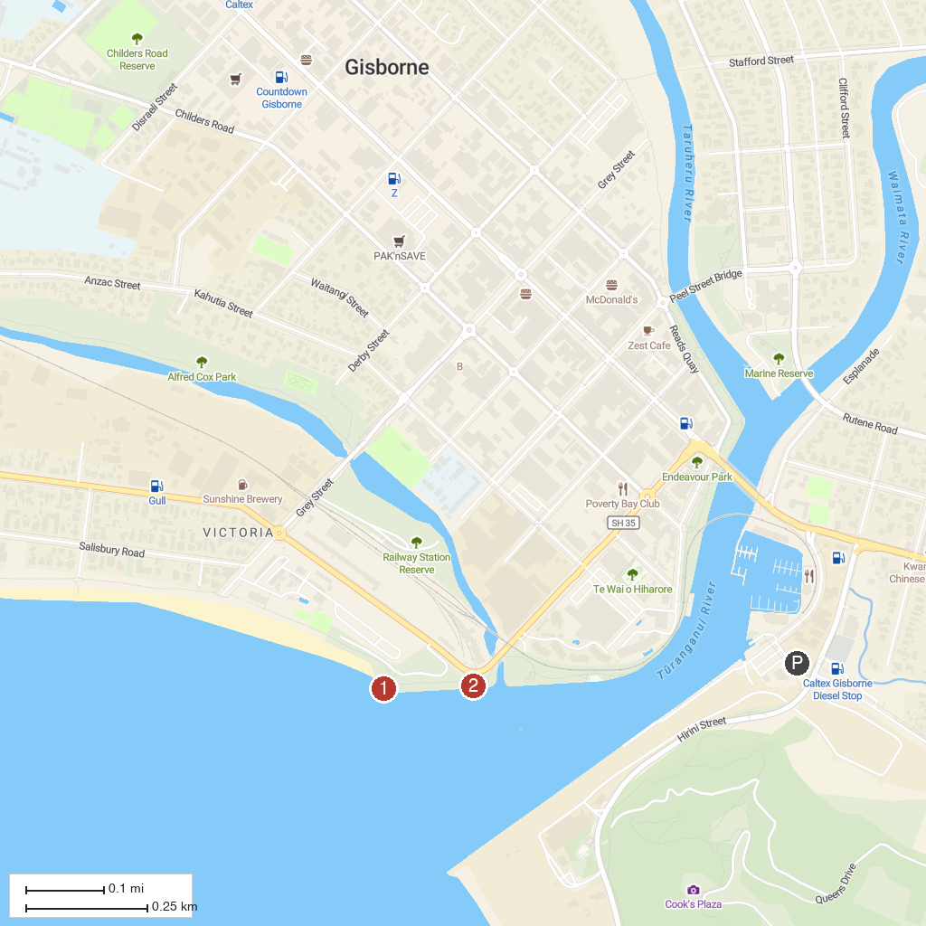
MAP KEY
1. Dive Tatapouri | 3. Captain Cook Statue
2. Young Nick Statue
P. Cruise port / terminal
Map © MapTiler © OpenStreetMap contributors · cruiseports.org

